Historical Association
Survey of History in Schools in England 2011
Authors: Dr Katharine Burn, Institute of Education and Dr Richard Harris, Southampton University
Nature of the survey
The findings reported here are based on the response of history teachers in England to an online survey sent by the Historical Association to all schools and colleges teaching students in the 11–18 age range.
Responses were received from 403 different centres including middle schools and sixth-form colleges. These were analysed in relation the different types of schools that responded: state-maintained comprehensives, state-maintained grammar schools, independent schools, old-style academies (established under the previous Labour governments in areas of socio-economic disadvantage) and new academies (established under the terms of the Academies Act of 2010 which allowed high-performing schools to switch to academy status). While both types of academy have similar independence from local authority control and are equally free to ignore the requirements of the National Curriculum, the different circumstances in which they were each established means that they tend to serve very different kinds of catchment areas.
Responses to the questions about teaching 11–14-year-olds (traditionally regarded as Key Stage 3 – although some schools now complete Key Stage 3 in two years) were received from 375 schools. These 375 schools included 249 state-maintained comprehensive schools, 16 state-maintained grammar schools, 52 independent schools, 25 old-style academies and 33 new academies. This means that responses in relation to Key Stage 3 were received from approximately 10% of grammar schools, 13% of the old-style academies and 11% of independent schools. The number of schools switching rapidly from comprehensive to academy status makes it difficult to calculate exactly what proportion of these types of school responded to the survey, but the figure for their combined responses represents approximately 10% of the combined total of comprehensives and new academies. Responses to questions about provision at Key Stage 4 (conventionally ages 14-16) were received from 370 schools; while 237 schools and sixth-form colleges reported on their AS and A level history provision.

1. History at Key Stage 3
1. 1 How history is taught
1.1.1 How history is taught in Year 7
Respondents were asked to describe how history is taught: as an entirely separate, discrete subject; as a discrete subject within a humanities programme; within an integrated humanities programme; or within some other model. The overall figure shows that 76.5% of schools offer history as a discrete subject, with a further 10.7% offering discrete history within a humanities programme. The figure for schools teaching integrated humanities is 7.5% and some other form of programme accounts for 5.3% of responses. The responses are very similar to those reported in the 2010 survey findings.
As in previous years, grammar schools and independent schools are far more likely to teach history as a discrete subject, and only one independent school indicated that they offer an alternative style curriculum. Nearly 85% of the new academies, established by the coalition government, reported teaching history as an entirely discrete subject, and just over 12% of them taught history as a discrete subject within a humanities framework; the high level of discrete history provision may be due to their previous position as high achieving comprehensive schools. Over 70% of comprehensives teach discrete history, which is similar to the figures from 2010. As in previous years the older style academies are the least likely type of school to offer discrete history, although the proportion of 56% doing so is slightly higher than last year. Older style academies were the most likely type of school to teach an integrated programme, with 20% of them reporting this approach. The proportion of older style academies reporting an alternative kind of curriculum programme was lower than in previous years (8% as opposed to 13.6% in 2010).
When comparing the results from the 2010 survey to the current survey, the overall pattern is very similar (see Table 1), but this year’s figures also show a slightly lower proportion of schools adopting a humanities model, either teaching discrete subjects under the umbrella of humanities or providing an integrated programme. As last year, academies are more likely to provide history as part of an integrated humanities or an alternative curriculum.
Table 1: Comparison showing how history is taught within the curriculum in Year 7
Figures in bold relate to data from 2011; figures in (brackets) to 2010 survey
Proportion of schools offering Yr 7 history | All schools  375 in total  (531 in total) | Comprehensive  schools  249  (377) | Grammar schools  16  (27) | Independent schools  52  (67) | Old style academies  25  (22) | New  academies  33
As a discrete subject | 76.5% (287 schools)  (72.9% = 387 schools) | 72.7%  (69.5%) | 100%  (88.9%) | 92.3%  (92.5%) | 56%  (45.5%) | 84.8%
As a discrete subject within humanities | 10.7% (40 schools)  (13.2% = 70 schools) | 12%  (15.4%) | 0%  (3.7%) | 3.8%  (4.5%) | 16%  (27.3%) | 12.1%
As part of an integrated programme | 7.5% (28 schools)  (9% = 48 schools) | 8.4%  (10.1%) | 0%  (7.4%) | 1.9%  (3%) | 20%  (13.6%) | 3%
Within an ‘alternative’ curriculum | 5.3% (20 schools)  (4.9% = 26 schools) | 6.8%  (5%) |  |  | 8%  (13.6%)

1.1.2 How history is taught in Year 9
Very few schools adopt alternative forms of history provision in Year 9, although a number of schools offer a condensed Key Stage 3; so for a significant minority of pupils, history becomes an optional subject during Year 9 (see Table 2). The numbers reporting history becoming optional are slightly higher this year compared to 2010 (11.7% compared to 10.5%). Older style academies are most likely to offer history as an option, with nearly a third doing so in 2011, compared to a quarter in 2010. Most schools teach history as a separate discrete subject; although academies continue to be the most likely to offer the subject within some kind of humanities approach. New academies have a similar profile to comprehensive schools, although they are more likely to make history optional in Year 9 (16.1% of new academies making history optional in contrast to 10.3% of comprehensives). There are 59 schools in total operating a two-year Key Stage 3. Both old style and new academies are more likely than other types of school to offer a condensed Key Stage 3 curriculum; a third of old style academies and a fifth of new academies offer a two year Key Stage 3, compared to 15% of comprehensives, 12% of grammar schools and no independent schools.
Table 2: The form of history teaching in Year 9 in different types of school
Figures in bold relate to data from 2011; figures in (brackets) to 2010 survey
Proportion of schools offering Yr 9 history | All schools  349 in total | Comprehensive  schools  261 | Grammar schools  16 | Independent schools  57 | Old style academies  25 | New  academies  31
As an optional subject | 11.7%  (41 schools)  10.5%  (51 schools) | 10.3%  (8.7%) | 0%  (11.1%) | 1.8%  (2.9%) | 32%  (23.8% ) | 16.1%
As a discrete subject | 90.5%  (211 schools)  87.9%  (429 schools) | 80.8%  (79%) | 100%  (85.2%) | 93%  (94.2%) | 48%  (47.6%) | 77.4%
As a discrete subject within humanities | 5.2%  (18 schools)  4.2%  (40 schools) | 4.6%  (8.2%) | 0%  (3.7%) | 1.8%  (1.4%) | 16%  (23.8%) | 3.2%
As part of an integrated programme | 2.6%  (9 schools)  2.7%  (13 schools) | 2.7%  (2.8%) |  | 0%  (1.4%) | 4%  (4.8%) | 3.2%
Within an ‘alternative’ curriculum | 1.7%  (6 schools)  1.2%  (6 schools) | 1.5%  (1.3%) |  | 3.5%

1.1.3 Teachers’ concerns about the way in which history featured within the Key Stage 3 curriculum
The questionnaire included a question specifically about any concerns teachers had about history teaching in their current school. Respondents were invited firstly to consider a number of possible concerns (a list based on issues that members have raised with the Historical Association) and to indicate whether they regarded them as a current concern, a potential future concern, or of no concern at all in their school. They were also then invited to note any other issues of concern to them, and 21 comments were made that related specifically to history teaching at Key Stage 3, with three specific comments focused on the merging of history with other subjects in a humanities programme. While there was considerable anxiety about what the new curriculum review, initiated by the coalition government, might entail and more general complaints about the pace and number of changes to the curriculum over recent years, there were no references this year to an emphasis on ‘generic skills’ at the expense of specific subject understanding.

1.2 Who teaches Key Stage 3 history?
1.2.1 The extent of non-specialist teaching in Year 7
Respondents were asked to state how much of the teaching was carried out by non subject-specialists. As last year the picture is very mixed. All types of schools report some degree of non-specialist teaching in Year 7, although the extent of this varies. In both comprehensives and new academies, approximately 60% of respondents report some degree of non-specialist teaching, which rises to 65% in older style academies. In grammar schools and independent schools around 30-35% report some non-specialist teaching. There does seem to be a trend towards greater levels of non-specialist teaching in Year 7; nearly 20% of comprehensives, over 20% of independent schools and new academies report that over 45% of classes are taught by non-specialists. It is unclear why this situation has developed. It is possible that the amount of non-discrete history provision may account for the use of non-specialist history teachers in Year 7, but it may also be the case that the humanities subjects are regarded (incorrectly) as needing less specialist input, in comparison to subjects such as maths and science. The growing financial constraints faced by schools may also account for this trend: several schools report concerns about a severe lack of funding, and note elsewhere in the questionnaire that class sizes are rising at GCSE and A level because there are insufficient specialist teachers available in school. Where cuts are being made (often by choosing not to replace staff who move on), it is likely that priority is being given to examination classes, leaving more Key Stage groups taught by non-specialists.
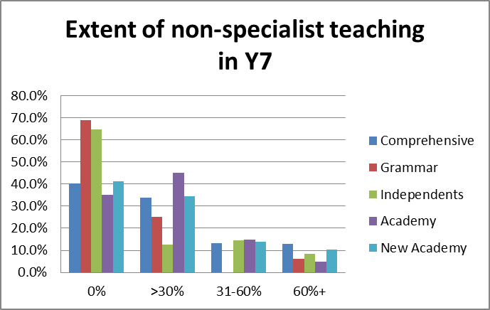
1.2.2 The extent of non-specialist teaching in Year 9
The picture in Year 9 is different, with far greater levels of specialist teaching. In all types of schools the majority of history teaching in Year 9 is carried out by specialists. Interestingly old style academies provide the highest level of specialist teaching in Year 9 (although they also offer the least amount of discrete history time in Year 9). Two thirds of comprehensives and new academies are able to provide specialist teaching for all Year 9 students, which perhaps indicates a shortage of history specialists in one third of state schools; the reasons for this are unclear. New academies seem to have the greatest difficulty in providing specialist teaching, with over a fifth of such schools reporting that up to 30% of their provision is non-specialist (although in many of these cases, the actual proportion of non-specialist teaching is at the lower end of the range).

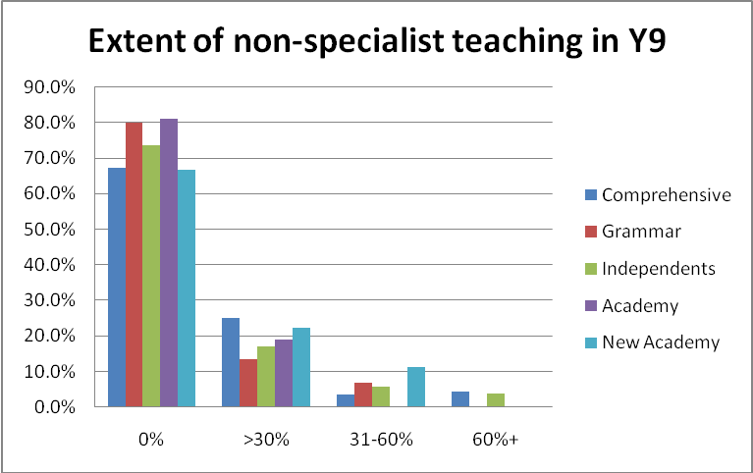
1.2.3 Teachers’ concerns about non-specialist teaching
Non-specialist teaching was one of the concerns about which teachers were asked directly. Of the 352 teachers who answered this question, 102 (29%) regard the extent of non-specialist teaching as a matter of concern (with 40 of them, or 11.4% of the total, claiming it to be a serious concern). A further 134 teachers (38.1%) regard it as a potential concern for the future. While this fear may relate to the possible introduction of an integrated curriculum it seems more likely to reflect the fact that schools are seeing history specialists leaving and not being replaced. Several teachers, responding to later questions about the impact of the announcement of the E-Baccalaureate, complain that the surge of interest in history GCSE that this has prompted, will create serious problems as more history specialists are assigned to GCSE classes, leaving more of the Key Stage 3 teaching in the hands of non-specialists:
Good students will be expected to follow GCSE History but that puts pressure on Years 7 and 8 with non specialists and lack of quality time to do history.
(Teacher 280, old style academy)

We are already a very popular GCSE choice, but the specialists are fully occupied with exam groups meaning KS3 is taught by non-specialists; any increase in GCSE take-up will make this situation worse.
(Teacher 143, ‘New academy’)

1.3 Time allocation for history
1.3.1 Variation in time allocated to history
As in previous reports there is considerable variation in time allocated to the subject and this continues to be one of the major issues highlighted by the survey. Old style academies continue to provide the most limited access to curriculum time, with over half offering 60 minutes a week or less. In contrast, approximately a fifth of grammar schools and a quarter of comprehensives provide a similarly limited provision. However among grammar school and comprehensive school respondents, provision is strong at the top end of time allocated, with over a third providing more than 90 minutes a week. Independent school provision continues to be the strongest. Provision in the new academies tends to be generous, particularly at the 76-90 minute allocation, but only a quarter of such schools provide more than 90 minutes, which means they are weaker in this regard compared to all other types of schools apart from the older style academies.
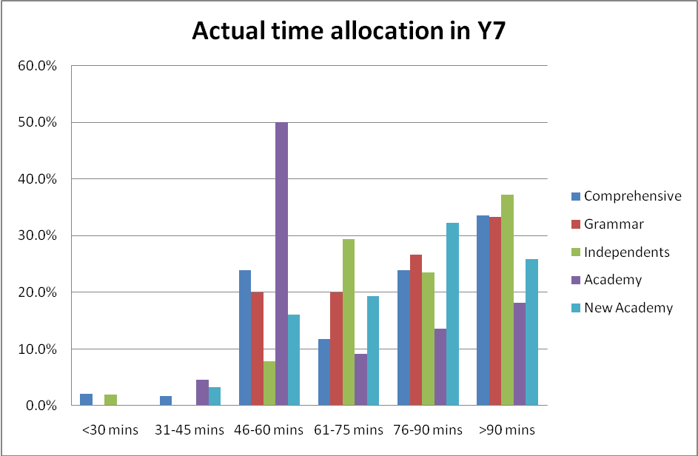

As reported last year, the situation in Year 9 looks rather different. For both comprehensive schools and old style academies the mode time allocation is more than 90 minutes a week, whereas this figure is lower for both grammar schools and independent schools, with modes of 76-90 minutes. This is partly explained, especially in the case of the old style academies, by students making an early start to GCSE courses in Year 9, thereby necessitating an increase in curriculum time. In some respects the time allocated in grammar schools is the lowest, with over a quarter only offering a maximum of 60 minutes of history teaching a week.
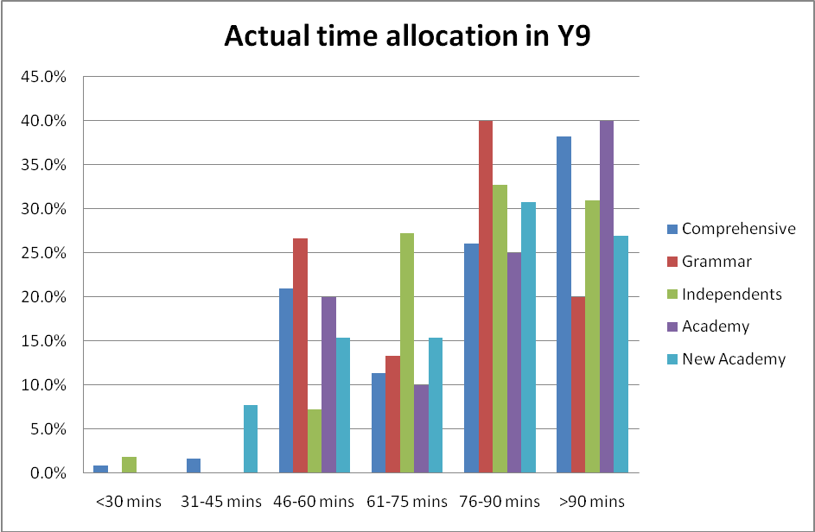

1.3.2 Cuts in the time allocated to history
There is still a worrying trend in the numbers of schools reducing curriculum time in Year7. A total of 354 schools responded to this question, with only 19 reporting any increase compared to 69 saying the time allocation had been cut. This is particularly true in old style academies, which are still far more likely to report a decrease in time allocation in Year 7 than other schools; indeed over 40% of old style academies reported a decrease in time allocation, making this the most common response from this type of school. This is the first time in any of the surveys that reported decreases in time allocation are more frequent than answers showing no change. A fifth of comprehensive schools also report a decrease in time allocation.
The pattern in Year 9 looks very different with a small number of schools reporting an increased allocation of time; out of 352 responses, 26 reported an increase in time, although 45 did report a decrease. The biggest change is in the old academies with nearly a third reporting an increase. The reasons for this are unclear but again it is likely to be linked to the number of schools where an early start to GCSE occurs, necessitating additional time. In contrast, nearly a fifth of new academies report a reduction in time allocation.

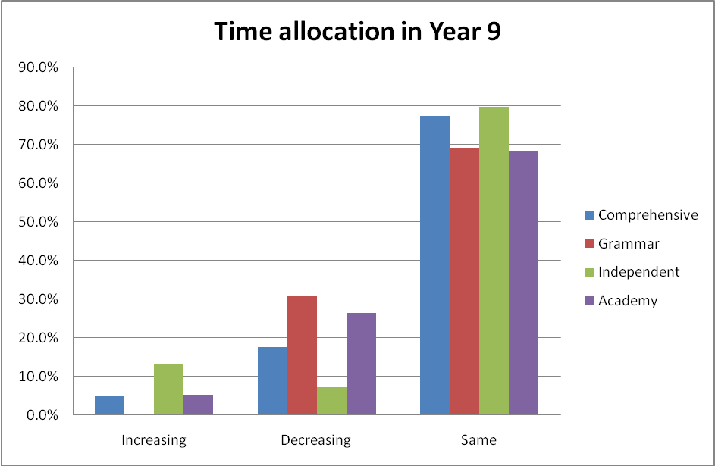

1.3.3 Teachers’ concerns about time allocation
When invited to express their own concerns, lack of time was the most frequently cited issue that teachers themselves raised about Key Stage 3, accounting for almost half of the comments made about Key Stage 3. It was striking to note that even as history results were beginning to seem more important because of the introduction of the E-Baccalaureate, some schools were continuing to take time away from the subject at Key Stage 3:
History is increasingly losing out in terms of time at KS3 yet the school will be judged on this by the E-Bacc. SMT does not seem to appreciate the importance of good quality/quantity teaching at KS3.
(Teacher 358, Comprehensive school)
My school are 'reviewing the curriculum for 2012' so far every option being considered at KS3 takes time from History and gives it to core subjects. Yet we are under pressure from the E-Bacc and we get the best results in the school.
(Teacher 119, Comprehensive school)
2. History at Key Stage 4
2.1 Uptake at GCSE
2.1.1 Overall uptake (all schools)
Respondents were asked about the proportion of each year group currently studying for GCSE history. There is no significant variation between the figures for Years 10 and 11. While there does appear to be a slight increase (3.4%) in the proportion of schools with between 31% and 60% of their pupils taking history (from 50.1% in year 11 to 53.5% in Year 10) the decline (1.4%) in the proportion with more than 60% of students taking history is almost compensated for by the 1.1% decline in the proportion of schools with 30% or fewer students taking history.
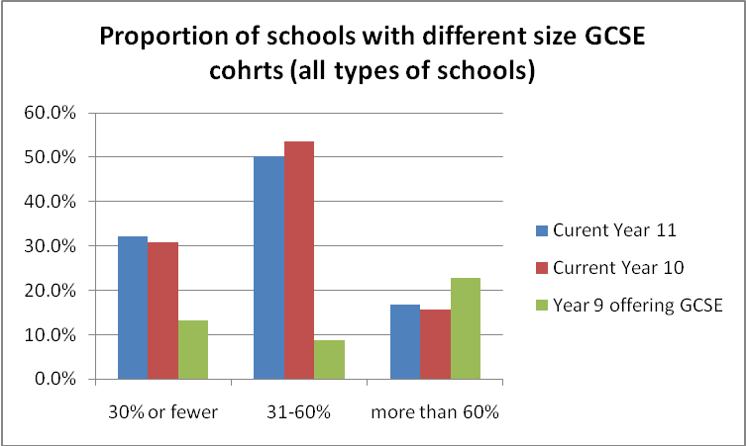
When this is compared with the data from last year, in all cases the signs are essentially positive (there are slightly smaller proportions with cohorts of 30% of students or fewer, and slightly larger cohorts with proportions of 31-60% or 60%+) but this may simply reflect the different sample responding to the survey.
Although respondents were asked about cohort sizes where GCSE was available in year 9, it is not possible to have confidence in the responses that indicate a proportion of 60%+ since some schools seem to have ignored the response ‘Not applicable in Year 9’ and claimed 60%+ when actually all their students were continuing with Key Stage 3 History.
What can be concluded with confidence from these figures is that in only 13.3% of those schools whose teachers responded in any way to this question (as opposed to the 25% or more reported in 2010 and 2009) are there 30% or fewer students continuing with history in Year 9. While this is undoubtedly an improvement on the previous two years, it should still be a matter of concern that there are 27 schools among those that responded to this survey in which more than two-thirds of students have given up history at the end of Year 8.
2.1.2 Uptake by type of school: GCSE options in Year 9
When the proportion of students studying for GCSE history is examined in different kinds of schools, very clear patterns continue to be evident, largely as in previous years.
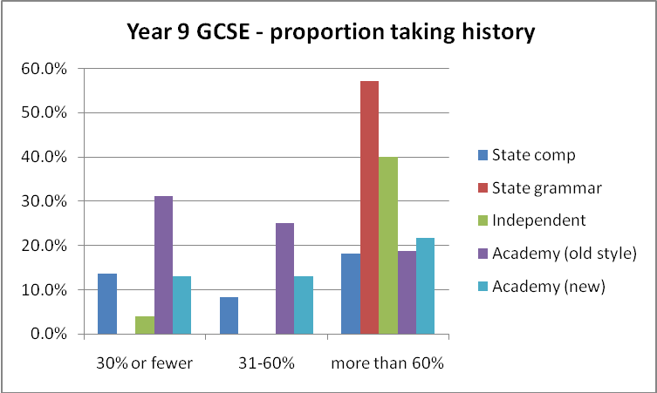
While, as noted above, the figures cannot be regarded as reliable evidence about GCSE options since the 60%+ figure may include some schools continuing to teach history in Year 9 within Key Stage 3, they can be trusted to show the number of schools in which 30% or fewer students continue with history in Year 9. Of those 27 schools, 18 are comprehensives (13.6% of the comprehensive schools respondents to this question); five (31.3% of relevant respondents) are old style academies and three (13.0%) are new academies established under the coalition government.

2.1.3 Uptake by type of school: Year 10
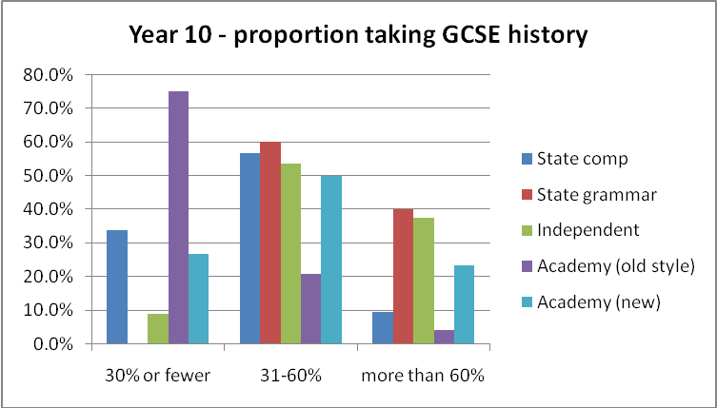
In Year 10, when all students are now following Key Stage 4 programmes (including GCSEs, BTECs and diplomas), three quarters of the old style academies and a third of the comprehensive schools that responded report that history GCSE attracts only 30% or fewer students. The new academies seem somewhat similar to the comprehensives in that 26.7% have 30% or fewer students studying history. For independent schools the figure is only 8.9% of schools whereas no grammar schools report having fewer than 30% of students studying history.
At the other end of the spectrum 40% of grammar schools and a similar proportion of independent schools have more than 60% of their cohort taking history in Year 10. In terms of take-up, GCSE history is more successful in the new academies than the comprehensive schools: in 23.3% of the new academies 60% or more of the year 10 cohort are studying history, compared with only 9.4% of the comprehensives. The picture is most worrying in terms of the established, older style academies, with only 4.2% of them achieving 60% recruitment to history GCSE.
While poor recruitment (30% or fewer) is even worse among the academies this year than in 2010, it is marginally better this year within the comprehensives. The comparison with 2010 is also very revealing in relation to the independent and grammar schools. While both types of school reported last year that history was recruiting 60% or more students in over 50% of their schools, this figure had dropped to around 40% of each type of school by 2011, suggesting a reduced level of interest in, or scope for the study of history. The proportion of comprehensives and old style academies recruiting well to history is very similar to that found last year, while the new academies seem promising in that 23.3% have recruited more than 60% of students to continue with the subject.
2.1.4 Uptake by type of school: Year 11
As the figures below show, the pattern is broadly replicated for current Year 11 students and reflects a similar distribution between schools to that observed in 2010.
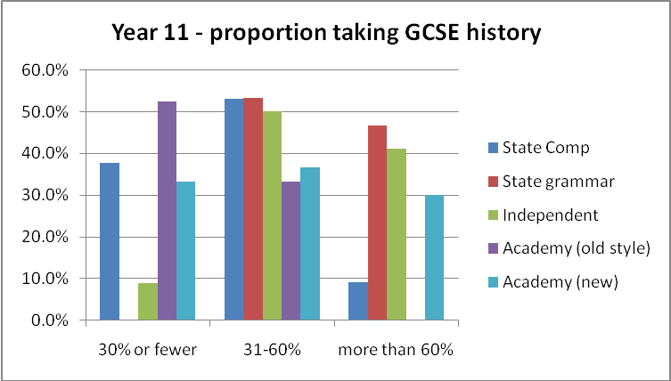

2.2 Patterns in GCSE uptake
2.2.1 Overall trends in GCSE uptake (all schools)
Schools were asked about any trends in their GCSE option figures over the last three years, indicating whether the number of students continuing with the subject was increasing, decreasing or essentially stable. Schools could also choose to indicate variation from year to year, but with no evidence of a trend in either direction. Examined in this way, the picture presented by the 364 schools that responded to this question, appears essentially positive in that overall slightly more schools (26.9% of respondents) report an increase in GCSE uptake than are reporting a decrease (18.7%). While this is broadly similar to the picture reported last year, the positive tendency among the survey respondents was slightly stronger this year than last. Numbers were regarded as stable in 24.5% of schools, with 29.9% experiencing annual variations.
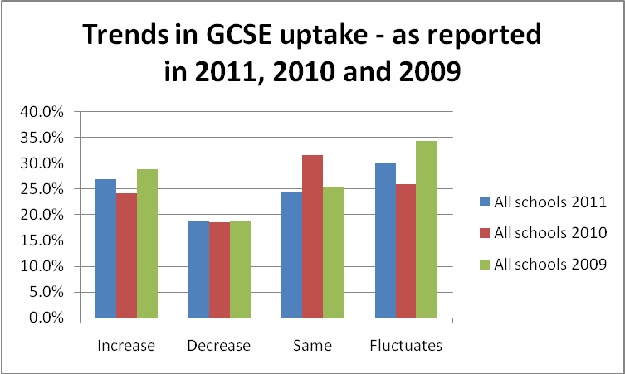
2.2.2 Trends in GCSE uptake by type of school
When the trends in 2011 are examined for different types of school, the responses show that schools with an increased uptake outnumber those with decreases in relation to all types of school except the old style academies in which where there is a net decrease. Although the total number of grammar school respondents is very small and therefore not necessarily a reliable guide, history appears most secure in that context.

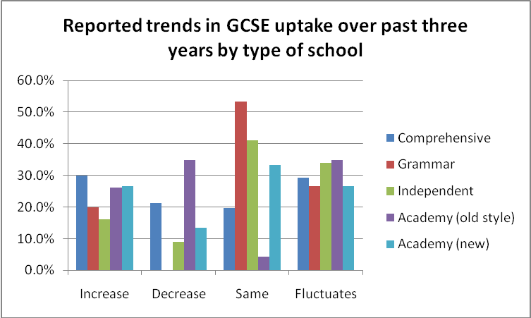
2.2.3 The relationship between time allocation and trends in Year 9 and GCSE uptake
In previous years a significant correlation was found between the amount of time allocated to the subject in Year 9 and trends in GCSE uptake – with those schools giving more than an hour a week to the subject in Key Stage 3 being more likely to see an increase rather than a decrease in GCSE uptake. That clear correlation is not in evidence this year, with reported trends towards higher GCSE uptake in the current Year 10 more prevalent than decreases in all schools regardless of the amount of time allocated to the subject in Year 9. (This change cannot be explained by reference to the introduction of the E-Baccalaureate since the announcement of this new measure was not made until after the Year 10 cohort in question had embarked on their GCSE courses.)
Table 3: Analysis of GCSE trends in relation to Year 9 time allocations
GCSE trend | Time allocation per week for history |  | Totals
 | 60 mins or less | More than 60 mins
Increasing GCSE uptake | 20 | 72 | 92
Decreasing GCSE uptake | 12 | 51 | 63
Total | 32 | 123 | 155
A similarly confused picture is also revealed when trends in time allocation at Year 9 are compared with trends in GCSE uptake. Schools in which the time allocation in Year 9 was stable or increasing were more likely to see an increase rather than a decrease in GCSE uptake, while those which had cut time in Year 9 were slightly more likely to see a decrease in uptake. However, the correlation between trends in time allocation at Year 9 and trends in GCSE uptake is not statistically significant.
Table 4: Analysis of GCSE trends in relation to trends in time allocations in Year 9
GCSE trend | Trends in time allocation in Year 9 |  |  | Totals
 | Decrease | Stable | Increase
Increasing GCSE uptake | 10 | 75 | 8 | 93
Decreasing GCSE uptake | 13 | 44 | 4 | 61
Total | 23 | 119 | 12 | 144

2.3 Restrictions on GCSE choice
2.3.1 The extent to which students’ choices were restricted
Respondents were asked whether all students were given the option of studying for GCSE history and 16.0% of the 376 schools that answered this question reported some kind of restriction, preventing certain students from opting for the course. This was almost the same as last year’s figure (16.8%) and a favourable comparison with that found in 2009 (23.6%). While restrictions were reported by all types of school, except the grammar schools, such curbs were applied much more frequently in the old style academies. The figure for these established academies was 25.0%, which was significantly higher than that of 17.6% for the comprehensive schools and double that of the new academies (12.9%).
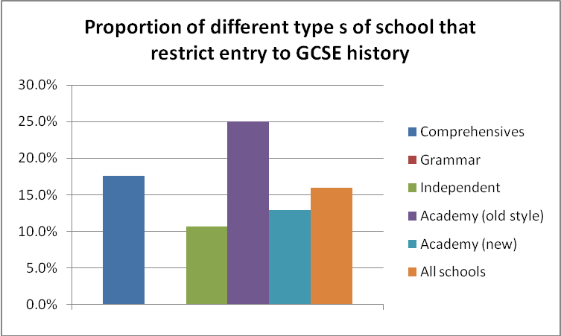
As last year, the restrictions that were applied were based largely on ‘ability’, and often expressed through the ‘pathway’ systems that limited students’ choices to a particular menu of courses deemed most suitable for them. Among the comprehensive schools 13 referred to ‘ability’ as the constraining restricting factor, while a further seven explained that this was based on students’ prior attainment and three others referred to literacy levels. Where prior attainment was specifically cited, some schools insisted on particular National Curriculum levels that students had to have achieved in English as well as history – but the levels varied from school to school, with most accepting level 5 but one or two asking for only level 4 or for level 6 at the end of Key Stage 3. In some cases the cut-off was defined in statistical terms with the ‘lowest’ ability being barred or only the top sets being offered the opportunity. The statistical boundaries varied dramatically between schools, ranging from an exclusion of the lowest 10% to the exclusion of all but the top third (effectively 67% excluded). Those assigned to what teachers described as the ‘lowest’ or the ‘alternative’ pathway, often undertaking a BTEC course, could rarely choose history, as the following quotations illustrate:
Some students are on alternative curriculum pathways which mean they do not choose any 'option' subjects. i.e. they study a BTEC and then only the core subjects (Teacher 343, Comprehensive school)
Pupils in the lowest pathway do not have the option to study any humanities subjects, instead being directed to additional English and Maths and vocational studies due to their literacy capabilities. (Teacher 275, Comprehensive school)
2.3.2 Alternative history or humanities options for those for whom GCSE was regarded as inappropriate
In a few schools alternatives were being offered to GCSE History. Among those schools that had followed a two-year Key Stage 3 course two schools reported an alternative to GCSE being studied in Year 9: one (an old style academy) was offering GCSE Humanities and the other (a state comprehensive) entry level GCSE.
In Year 10, 14 schools reported offering alternatives to GCSE, and 22 (some of them being the same schools) reported alternatives for Year 11. For the lower attainers, schools (usually the comprehensives) were offering ‘entry level’ qualifications or Certificates of Achievement, some of them in ‘functional skills’. Three schools reported offering GCSE Humanities. There were alternatives for higher attainers too. Among the grammar and independent schools one of each followed an IGCSE while two others followed the International Baccalaureate Mid-Years programme. One comprehensive school, one old style and three new academies were allowing high ability students in Year 10 or 11 to study for AS level history, but one of the new academies reported that this initiative would be abandoned in light of the E-Bacc since an AS would presumably not be counted within the ‘award’.

2.4 Early assessment of the impact of the English Baccalaureate
Respondents were asked to comment on the likely impact on history in their schools of the announcement of the English Baccalaureate, which has been described as an ‘award’ for students achieving six grades A* - C in English Maths, Science (accounting for two grades), MFL and either History or Geography. While a quarter to third of the 379 respondents to this question thought that it was simply too soon to tell, the majority made some kind of prediction, and most thought that it would have a significant impact. However, almost half of the independent schools and a third of the grammar school respondents thought it would be unlikely to make much difference.
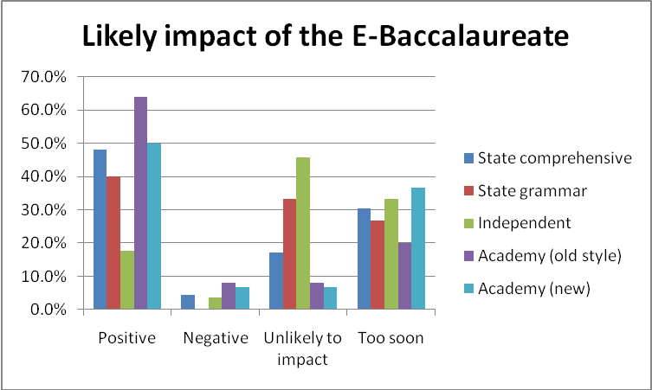

Among those who thought that it would have an impact of some kind, the expectation was overwhelmingly positive with respondents from all types of school expecting more gains than losses associated with it. The most enthusiastic respondents were those teaching in the old style academies, over 60% of whom thought its impact would be essentially positive. The proportion of positive responses for both new academies and comprehensives was around 50%, while even 40% of respondents from grammar schools and nearly 20% of those from independent schools thought it would be beneficial.
When asked to explain their positive expectations, the vast majority expressed the hope that it would – or had already – led to an increased uptake for history. Forty-three respondents pointed directly to an increase in numbers opting for the subject. Some of them explained the ways in which this increase was being promoted, with nine respondents reflecting on the fact that the subject was now being given support and being seen as valuable by senior leadership teams in schools:
We are no longer having Technology as a compulsory option (due to the proposed changes to Specialist Schools). This, plus guidance on our options form to take a Humanities option, may lead to an increase in our numbers, and an increase in esteem for the subject.
(Teacher 289, comprehensive school)

[It has brought an] emphasis on history as a respectable and worthwhile subject
(Teacher 58, grammar school)

This support was evident in a better position for the subject within the options system and encouragement in some cases, and a requirement in others for high attaining students in particular to take history:
More higher ability pupils will be encouraged and motivated to pick the option.
Moves are afoot to make children likely to achieve a C or above study either history or geography at GCSE
(Teacher 32, comprehensive school)

As in this case, such students were being urged or directed to choose either history or geography. Several references were made to the impact of the E-Bacc on parental views – with an increased awareness of its value in supporting later university applications, for example, and support for a return to ‘traditional’ subjects:
In my school there is a Humanities option block where 75% of students have to pick history or geography. Even if only 40% of these pick History, for example, this will be an increase in numbers on previous years. Although not necessarily liked by SLT [the Senior Leadership Team], the English Bacc has actually been well received by parents who see it as a return to traditional academic subjects. This was surprising as our school serves a low socio-economic catchment area.
(Teacher 136, comprehensive school)
However, despite the references to support for the subject it in school, only one teacher mentioned that this had impacted positively on the time allocation for the subject in Key Stage 3. So far, it would appear, that even though more students are being encouraged or directed to take history for GCSE, the announcement of the E-Bacc has not promoted a re-evaluation of previous decisions to cut time allocated to the subject in the early years of secondary school. As one teacher lamented:
History is increasingly losing out in terms of time at Key Stage 3 yet the school will be judged on this by the EBacc. The Senior Management Team does not seem to appreciate the importance of good quality/quantity teaching at KS3
(Teacher 358, comprehensive school)

It should be noted that, even among those who ticked the box suggesting that the impact of the E-Baccalaureate was ‘essentially positive’, several expressed reservations about it even as they explained why they thought it would be beneficial. In addition to the 17 respondents who offered explanations of negative expectations were a further eight comments expressing some concern within an overall positive outlook, as the following comments clearly illustrate:
I think parents now believe that their children have to seriously consider the English Bacc subjects if they want their child to be successful in the future. Current Year 9 options have seen over 75% of students opt for GCSE History. As a result class sizes will increase and achievement may dip as a result in 2 years.
(Teacher 317, comprehensive school)

Figures just in from the SMT [Senior Management Team] 120 students have opted, compared with the current Year 10, of 90 students. This is problematic - resources, rooming etc. No increase in budgets. Class sizes - predicted to be 28-34! This is unmanageable.
(Teacher 136, comprehensive school)
Several teachers echoed this anxiety about increased group sizes and a very strong concern expressed here by three teachers but repeated elsewhere in the questionnaire by others, was the fact that additional GCSE groups would draw on all their teaching time, leaving much more of the Key Stage 3 teaching to non-specialists:
‘We have already seen an increase in the profile of history which is good in terms of GCSE. However, it has a potentially negative impact on KS3 as there will not be sufficient specialist staff to cover History at KS3 due to budget restrictions. (Teacher 73, comprehensive school)

Another recurring theme related to students being forced to take certain subjects or prevented from doing so. Three teachers feared that students would be compelled to take history against their wishes,
SLT [Senior Leadership Team] seem determined to force students to do GCSE History. (Teacher 118, comprehensive school)

Two teachers lamented the fact that students were being forced to choose between history and geography, whereas previously they had been able to do both:
In our school students are able to take both Geography and History and both subjects have had healthy numbers for many years. The announcement of the E-Bacc has resulted in students taking one or the other, rather than taking both.
(Teacher 331, comprehensive school)
In a few cases the encouragement or coercion did seem to mean that a wider range of pupils than previously would study history for GCSE:
We are going to find it difficult to maintain our good results (in percentage terms) with more ‘C’ grade and below students being part of the equation. We are hopeful, of course, that the ‘experts take into account the challenge that the subject might hold for some pupils’.
(Teacher 33, comprehensive school)
But, more common were fears that the restrictions on those who could take history (discussed in section 3.2.1 above) were likely to be even more rigorously enforced, so that those students who were thought unlikely to achieve a C would have even less chance to continue with the subject, or that the lower attainers would be compelled to take geography rather than history:

The school is very ambitious in terms of its improvement, and will probably embrace the E-Bacc as a yardstick for success. More students may be encouraged to take history, but the department might be under pressure to place restrictions on who can take it based on ability.
(Teacher 392, comprehensive school)

SMT [the Senior Management Team] are highly concerned about results and History is seen as more challenging than Geography, meaning some students are steered away from it. (Teacher 78, old style academy)

This early evidence suggests that the announcement of the E-Bacc may therefore have relatively little impact on the kinds of restrictions reported in section 3.2.1, and to which Ofsted has drawn attention in its most recent report, with ‘lower-attaining students still actively ‘prevented from studying history to age 16 because the subject [is] seen as too demanding for them’. As we have argued elsewhere, it is surely unacceptable that such students in particular – who are usually those from the most disadvantaged backgrounds – are denied access to learning about the past – learning intended to inform and enrich ‘their capacity to make sense of the world in which they live and their place within it’; to ‘help them ‘develop their own identities’; and to ‘equip them to participate in a democratic society’.
2.4 Teachers’ reactions to the new GCSE specifications
2.4.1 Overall reactions to the new specifications
Respondents were asked about their reactions to the new GCSE specifications that they had been teaching since September 2009. Among the 309 respondents who gave an overall evaluation of their experience, almost one quarter (24.3%) felt that the change to the new specifications had essentially made no difference. Another quarter (23.9%) claimed that their experience had been largely or entirely positive. Just over 40% (41.4%) felt that the changes had been a mixture of positive and negative experiences, but only 10.4% regarded the introduction of the new specifications as essentially negative.
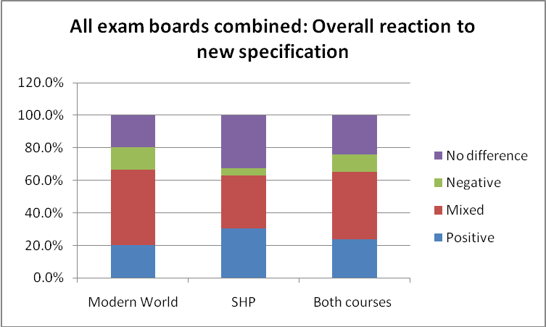
This overall picture obviously obscures the variation between the different exam boards, but more evident are the differences between different specifications. While respondents following the Edexcel SHP (Schools History Project) course offer the highest proportion of positive evaluations, those following the Modern World course set by the same examination board also offer the highest proportion of negative comments!
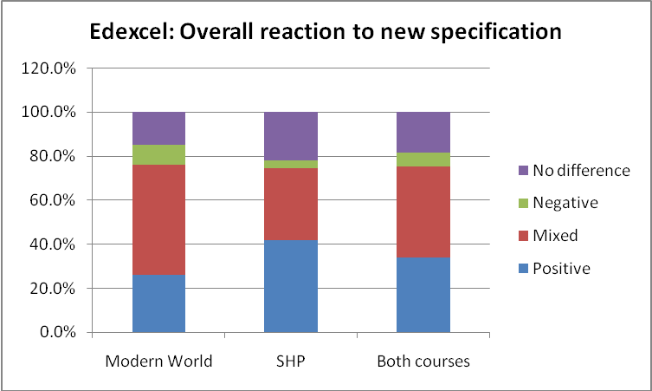
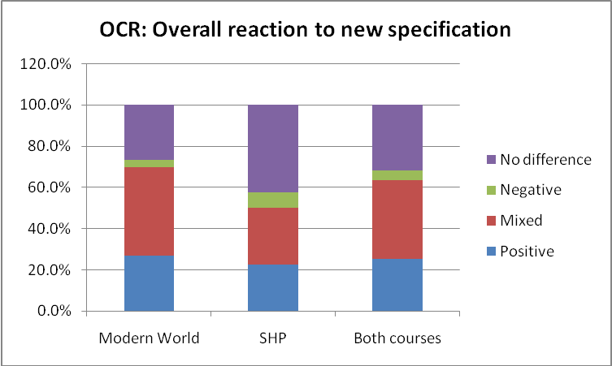
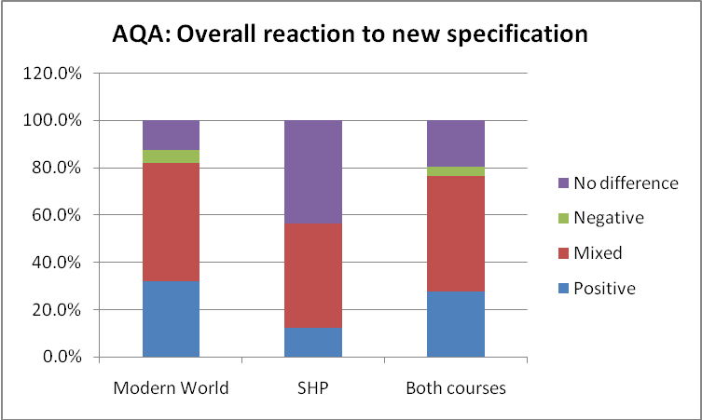
The clearest impression is in fact that views are overwhelmingly mixed. Most comments relate to the modular structure of the specifications, and while teachers welcome the opportunities that this gives for students to take one module at a time, they simultaneously acknowledge that this structure can prompt students to pay less attention to any one exam, thus giving rise to repeated re-takes that disrupt teaching at several points over the course of two years.
While some teachers welcome a reduction in the amount of content to be covered, others, particularly those following SHP courses, regret the loss of an interesting fourth module and some see their new specification as actually more content heavy than the previous one. The few clear messages seem to be that the new Edexcel SHP course is more interesting and indeed ‘inspiring’ than previously, and has generated an enthusiastic response from students; that there is thought to be considerable inconsistency or even ‘idiosyncrasy’ in examination marking, with considerable variation (as much as 9 or 10%) from one year to the next in the actual mark needed for the award of a C grade; and that in many cases the nature of the questions set means that students are still essentially ‘jumping through hoops’, simply trying to meet the particular exam board’s requirement for that particular type of question:
Good topics, but there is a lot of hoop jumping. We like unit 1 and 2, but the sources paper is particularly farcical, the previous paper had lots of rules on what to do/ how to write an answer, but this paper is even more formulaic. We are worried how these students will make the transition from GCSE sources to AS level source-based papers as a result
(Teacher 251, comprehensive school, GCSE: Edexcel Modern World)

Far too much emphasis on the technique needed to answer particular questions: we've spent more time 'revising' each paper rather than the content of each exam.
(Teacher 47, independent school, GCSE: Edexcel Modern World)

2.5 Teachers’ reactions to the introduction of controlled assessment
2.5.1 Overall reactions to controlled assessment
Reactions to the specific experience of ‘controlled assessment’ were rather more negative than overall reactions to the new specifications. Here the differences imposed by the new specification were much more fully acknowledged, with only 7.2% claiming that the new style GCSEs, first taught from September 2009, were essentially the same as those taught previously. Over half of respondents (53.1%) had mixed views of the impact of the changes, while those reporting a negative experience represented 26.4% of respondents – more than twice as many as those reporting a positive view. (13.4%)
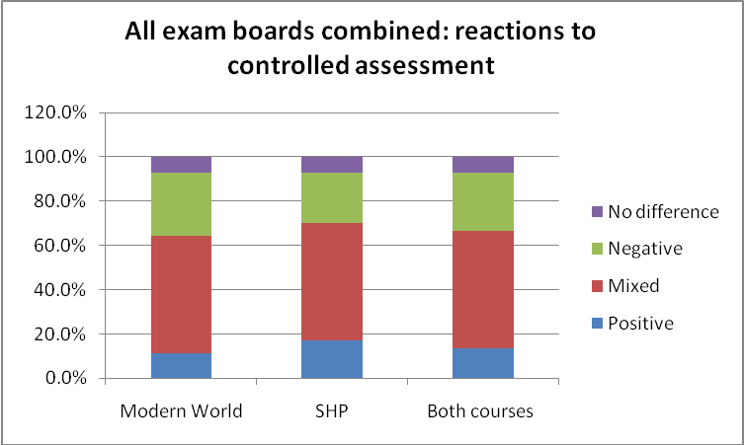
Again, SHP adherents seem to have regarded the changes slightly more favourably than those pursuing Modern World courses, but fewer than 20% of respondents regarded the change to controlled assessment as entirely positive. Again there was some variation between exam boards, with Edexcel apparently most highly regarded, and OCR seen as involving least significant change.
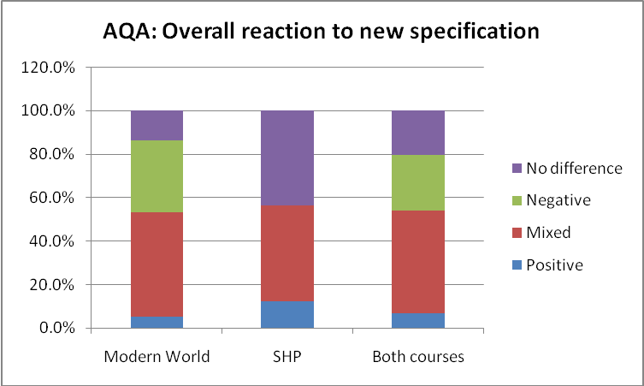
2.5.2 Positive reactions to controlled assessment
Two types of response featured most prominently among the positive endorsements of controlled assessment: the fact that the whole process was much easier to manage and the strong sense that the work that was produced was a much more genuine representation of the students’ abilities. The fact that the work was undertaken within the classroom not only saved teachers’ time in chasing up late or incomplete work, but that weaker or more disorganised students who would tend to invest less effort in work undertaken at home – as well as those who had little support for work outside the school environment were more likely to submit finished pieces of work and thus to receive credit for their achievements. Completing the work in supervised conditions not only eliminated the advantages that might come from helpful parents, guiding and directing their children’s work at home, but also removed the risk of plagiarism, with essays simply down-loaded from the internet:
It has levelled the playing field for all students. All students have had the same support and guidance. Also as work is now done in class students have all completed it and there has been no chasing of missing or incomplete work.
(Teacher 131, comprehensive school, GCSE: AQA SHP)

We are currently undertaking our first batch, but on the whole I think it a much fairer way than the old coursework, it gives students a real opportunity to show what they can do without the temptation to resort to the internet and plagiarism.
(Teacher 108, comprehensive school, GCSE: OCR Modern World)

Other benefits noted included a reduction in stress for the students, partly because the number of coursework tasks had been reduced, and a tendency for more of them to take the remaining assessments more seriously. As a result they had seen students achieving more highly than in previous years. The reduction in the number of assessed pieces also meant that there was more time for teaching. Five teachers commented that the tasks now set offered better – more genuine – historical questions that tested worthwhile kinds of understanding, and that this also provided a better foundation for A level work.
2.5.3 Negative reactions to controlled assessment
The positive responses noted above were, however, vastly outnumbered by complaints about the new approach to coursework. For every teacher welcoming the new arrangements as easier to manage (17), there were nearly three (47 in total) who regarded the need to provide supervision for students over a prolonged series of lessons as a ‘logistical nightmare’ because of the demands created by student absence (since making up any time missed required further staff supervision) and the problems (in competition with other subjects) of securing access to ICT facilities to allow students to word-process their work:
The idea of doing different assignments each year is good but in the first year it proved a logistical nightmare. Several subjects were all vying to do controlled assessment at the same time (second half of Autumn Term) due to the structure of their respective GCSE courses. The whole process took far longer than planned due to pupil absences etc. We ended up running seemingly endless additional sessions at lunchtime for the absentees to catch up. As a result lunchtime activities such as booster classes, History club etc had to go by the board.
(Teacher 305, independent school, GCSE: AQA Modern World)

Eighteen respondents complained that the new form of assessment and the kinds of questions asked merely served to advantage the higher attaining student, reinforcing the literacy demands of existing GCSE courses, and leaving them frustrated that so much of what had previously been teaching time was now spent observing students to whom they could give no advice or direction:
The questions given so far have proved to be very hard. This is given that GCSE is an open exam with grades ranging from A* to G, the question in the controlled assessment (given that we are not supposed to help pupils to interpret the question or guide them in any way) is very much geared to the very top and most able pupils. The question set this year is a prime example. The question (without guidance) proved too much for all but the most able pupils despite our thorough preparation of all aspects of our topic...To us it does seem as if the boards only see the most able doing History and so once again History has 'shot itself in the foot'. We will now be actively discouraging all but the most able from doing it as they will be the only ones who will be able to tackle the Controlled Assessment questions in the way prescribed by the exam boards.
(Teacher 57, comprehensive school, GCSE: OCR SHP)

Due to all work being done in lessons students spend large amounts of lesson time writing up their assignments under controlled conditions. This has not helped them develop their historical skills and has lost valuable teaching time. Students were much better planning work in school and writing their essays in their own time. It seems a waste of valuable development time to be working in silence for hours.
(Teacher 331, comprehensive school, GCSE: AQA Modern World)

Overall, more teachers reflected that they had lost teaching time to the new system than thought they had gained it. To compound this sense of frustration, several teachers remained unconvinced that the new system was actually any fairer, since they could not guarantee that teachers elsewhere were not giving the kind of guidance that was now officially prohibited. Thirteen responses also commented on very poor support from the examination boards, with late changes to the markscheme and a lack of clarity or extensive delay in response to their questions:
Very little support or guidance from the board until too late; support materials published far too late; lack of clarity with regard to mark schemes
(Teacher 134, comprehensive school, GCSE: Edexcel SHP)
For all those regarding controlled assessment as offering more genuine historical questions, there were nearly twice as many lamenting its formulaic and restrictive structure:
My initial experience of applying the markscheme makes me fear that students will produce ever more mechanical, formulaic responses to the assignments as time goes on, increasing the difficulty of differentiating between candidates, particularly at the top end of the ability scale. It actually seems to be encouraging the stereotyped source evaluation criticized by the HA in its 14-19 Report a few years ago. We have ended up having to rush the Unit 2 part of the course.
(Teacher 305, independent school, GCSE: AQA Modern World)

While some of the reported concerns reflect the inevitable teething problems associated with a new system and many can be addressed as teachers become more familiar with the nature of the new requirements, it does not appear from these reactions that previous concerns both about the inaccessibility of GCSE for many learners and the rigid and often sterile nature of some of the questions set have been addressed by the latest round of changes to the specifications.

2.5 Other concerns reported by teachers relating to history GCSE
The one specific concern that the survey asked about in response to concerns previously raised by members was related to the quality of marking. Almost 40% of respondents (compared with 30.5% last year) indicated that this was a matter of current concern to them, with 12.9%this year indicating that it is a serious concern.
As noted previously in considering responses to the E-Baccalaureate and in seeking to explain the increase in non-specialist teaching reported at Key Stage 3, a few more teachers (three) raised concerns in the open section at the end of the questionnaire about the increase in size of their GCSE groups, while five others complained about the reduction of subject time allocated to history, in one case by as much as 25%.

3. History at A-level
3.1 Uptake at AS/A2
3.1.1 Overall uptake (all schools)
Out of all the institutions that responded to the survey, 247 offer history at AS/A2. The majority of schools and colleges report that between 11–20% of their sixth-form cohort study history. The overall figures suggest that uptake is stronger in Year 12 with numbers falling as students move into Year 13, which is similar to trends seen in the previous surveys. A comparison of the figures with these previous surveys confirms a high degree of stability in the numbers of students taking AS and A2 history.
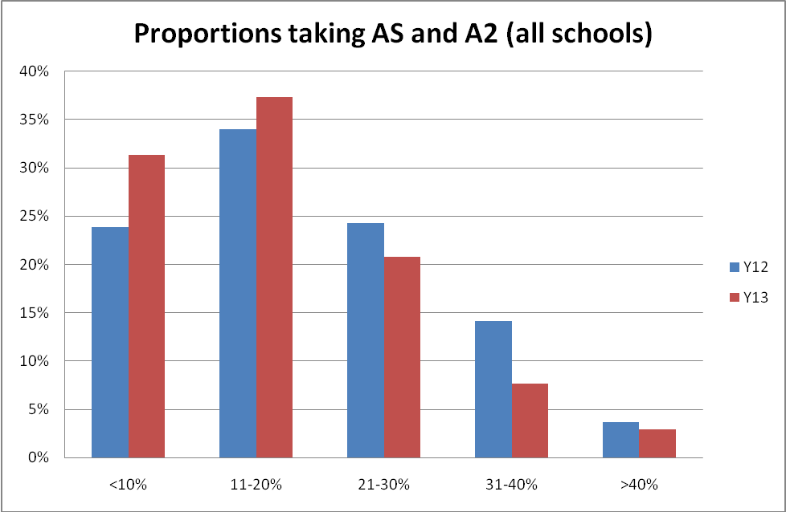

3.1.2 Uptake by type of school
As in the previous surveys, there are noticeable differences by type of school when comparing uptake at AS. The mode for comprehensive schools is for 11-20% of the cohort to study history at AS, as is the case in independent schools. Grammar schools have the higher mode with 21-30% of students studying history, whereas the new academies are successful in attracting 31-40% of students to study at AS; this perhaps reflects the nature of these schools, as only successul schools were allowed at the time of the survey to apply for the new academy status. The old style academies have the lowest mode with over 70% reporting that fewer than 10% of the cohort study history at AS, which is a large shift in comparison to the 2010 survey findings when the figure was closer to 50%. To an extent this may reflect the numbers of students in these 6th forms – smaller cohorts of students are likely to give rise to quite wide fluctuations in the numbers studying AS history.
A general fall in numbers from AS to A2 is evident from the data. The new academies appear to suffer the biggest decline in numbers; the figures for 6th form colleges are distorted by the low number of responses. As reported previously, there does appear to be a large variation in history uptake by type of school, so there does not appear to be any particular trend, apart from the generally stronger numbers studying history in grammar and independent schools.
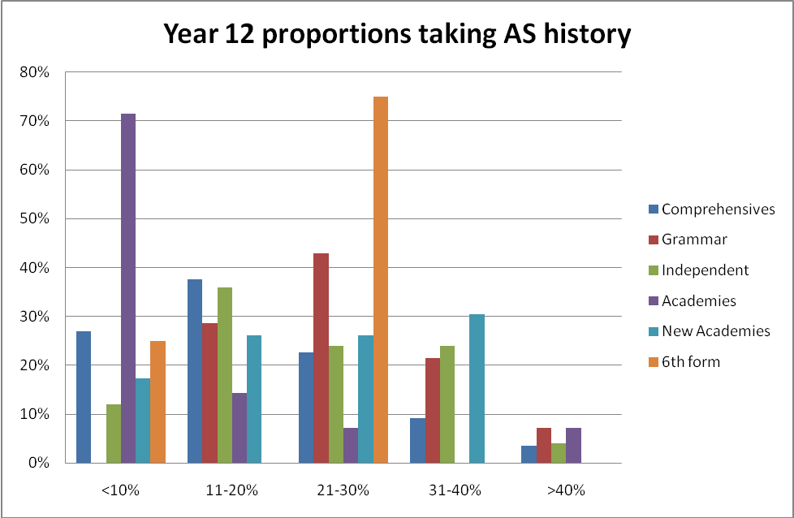
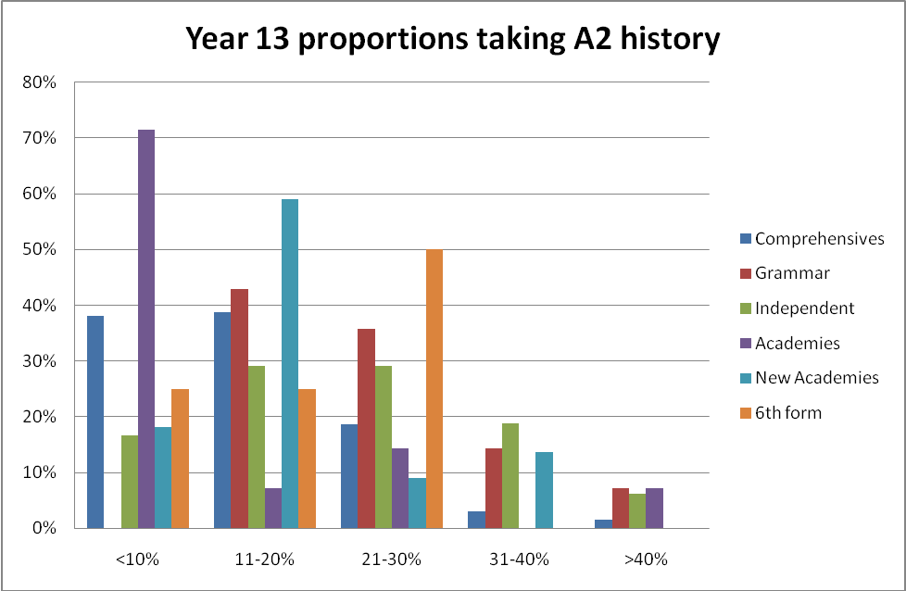

3.2 Patterns in AS/A2 uptake
The general picture, from those schools that responded to the survey, is positive. The number of institutions indicating an increase in uptake at AS is double that of schools reporting a decrease; although this figure is weaker than that reported in 2010 where the number of institutions reporting an increase in AS numbers was three times that of institutions reporting a decrease. The largest increases can be seen in academies (both old style and new) and comprehensive schools. Grammar schools show the greatest stability and also have the lowest reported decrease in numbers.
Table 5: Analysis of trends in Year 12 uptake of AS history by type of school
Trends in year 12
 | Increase | Decrease | Varies | Same | Total respondents
Overall | 53 | 25 | 100 | 59 | 237
Overall | 22% | 11% | 42% | 25%
Comprehensives | 30 | 12 | 58 | 32 | 132
Comprehensives | 23% | 9% | 44% | 24%
Grammar | 3 | 0 | 5 | 6 | 14
Grammar | 21% | 0% | 36% | 43%
Independent | 6 | 6 | 25 | 13 | 50
Independent | 12% | 12% | 50% | 26%
Academies | 6 | 3 | 4 | 1 | 14
Academies | 43% | 21% | 29% | 7%
New Academies | 7 | 4 | 6 | 6 | 23
New Academies | 30% | 17% | 26% | 26%
6th form | 1 | 0 | 2 | 1 | 4
6th form | 25% | 0% | 50% | 25%

At A2 the figures are more mixed. Unlike at AS, there are some types of schools which are more likely to report a decrease than increase in terms of numbers studying history at A2. Both the new academies and independent schools are more likely to report a decrease in numbers. The figures for independent schools are out of line with the previous surveys, which showed a more positive trend. The figures in comprehensive schools and older academies show even numbers of increases and decreases reported, whilst grammar schools are more likely to report an increase in numbers, as well as showing greatest stability in numbers year on year. The responses from 6th form colleges make it difficult to draw any sensible conclusions about trends in this part of the sector.
Table 6: Analysis of trends in Year 13 uptake of A2 history by type of school
Trends in year 13
 | Increase | Decrease | Varies | Same | Total respondents
Overall | 30 | 27 | 111 | 62 | 230
Overall | 13% | 12% | 48% | 27%
Comprehensives | 16 | 13 | 69 | 30 | 128
Comprehensives | 13% | 10% | 54% | 23%
Grammar | 2 | 0 | 6 | 6 | 14
Grammar | 14% | 0% | 43% | 43%
Independent | 4 | 6 | 27 | 12 | 49
Independent | 8% | 12% | 55% | 24%
Academies | 3 | 3 | 3 | 4 | 13
Academies | 23% | 23% | 23% | 31%
New Academies | 4 | 5 | 6 | 7 | 22
New Academies | 18% | 23% | 27% | 32%
6th form | 1 | 0 | 0 | 3 | 4
6th form | 25% | 0% | 0% | 75%

3.3 Impressions of the new AS/A2 specifications
The findings from the 2010 survey showed that the number of positive comments generally outweighed the negative ones. The 2011 survey presents an even stronger picture; out of 237 responses, 41% (98) of teachers indicated a positive view of the new A level specifications and only 2.5% (6) felt negatively about them. There were a further 32% (76) of teachers who felt the new specifications were a mix of positives and negatives, with 24% (57) saying they felt there was no real difference compared to previous specifications.
Of the positive comments expressed, choice of topics available for study was mentioned favourably by 27 teachers. The second most welcome feature relates to the new course structure, particularly the move from 6 to 4 modules, with 17 comments made. Ten teachers said their students enjoyed the new specification, 9 welcomed the assessment, with a further 7 citing improved results. Other comments mentioned the straightforward nature of the new specifications and exam papers, exam board support and the new courses being a good preparation for university study. For example:
Excellent - really like the Edexcel course - skills really develop over the two years and the skills required for each module complement each other - very much like the coursework in year 13 - excellent university preparation - like the topics - we offer a wide ranging course - both globally and chronologically - most of the new textbooks are excellent - board provides very good support and advice (Teacher 316, comprehensive school, A level: Edexcel)
It is also seen as an appropriately demanding course:
Especially at A2 having the personal study gives students chance to 'fly' and the final examined unit - they love the stretch of the synoptic requirement
(Teacher 192, independent school, A Level: AQA)

The number of negative comments was very few, but 3 were to do with the coursework or loss of previous ways of doing coursework. Other comments were individual points.
When looking at those who expressed mixed views, it is difficult to identify clear trends and issues. For some the coursework is excellent, whereas others feel it is too challenging for students, or too time-consuming; or they wish for the return of an independent study. Some commented that there was too much content to cover, whereas others said there was too little. There were further comments about the good range of interesting topics that could be taught.
3.4 Other reported concerns about A-level history
Participants were asked whether they felt any concerns with marking at AS/A2. Over a quarter of independent schools and a fifth of grammar schools said they had serious concerns over marking at this level. A further third of independent schools and nearly a half of grammar schools indicated they had concerns. Such concerns were less marked in comprehensive schools; just over 15% of comprehensives had serious concerns about marking with over a quarter saying they were concerned. The figures for the academies, both old and new were much lower.
Further concerns were also identified by individuals, and these were related to the perceived difficulty of the subject, an increase in students studying history yet no new staff being taken on, and the workload associated with the subject. All these concerns were individual comments and with the exception of the concerns about the increase in examination classes (at GCSE and A level) impacting on the lack of specialist teaching lower down the school, there does not appear to be a groundswell of feeling around these issues.

4. Other concerns about history teaching
In light of the range of new courses being introduced in the past few years (with changes to GCSE & A-level specifications as well as the introduction of the Key Stage 3 curriculum in 2008, and a further review currently underway), the survey also included questions about the scale of funding available for teachers to deal with all these changes – about the time offered to teachers to prepare and plan ahead for these new courses and the opportunities available to history teachers to attend subject-specific professional development. In relation to all these issues, concerns were voiced by a high proportion of teachers, with very serious implications for any future decisions about further changes either to the public examination system or to the ‘National Curriculum’. Lack of preparation time and funding for new resources were the most significant concerns (regarded as important issues by 66% and 61% of respondents respectively), with more than 25% in total in both cases indicating that the issue was a serious concern). Lack of provision of subject specific CPD was noted as a concern by 36.1% of respondents; but even when it was provided, the chance of teachers being able to attend such provision was extremely limited. Almost 50% regarded the lack of such opportunities as a concern.

Ofsted (2011) History for All: History in English Schools 2007-10, available from www.ofsted.co.uk/publications/090223
Harris, R. and Burn, K. Curriculum theory, curriculum policy and the problem of ill-disciplined thinking, Journal of Education Policy, 26, (2), 245-261.
QCA (2007) National Curriculum for England at Key Stages 3 and 4: Programme of study for history. Qualifications and Curriculum Agency. http://curriculum.qcda.gov.uk/key-stages-3-and-4/subjects/key-stage-3/history/programme-of-study/index.aspx?tab=1

