The Great Wave

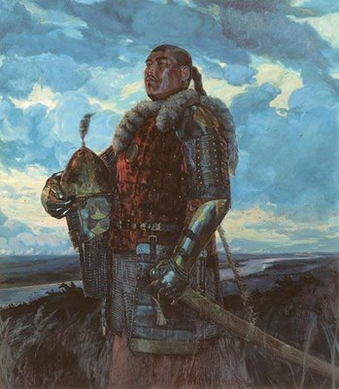
The Story of a Mongol General
Agitated and violent, the sapphire waves crashed against the well-beaten sides of an old boat. ‘Was this old wreck all that Kublai Khan could muster up?’ A warrior thought sourly, as strong winds whipped the sails. Fierce though the warrior was, he still waited apprehensively for the moment upon which they would land on the shore – he just hoped the rickety boat would hold up until then. Although the warrior honoured and respected Kublai Khan he could not help feeling angry towards him. ‘Why didn’t he bide his time and build the strongest fleet possible, as advised, to ensure their advantage over the samurai? Had Kublai Khan become so convinced of his own infallibility that he could not see how absurd it was to ‘dump’ his warriors on old wrecks he found in boat-yards?’ These resentful thoughts lurked endlessly inside his head, till he was whisked away to the moment when his destiny was sealed....
***
Although it was already positively radiant, he, a lone warrior (a general, at that), sat polishing his sword in his small house along a dingy street in China. It was late; a complete white eye was sitting in the sky, glaring down upon all of China – as though daring someone to challenge it. Silence reigned over everything, unbroken by a single sound; not a whisper, or a cry, or even, the scuttling of a mouse. This silent harmony was rudely interrupted by a loud BANG! There was someone at the door; the candlelight flickered as the general got up to greet the unwanted stranger. BANG. Wearily, he shuffled through the house, body aching from a hard day, heart rate unhurried and easy-going. As the warrior drowsily opened the creaking door cold night air rushed into his house and his eyes fell on a scrawny messenger boy from the palace. “Hurry – Kublai Khan wishes to see you in his palace” he stuttered frantically. “If you say so” the warrior said calmly, though his heart skipped a beat. Together they walked silently, immersed in their own thoughts. Shivering from the cold, the general wondered why Kublai Khan had requested his presence at such a late hour. Only the chatter of steady footsteps kept them company, until they reached the palace, where they said their goodbyes and went their separate ways.
As soon as he entered though the colossal palace doors he was greeted by a rush of warmth followed by a medley of cheerful sounds. Still extremely tired, the general shuffled towards the palatial room, decked out in all manner of finery; in here the mighty Kublai Khan waited. BANG. Although the warrior had only knocked gently, the immense size of the room caused the sound to echo and expand. At one touch the grand door silently flew open. “Come in” said the deep, rich voice of Kublai Khan. Humbly, the general stumbled into the room and bowed so low that his nose almost touched his feet. “I have made a decision about the problem with the Land of the Rising Sun.” Stated Kublai Khan “and naturally I thought to inform you all” Realising that he was not alone, the general looked around and saw that the room was full of decorated generals and commanders. Seeing all eyes were focused on Kublai Khan he hastily directed his gaze the same way. “I have decided” Kublai Khan continued “if we cannot enter Japan with permission we will have to do so without. We will use force and tame this disobedient child; her insolence has been tolerated for long enough!” Everyone gasped in astonishment and fell silent at once under the forceful glare of their master. “But...... but” a General dared to venture. “SILENCE” commanded Kublai Khan “do not question my decision” The General obeyed immediately realising that his intervention was ill thought and unwelcome. Kublai Khan, sensing his generals’ unease, sighed and then spoke once more “I have tried countless times to make an allegiance with the Japanese Shogun and countless times I have failed. I will not be made to look like a fool by these people! I have conquered the whole of China with my Father the great Genghis Khan and now I am revered by the Yuan Dynasty and feared by my enemies. We are powerful and respected, but my friends if we are to retain our position and strength we cannot be seen to be weak, so it is essential that Japan becomes part of our emperor. Go now and inform your warriors to prepare for battle!” He concluded. It was not questionable – there was a certain tone of finality to his voice.
***
“Land ahead!!” someone shouted. The general snapped out of his reminiscence and back to the present. There on the beach stood the famous Samurai; the general smiled and relaxed slightly – their numbers were small compared to his Mongol warriors. But his reassurance was short lived as he gazed into the eyes of the Samurai; these men would fight to the death and would never disgrace themselves with surrender. They numbered a few but the silent roar of their bravery thundered across the sea like a tidal wave. New-found uneasiness poisoned his body, as the boat neared the shallows. Finding the courage to lead his men, the faithful General strode ashore and rallied his men with a battle cry that could be heard by all. The samurai leader stepped forwards and taunted the Mongols with an even louder one, accepting the challenge. Then the battle began....
Ferocious and bloodthirsty, the Mongol warriors charged forwards and (being unfamiliar with the samurai code) fought what should have been one-on-one, en masse. The samurai struggled valiantly; though losing many they continued to fight heroically regardless of how many had fallen. Although the samurai had deadly blades and long bows, the Mongols’ superior short-bows had twice the range of the Japanese. Their better quality bows together with the use of poison tipped arrows ensured that if the samurai weren’t killed by the blow, they would nonetheless be dead by nightfall. It was undeniable that the noble samurai were fighting a losing battle, even if they were prepared to die rather than dishonour themselves with surrender.
Night time was now upon them; the battle had raged all day long, and only due to sudden reinforcements did the samurai remain undefeated. The General was losing his patience; he had fought all day and victory still eluded him – though the samurai had been greatly weakened. He would have been fighting still if his men hadn’t persuaded him to rest and return to the safety of the ship.
As he lay in his cabin, the general listened intently to the storm raging outside. Vicious wind thrashed at the boat, while rain beat at its worn sides, following this was a deafening roar of thunder and an erratic stab at the earth by a bolt of lightning. The general, feeling agitated and sombre welcomed a distraction in the form of a burly warrior. “Our ships are at risk of being driven ashore, your assistance is required on deck” rumbled the warrior, tripping over his own words. Sensing the urgency in the soldier’s voice, the general, though warn and tired, left the warmth of his bed and climbed up on deck. Immediately he was drenched in glacial rain and toyed with by powerful gusts of wind, he could barely shout above all of the noise. To the general the situation was crystal clear; if they were to escape the clutches of this deadly storm they needed to sail out to sea as fast as possible. His men were quick to follow his orders, since they too realised the fatality of the situation in which they were engulfed. With his men the general haplessly battled against the storm. ‘For the second time today’, the general thought resentfully ‘the Gods fail to reward us for our valiant efforts’. Suddenly there was a rumbling, crashing, thundering noise, everyone stopped to listen – the boat seemed to be frozen in time. And then the world disappeared...
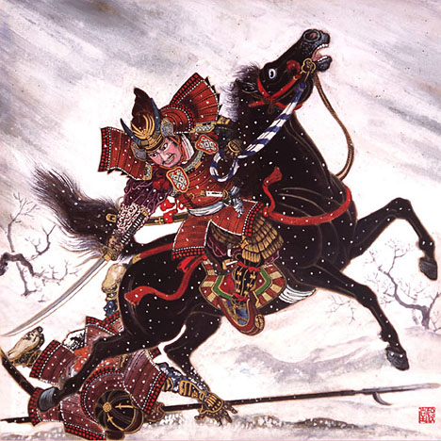
The Story of a Samurai Leader
There he stood, an honourable samurai leader, apprehensively waiting for his impending doom. It was a dull grey day and the clouds were dampening spirits by dampening people; the whole island seemed to have temporarily turned slow and scared. But, for the samurai, the world was swirling dizzyingly around them, making them feel nauseous. There ahead of them lay their destruction. A large armada of wooden boats, varying in size, glided towards them on an irritable sea. In those boats were fearsome, bloodthirsty Mongol warriors, carrying poison tipped arrows and bows that they could not match. Their numbers and weaponry ignited fear amongst the inhabitants, allowing it to turn into a raging inferno. Even the samurai leader was unable to deny he was frightened, as he spotted almost 600 vessels coming towards them, containing approximately 40, 000 men. The samurai’s 10, 000 ever-squabbling men (from different clans) were no match for the Mongols. So that is why, terrifying though he was, the samurai leader knew he was soon to be facing death. Uncertainty and anguish gripped him as it had the villagers when the Mongol invasion had been sighted. He remembered how the noose of fear instantaneously strangled their happy lives......
***
He, the samurai leader, had been enjoying a delectable breakfast cooked by his wife when he heard a loud voice booming to all that a huge fleet had appeared on the horizon. There were many screams, including one from his wife, children started crying at the looks on their mothers’ faces, he, himself had frozen on his seat, so shocked was he by the news. Quietly, he got up and sent his family to the hills away from the beach which would soon be riddled with danger. When he was assured of their safety he rushed down to the sea-side. Gripping tightly his fatal sword, his body covered in a cold sweat, he gathered his dignity and assumed his duty as a samurai leader. There he waited with his men for the enemy to arrive.
***
With a sudden jolt he was snatched back into reality as he heard a deafening war cry from a Mongol general. When he opened his mouth to defiantly send a cry back, he felt as though no sound would come out, but surprisingly an ear-splitting roar of anger was shouted. With that a fighting spirit was unleashed and the battle began.
Courageously, the leader and the samurai strode forwards and prepared for a one-on-one battle. Little did they know, the Mongols weren’t familiar with the samurai code, and so as the samurai prepared to fight by the code the Mongols dishonourably swarmed the samurai as ants swarm a beetle. Unable to withstand fighting four people at once, many of the samurai died very quickly – although taking down a few Mongols with them before they did. Though he and his men fought heroically, the samurai leader was aware that they were fighting a losing battle. Watching his men sacrifice themselves and die around him was the hardest part for him to bear; he knew that if they had not engaged all it would have ensured their survival, BUT NOT THEIR HONOUR! He thought as his sword pierced another Mongol warrior.
The fighting continued through the afternoon, both sides had lost many men. But, seeing as they had fewer men to start with, it was a bigger setback for the samurai than it was for the Mongols. The samurai had suffered many casualties and the few samurai remaining were weakening. ‘Soon the battle would be lost and Japan would become yet another part of the Yuan Dynasty’, thought the samurai leader miserably, as he fought five Mongols at once. Just as impending defeat began to invade his brain, much needed reinforcements for the samurai appeared. The samurai leader found new hope and, with one swipe of his sword, killed two of the five Mongols he was fighting. It seemed almost a miracle; many men dead and injured, they were losing the battle and then unexpectedly destiny looked kindly on their dwindling numbers and sent help when it mattered the most.
With nightfall an eerie silence loomed over the island – fatigued and battle worn both sides had retreated for the night; the Mongols to their ships and the samurai a few miles inland. Reinforcements had brought new hope, and the samurai leader resolved to renew their nearly hopeless defence in the morning. Strong winds and heavy rain came with the moon as if to applaud their valour and wash the battlefield clean, much to the resentment of the noble warriors. The samurai leader was listening to the roars of thunder and the cracks of lightening when he heard what sounded like a Mongol battle cry. Having found out earlier that the Mongols had no respect for the laws of battle, he immediately jumped out of bed, grabbed his sword and ran to the beach where he was greeted by a wonderful sight. The Mongol armada was nowhere to be seen (they have retreated!! Thought the samurai leader) Full of elation he turned around ready to run back to the village; but then he heard a rumbling, thundering, crashing noise. A scream, a wail, a cry, a shadow fell over him. And then the world disappeared...
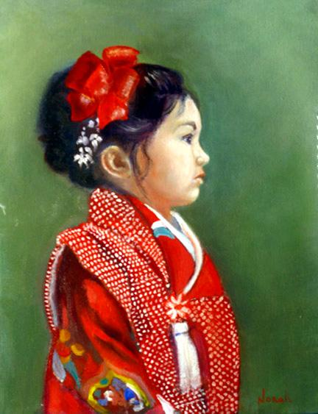
The Story of a Small Child
Panting, a small child, who was wearing an intricately patterned kimono, reached the top of the tallest hill in the village. Tears were welling up in her eyes as she gazed down at the beach where the samurai stood, waiting for their death – which was in the form of approaching Mongol warriors. Her eyes raked the horizon, scanning for a sign that the Mongols had arrived – and, sure enough, there they were; some in old boats; some in new; some in small boats; some in large, though all equally terrifying. The closer and closer the Mongols ventured, the scarier and scarier they became. Tears were now streaming down the child’s face, blurring her vision and distorting the world around her. The fact was not new to her, the child knew that the samurai army was no match for the Mongols, there were 10 000 samurai against 40 000 Mongol warriors. Soon, she thought, soon this Japanese island will belong to the Yuan Dynasty; soon my home will belong to the Mongols. A distant war cry from the Mongol general echoed around the island, followed by a far away proud shout from her father, the samurai leader. Then the battle began.
Immediately, the samurai stepped forwards preparing for a one-on-one fight; little did they know the Mongols weren’t familiar with their honourable, noble code, so they swarmed the samurai as ants swarm a beetle. Within the first few minutes of the battle the child saw many samurai die, she recognised some such as Ashikaga san or Shimazu san. Silently, hardly daring to breathe, the child watched as the samurai spectacularly lost to the Mongols, though there was no denying the samurai were fighting valiantly.
By afternoon the remaining samurai were on their last legs, her father was fighting four Mongols at once. It would all be over soon, thought the little girl, the Mongols will have won. And then, as though her prayers had been answered, samurai reinforcements appeared – it seemed like a miracle. Maybe the samurai wouldn’t lose after all!!
It was now night time and the moon was shining down on all of Japan. The samurai warriors had drawn back a few miles inland and the Mongols were moving their boats further out to sea, to stop them getting driven into the beach by the raging storm now going on. However, the child who had been watching the battle was still on top of the hill, braving the wind and the rain to watch over the town during night. Occasional bolts of lighting and roars of thunder were the only sounds to be heard apart from the pouring rain and the crashing of large, violent waves. Above the rain of the storm, came what sounded like a war cry from the Mongols. The whole town ran out of their houses into the fierce storm, immediately being drenched in glacial rain. Swiftly the little girl on the hill turned to look at the sea. At first it appeared that the Mongols had fled home – causing her fear, that her father would die, to recede straight away; but when she looked more closely she saw on the horizon an approaching tsunami. As quick as lightening her eyes travelled to see the beach. Stood there, looking triumphant was her father; shouting something the little girl could not make out. Fear flooded her body, and, although the Mongols had been entombed by the sea, the dread that her father would die entered her once more. Like wind, the small child ran down to the beach to warn her father – but it was too late, the great wave was already crashing down upon them. And then the world disappeared...
By Hannah Pook

