4.1 How good is the relationship between history and the rest of the school curriculum?
At Heron Cross history the whole school is involved in a story topic approach. This means that though history has an explicit timetable to ensure coverage. It also has many cross-curricular links within the rest of the school curriculum.
Whilst learning about World War 1 for the centenary Heron Cross took part in a dance performance at the Regent theatre where the children created a remembrance dance. Opportunities are used in ICT to conduct research and children have even explored and created meals from different periods.
During the whole school World War 1 day the children preformed the dance created for the Regent Theatre.

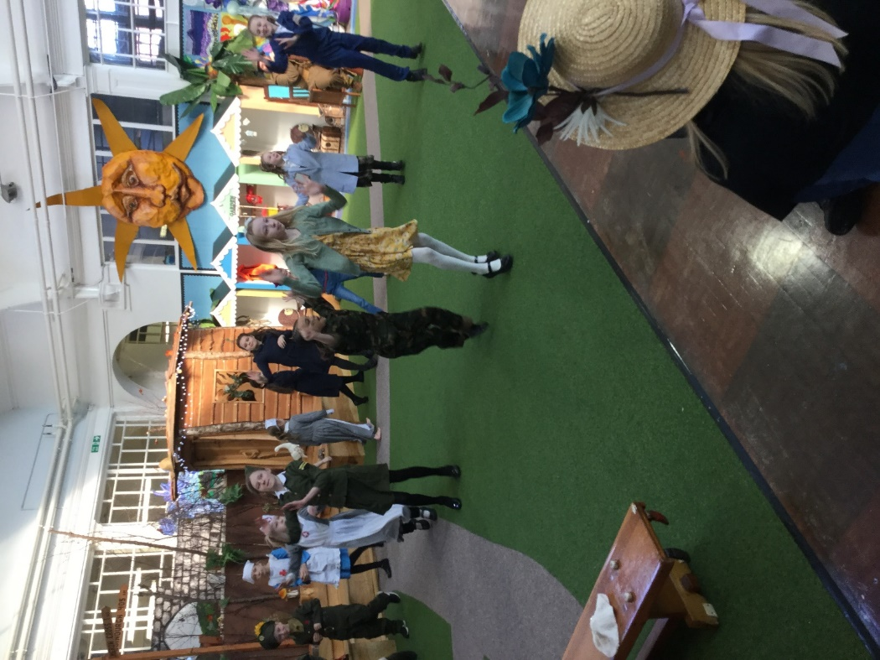

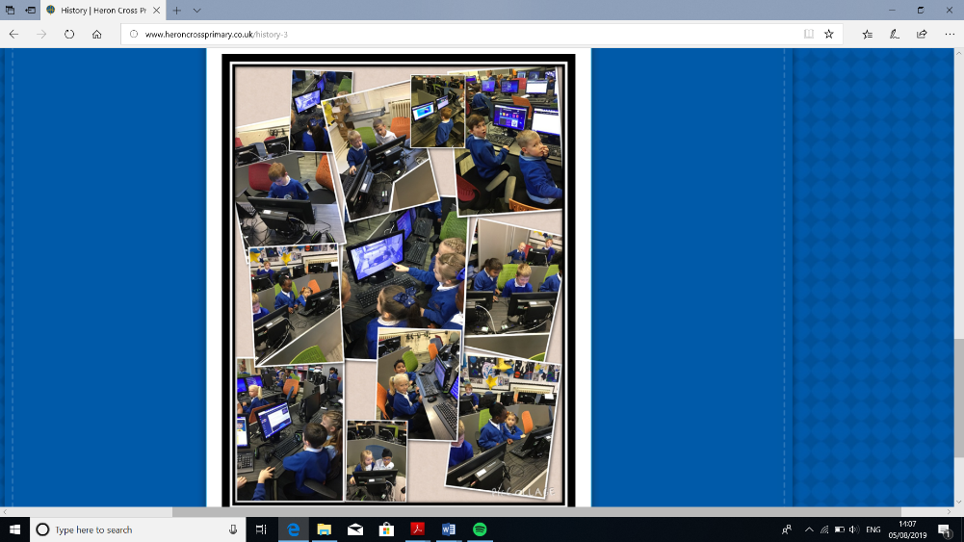
Throughout the school ICT lessons are used to find information about time periods and to create interesting ways of presenting this information.
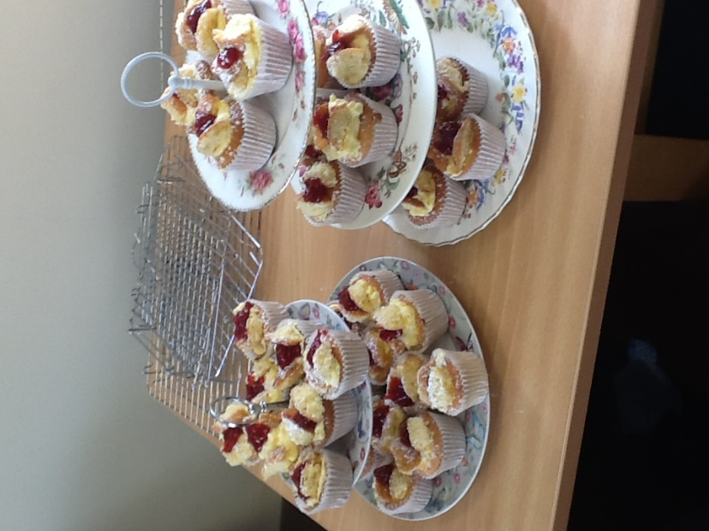

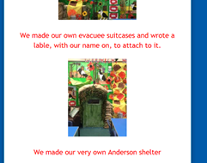
The children had an opportunity to create their own Victorian feast

Story topic are often chosen that link with the history topic to allow for the best opportunities for cross-curricular links. Year 4 studied Goodnight Mr Tom and then created their own evacuee suitcases and an Anderson shelter.

4.2 How does history beyond the classroom enrich the pupils’ experiences?
At Heron Cross the SLT and subject lead try to ensure that the whole school are given opportunities to experience history beyond the classroom. Trips are organised that allow the children a greater understanding of the topics that they are covering. Artefacts are used in lessons and workshops that take place. A whole school topic days are arranged that give the children cross-curricular activities to promote historical skills. Visits to museums allow the children to meet history professionals and all year group attend assemblies promoting and discussing history.
These experiences are then used within the classroom to further historical knowledge and skills.
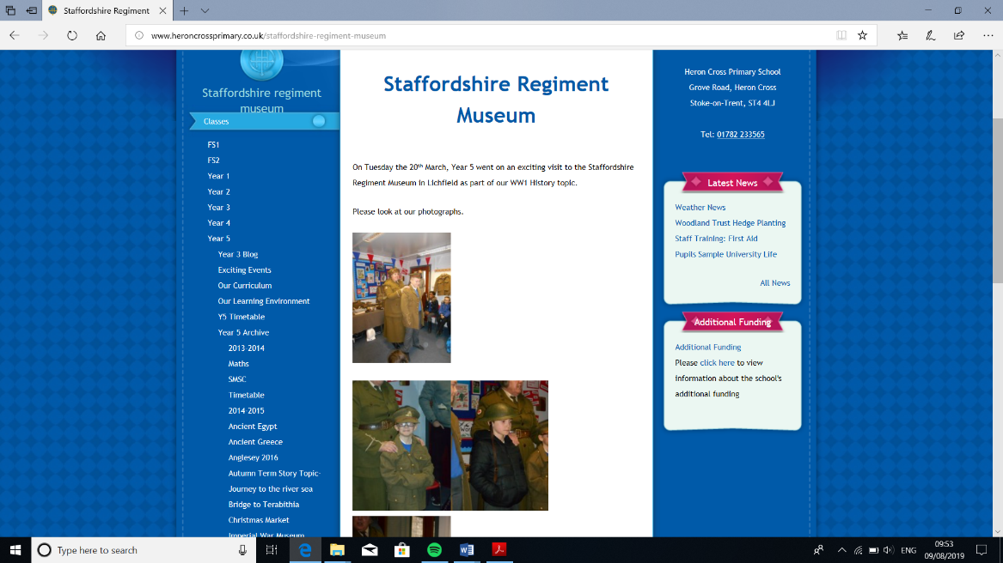
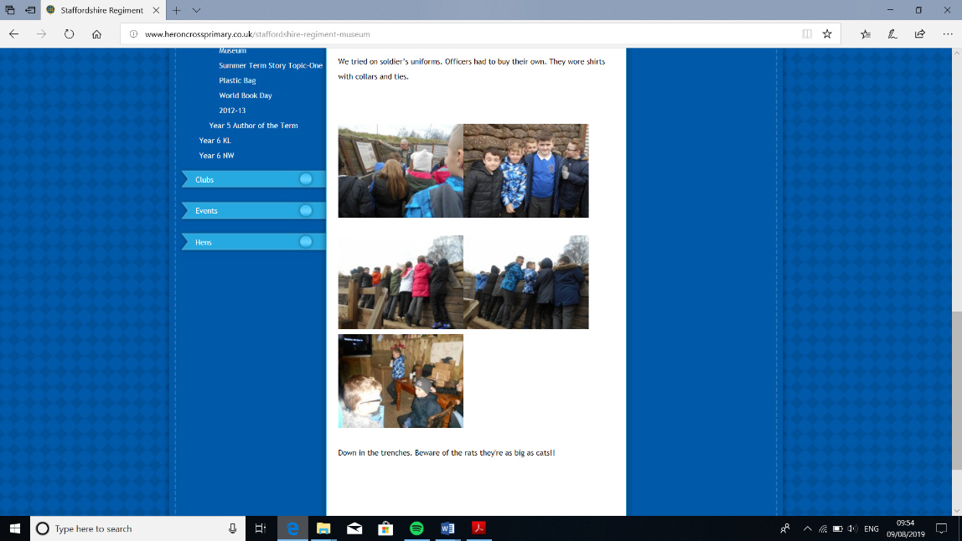
Whilst learning about World War 1 the children were able to visit Staffordshire Regiment museum. They were able to role play what it was like for a soldier dressing in uniforms, handling artefacts from that time and even going into replica trenches to give the children some understanding of what it would have been like.

4.3 How well does history contribute to the school’s online communications?
At Heron Cross history is promoted on the Heron Cross website. Every year group has a humanities section in which history topics and events are shared. These pages are used to promote discussion and to allow parents/ carers to discuss the topics that the children have been learning and to promote the museums and trips that they have attended.

The screen shots below are example taken from the history page from each year group:

Year 1s information on the Victorian Day:
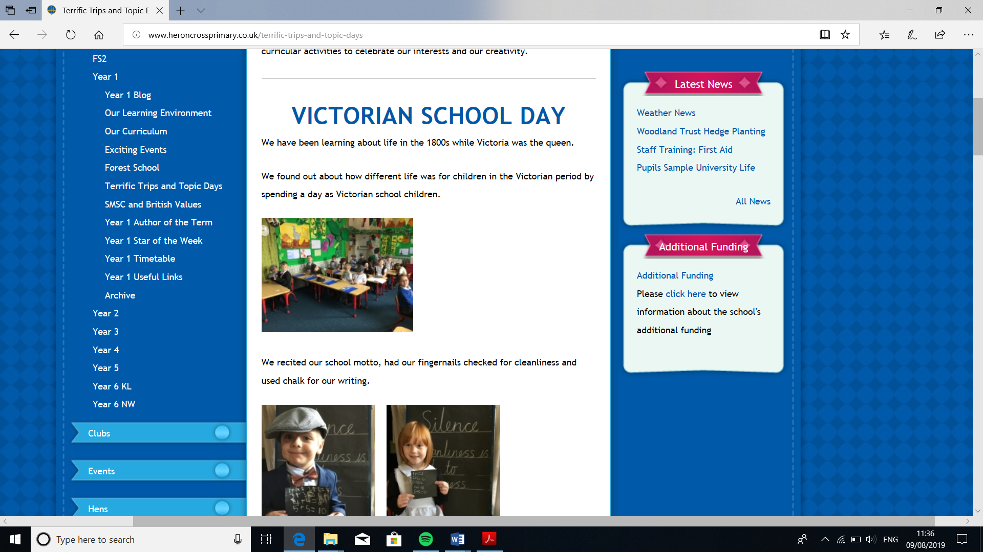

Year 2 provided information on the chronology activity based on Guy Fawkes:
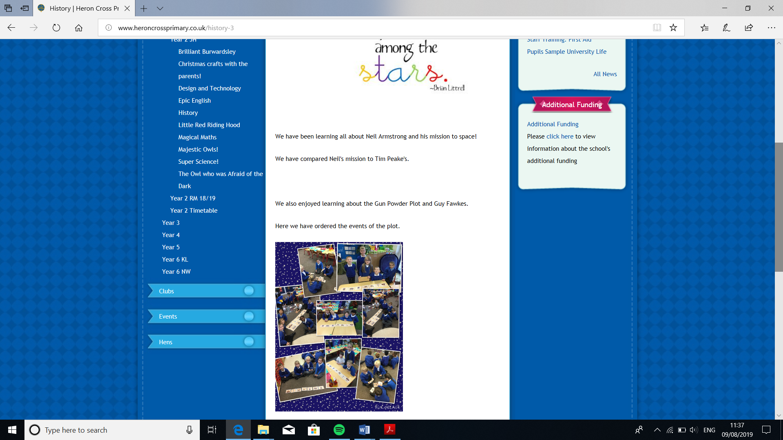

Year 5: Included information of the activities that they have completed for Victorian Day:
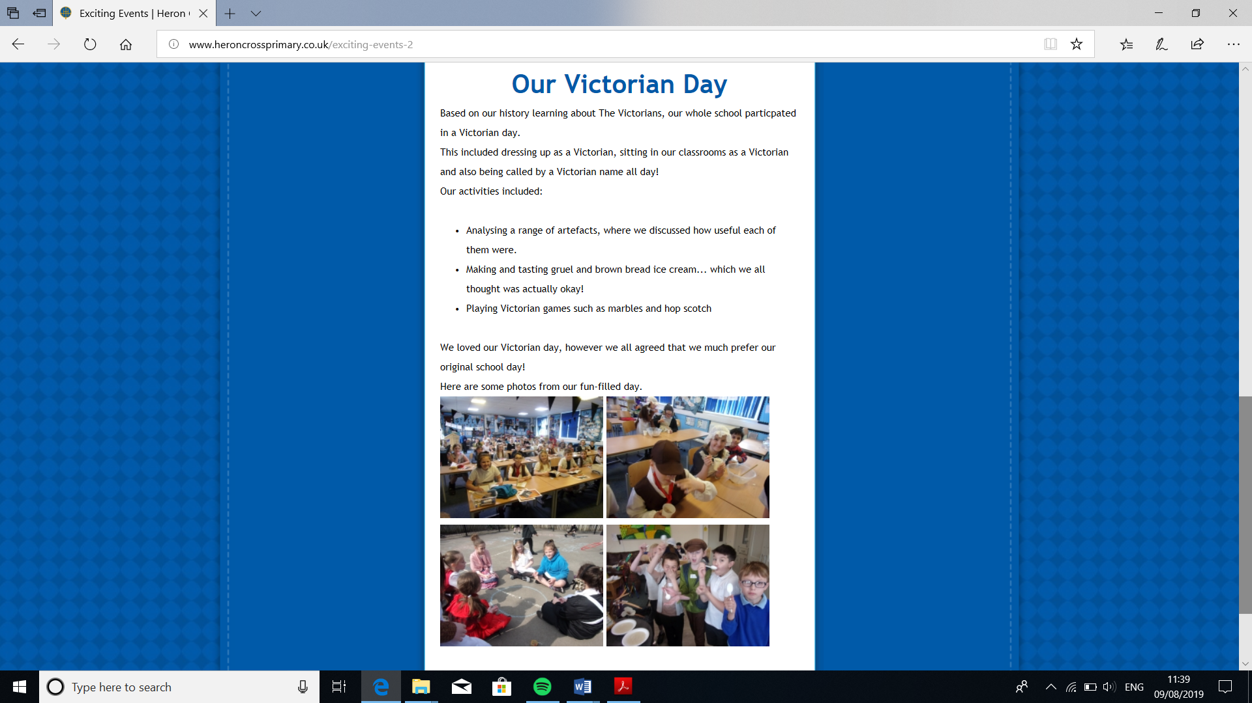

… and of their trip to the Staffordshire Regiment Museum.
