2.1 How much status does history have in your school?
At Heron Cross history is seen as a prestigious subject that every year group, including the EYFS, participate in regularly, through a timetabled and structured curriculum (see long term plan). Many of the topics are supplemented with whole school theme days, prominent displays, showcasing on the website assemblies, visitors and trips.
These are all shared with the governors and parents through letters, newsletters or updates on the school website. Staff meetings and CPD occur with specific focuses following teacher questionnaires and the monitoring completed by the subject lead.
At Heron Cross the SLT team is eager to ensure that history has a high status. They will review the curriculum with the subject lead. Are heavily involved in whole school theme days, encourage the use of trips and visitors and the head teacher has visited EYFS and KS1 to discuss her experience of watching the moon landing and to talk to the children about toys she used to play with.
Throughout the school learning environments that promote historical enquiry are made prominent in classrooms.

2.1 continued…
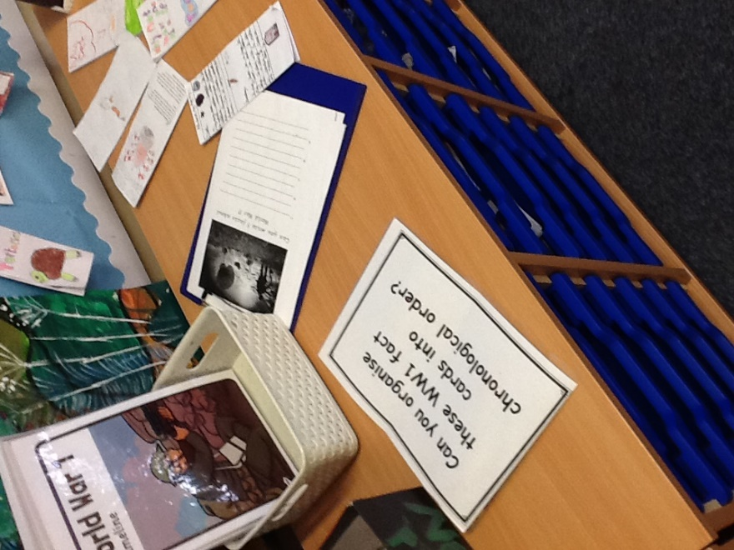
Displays- Displays are created in each classroom to promote the status of history. These are often interactive displays that the children feel are purposeful.
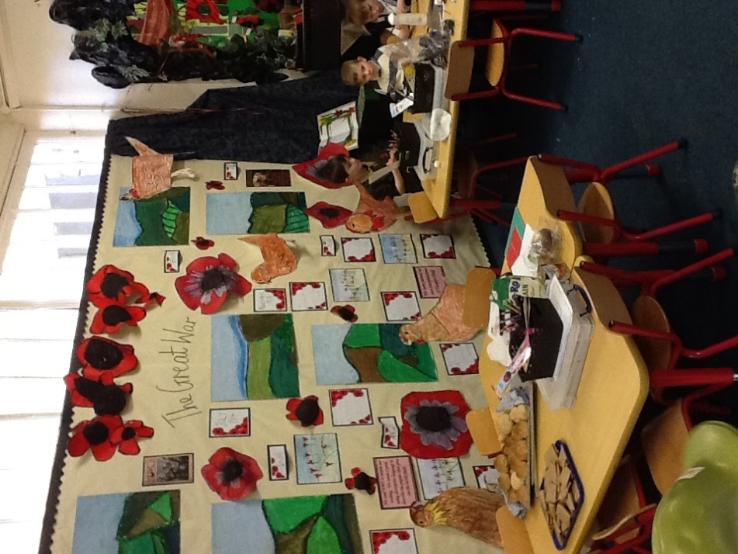
The children are involved in creating each display, giving them ownership over the topic they are learning about.

Year 2 created a working display that changed as their knowledge of the time increased.

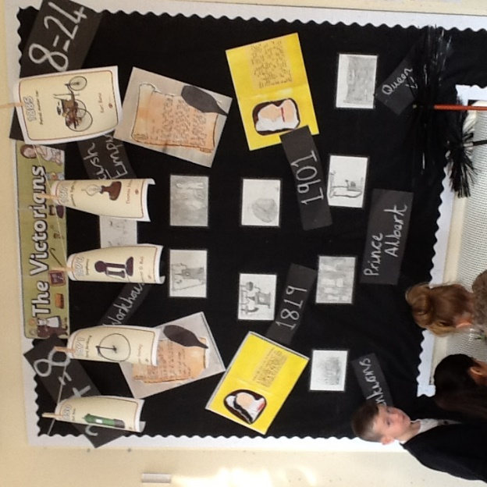

Assemblies:
Throughout the year, there are regular history assemblies. These are often linked to theme days, visitors coming into the school or special times for example, Remembrance Day.

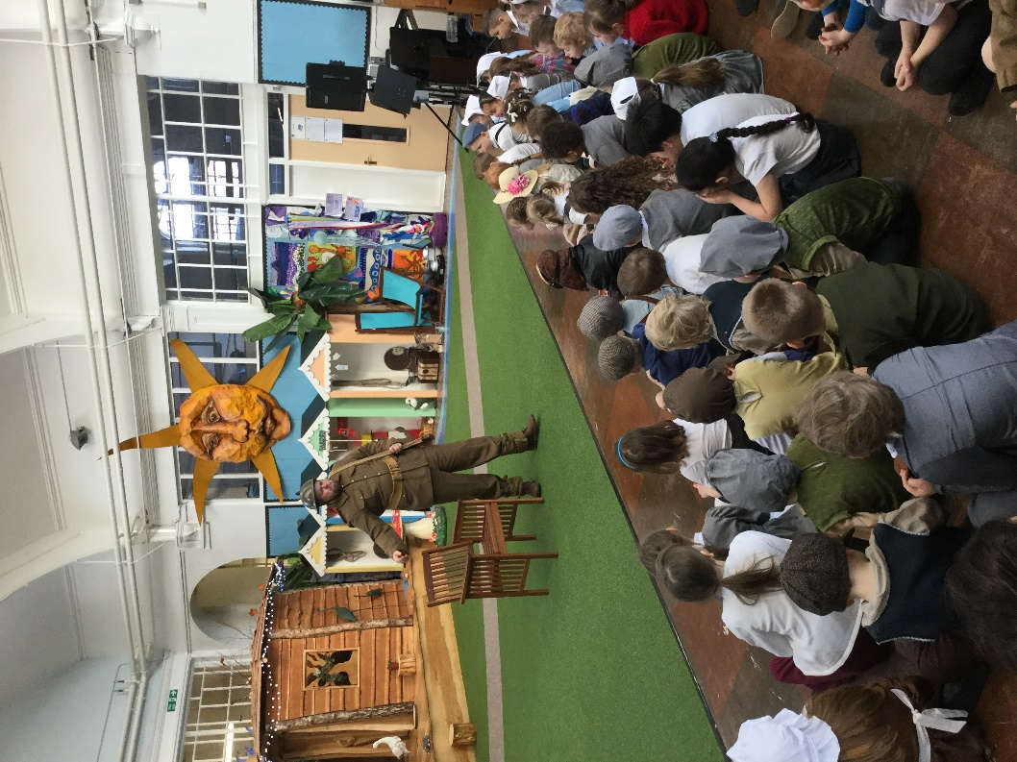
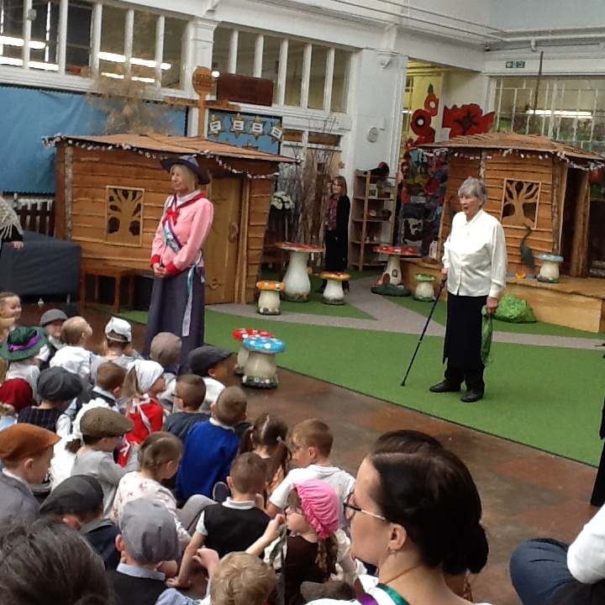
For the centenary of the First World War, Every year group spent time learning about the First World War. We all came together to participate in a whole school theme day. In which every child and member of staff dressed up and took part in different activities. They were visited by a member of a historical organisation who talked about the uniform soldiers would wear and other historical information. Year 4,5 and 6 then completed workshops based on this.
Visitors regularly attend to share their knowledge in whole school assemblies.

2.2 How is history organised, administered and managed?
To ensure that the full coverage of the national curriculum occurs the history long term plan is reviewed and shared with staff annually. Through the monitoring procedures, staff questionnaires and pupil questionnaires topics that worked well and those that need development are identified allowing the subject lead to put into place any CPD require by the staff or any changes in topics to be made. These are shared in a staff meeting allowing the staff to give suggestions or ask questions.
With the support of SLT the subject lead organises any additional CPD that is needed through staff meetings given by the subject lead where possible or with the support of outside agencies/ organisations where needed.
Assessment documents help to make clear the national expectation of a secure child and helps teaching staff to differentiate the work that they are asking particular groups of children to do and this occurs in different ways.
Learning walks and book scrutinies ensure that high quality teaching is occurring with purposeful lesson that promote independence and development of skills as well as knowledge.
The subject lead also works alongside link primary schools in our Stoke 6 group and with the high schools in the area to ensure all skills required have been covered and to ensure that the curriculum covers all progression. The curriculum, practical activities, essential vocabulary is discussed and a high quality curriculum is developed. These discussions are fed back and changes are monitored by the subject lead.

Please see the monitoring overview.

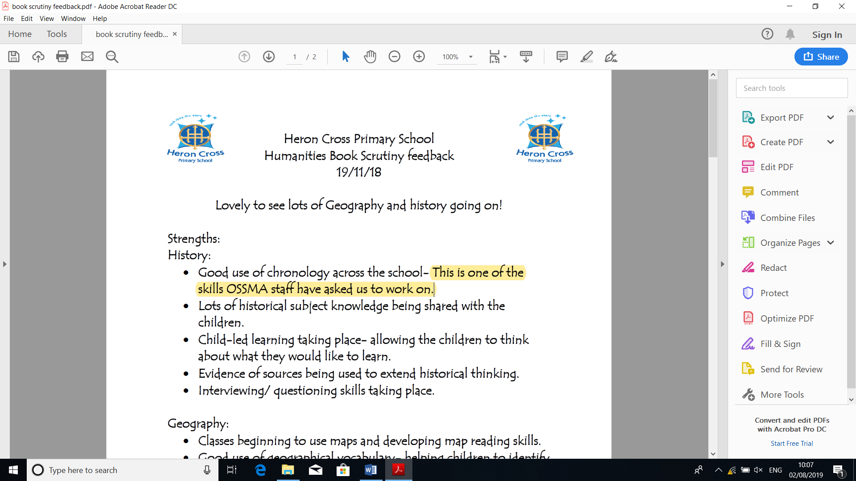
2.2 continued…

Information was fed back from the subjects lead to OSSMA high school, she then completed a book scrutiny and fed back to the staff the positive changes that had been made.

2.3 How well does the school evaluate performance in history?
To ensure accurate monitoring of progression occurs throughout the subject the history lead has created a progression document (please see attached document) that is used in each year group to assess the children. This ensures that all members of staff are fully aware of the expectations for each pupil. The levels of each class are shared with the subject lead to allow her to track the development of each child and to identify any children that may need additional support.
For each lesson teachers create learning objectives and WALTS are used in history books to allow the children to identify what they are learning. Teachers will actively mark and assess throughout the lesson, allowing them to put into place any support or interventions where required.
The subject lead works within a collaborative group of schools to share good practise and to enable her to compare the levels of history being taught within Heron Cross and the other schools in the collaboration.

2.4 How well does the school support the ability of staff to deliver effective history?
The subject leader provides support for staff through staff meetings. There are focused on the strengths and development points that are required following discussions with staff, staff questionnaires, learning walks and book scrutinies. In doing this the subject lead is able to monitor and identify specific and collective needs of the staff.
After conversations with staff it was felt additional CPD was required to ensure that all areas of history/ particular skills were being taught effectively and so the subject lead has provided CPD for all teaching staff through an outside agency.
Heron Cross holds network meetings with several other schools in the area and so the four school’s history leads work together to ensure that internal moderation of the subject can take place. This has supported the subject lead in areas such as progression and coverage of skills.
The school’s SLT and the history link governor (see additional document) have supported the subject lead in creating links within high schools in the area who have been eager to share their knowledge and who have helped to develop the new history curriculum.
After completing staff questionnaires of teacher’s confidence to teach history. The history lead identified a need for support regarding teaching of history skills. With the support of SLT, she was able to organise training led by Aaron Wilkes that shared activity ideas and best practise. Please find below a screen shot of the email informing members of staff about the training.

2.4 continued…
