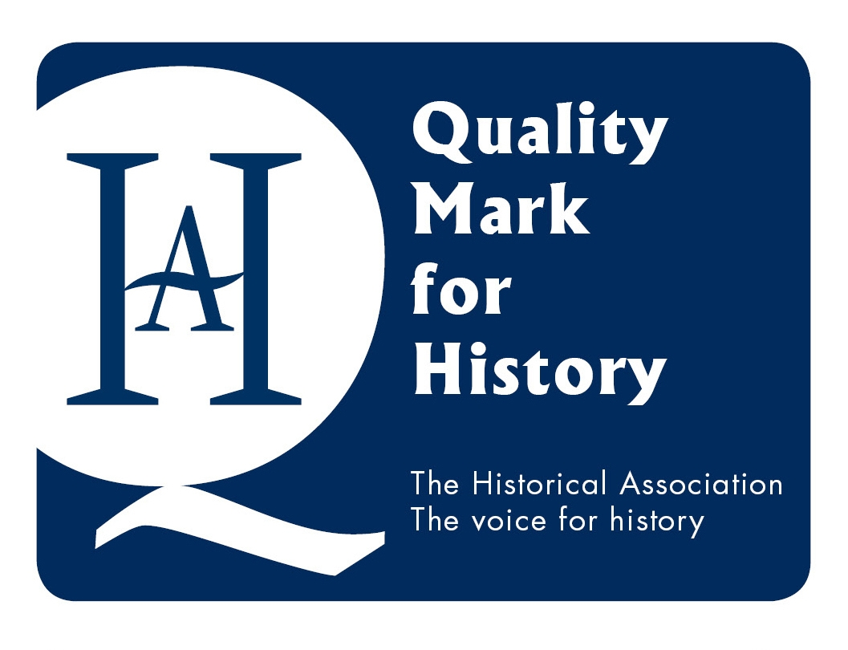
Why Choose a History Quality Mark?
The Historical Association as the subject association for history in schools recognises and celebrates the outstanding history education that is taking place in many of our schools. The Quality Mark is a way of helping to recognise and give credit to those schools and individuals delivering a high quality history education.
Schools are required to demonstrate the quality of their curriculum, leadership, teaching and learning and the quality mark can also be a tool for those looking to improve.
Ofsted frameworks require schools to deliver a broad and balanced education, but with the current inspection emphasis lying with the core subjects, it is difficult for those subjects outside of the core to gain the support for improvement, recognition and validation that they want and need. This is where the Historical Association Quality Mark can help to provide a quality assured rigorous, yet achievable mark of quality for schools that would like to see their high quality history curriculum, improvement and teaching rewarded.

What is the Quality Mark?
There are 2 levels to the Historical Association History Quality Mark; silver and gold. While both levels require a rigorous approach, the upper level indicates a wider impact for history, beyond the school environment, for example working with community groups on local history projects, or establishing history CPD networks with other schools. Please see the self-assessment criteria document
Schools will register in the same way for both levels and are welcome to apply for assessment for the gold award without having completed the silver award if they feel that they have reached this level. Please note that the quality mark is entirely based upon school self-assessment up until the point of quality assurance at which point an assessor will visit the school and view the electronic portfolio before any award is made.
Schools seeking advice may send email queries to melaniej@history.org.uk and these will be forwarded to assessors, however, schools wishing to book more lengthy training or discussion with assessors will need to pay for this and arrange separately. Only the final assessment visit from an assessor is funded through the Quality Mark scheme. An assessor who visits the school, may award a silver award if they feel that the school has not yet met the criteria for a gold award.
How many levels are there?
There are 2 levels to the Historical Association Quality Mark; silver and gold. Both levels are indicated within the criteria. Criteria that are differentiated between silver and gold level are clearly marked. The gold level is highlighted in gold.
How Do I Qualify for Each Level?
To qualify for both silver and gold level, you must provide evidence for all of the criteria, although you may choose four criteria (five for gold) from each of sections 1,2 and 3, two (three for gold) from section 4 and three (four for gold) from section 5 that you wish the assessor to particularly focus upon.
Other: Please support your application with one final piece of evidence that is innovative and clearly reflects the good quality history in your school or that shows evidence of improvement that is not listed elsewhere.
How Long Will We Have to Complete it?
Schools will have a period of up to 12 months from registration to apply for quality assurance. Schools who do not apply for quality assurance within 12 months will have to re-register and pay a further £150 plus VAT to be assessed.
How Long Will It Last?
Once the Quality Mark is awarded, schools will keep the award for a period of 3 years from the date of award before needing to re-apply.

