Teaching history using micro blogging (or Twitter): An Historical Association Project

Findings/ recommendations
Whilst schools are required by the National Curriculum to use emerging technologies, in practice this is not easy. First there are the technical difficulties that arise even though schools ICT facilities are now much improved. Second, and more significant is that schools have not yet come to terms with how to make use of emerging technologies. Banning them for issues associated with bullying may be short sighted; that is like banning playgrounds because bullying occurs in them. However, banning them for child protection reasons is far more understandable. The question ahead is what happens as mobile technology allows pupils to access the web independently of school or local authority controlled systems. In the short term there are alternatives to Twitter which may not be blocked in individual schools, see Appendix 4.

Using micro blogging or Twitter had a number of positive benefits: -

- Pupils enjoyed it and were engaged. They perceived Twitter to be absolutely on their wave length, ‘it was cool!’
- It facilitated role play, discussion and debate and author interview.
- Its less threatening nature increased active participation.
- It led to gains in pupils’ skills of historical questioning and historical communication
- It led to gains in pupils’ knowledge and understanding of the historical events under consideration, the concepts of diversity, change and continuity and learning about the process of researching and writing historical fiction, the diversity
- In every case there was a permanent record of the debate, discussion that could be used for follow up work

In each case study below a number of factors were essential for success. The:-

- history teachers needed to be committed and determined
- ICT staff needed to be fully supportive
- Senior Management teams needed to be supportive
- technology needed to be robust
- history planning needed to be thorough
- history activities needed to be rigorous, engaging ….
- pupils required basic key board skills
- pupils required thorough grounding in the history and learning skills required

Dave Martin, 16th October 2010
The Project Outline
The project was set up with funding from the Historical Association in 2009. http://www.history.org.uk/ Its purpose was to explore the potential of micro blogging software such as Twitter as a resource for history teachers to help students learn about the: -

- diversity of experience of people in the past;
- the construction of multiple narratives;
- cause and consequence;
- interpretation;
- and historical communication using emerging technologies.

These all form part of the key stage 3 History Curriculum.

Also a focus of the work were three of the guiding principles of the School History Project. http://www.schoolshistoryproject.org.uk/ SHP: -

- believes that historical enquiry, the analysis of evidence and creative forms of communication should form the bedrock of the school history curriculum;
- promotes diverse content, diverse approaches to the study of history and a focus on the diverse experiences of people in the past;
- is committed to developing approaches to teaching and learning that combine enjoyment and active engagement with historical rigour.

The project involved history teachers from three Dorset and one Somerset schools – Nigel Watt at All Saints CE School, Weymouth (11-16 comprehensive); Fiona Ray and Fiona Scott at Dorchester Middle School (9-13); Anna Killik and Katie Taylor at The Thomas Hardye School, Dorchester (13-18 comprehensive) and Stuart Roper at Holyrood School, Chard (11-18 comprehensive). The Dorchester Thomas Hardye School (a training school) kindly provided free meeting space for the project and Michael Riley joined us in the planning stage.

The participating teachers met face to face on three occasions in the autumn and summer terms of the 2009-10 academic year. The first meeting was to set up the project and to consider possible applications of micro blogging or Twitter in the history curriculum. It drew upon the very limited existing research literature and offered a suggested example centering upon the events of 1066. See Case Study 1.

The participating teachers undertook to sign up for a Twitter account and to spend the next few weeks exploring its affordances and discussing possible applications in history. The plan was for the teachers to maintain a history network throughout the duration of the project. See Case Study 2.

Next a half day planning event took place when the teachers met face to face to plan a teaching episode, lesson or series utilizing micro blogging or Twitter. These were tailored to their own school circumstances. They then undertook to go away and complete the planning and preparation and trial their activity. Finally they agreed to meet for a second half day event where they would report back on the effectiveness of the planned learning experiences. From this a set of mini case studies and this report emerged.

It should be noted that these activities were ‘bolt on’ experiments. In the future all concerned when they did something similar would be planning the use of micro blogging or Twitter or forums within their medium term planning.

Case study 1. Historical role-play - Multiple narratives from the Battlefield of Hastings
The set up
The lesson objective was for the pupils in a mixed ability Year 7 to create multiple narratives on the Battle of Hastings, based on eight characters that fought in the battle. In the lesson eight groups of pupils would take on the role of the battle participants and would be asked to send a tweet capturing what their participant was thinking at each of the chosen moments within the battle. In order to achieve this a number of preparations were necessary
Firstly the history. Pupils needed to know about the events of 1066 leading up to the battle. They also needed to know about the battle itself. Who would be there, how they fought and what actually happened on the day. Pupils also needed to hone their source handling skills as they were going to work with scenes from the Bayeux tapestry. All of these were covered by the teaching in prior lessons
Secondly the software – Twitter. This was possible thanks to the enthusiastic cooperation and hard work of the school’s ICT Coordinator. 1. A set of fictitious pupil email accounts in the names of the battle participants such as Earl_Hugh had to be set up. 2. Then using these email accounts a set of Twitter accounts were set up. 3. Next each of these Twitters was set to follow the teacher, Nigel Watt, so that the Twitter stream could be shown on the board in the lesson. Additionally the school barrier to Twitter had to be removed for the duration of the lesson, normally Twitter is banned.
Thirdly the hardware. The school has a set of bookable laptops. Eight were booked for use in the chosen lesson, one for each character. The classroom in question had wifi access. In the event during the lesson all this technology worked smoothly.
The lesson (See appendix 1 for Nigel Watt’s lesson plan)
Prior to the lesson a number of additional materials were created. These were a PowerPoint presentation with the task instructions and selected scenes from the Bayeux tapestry of incidents within the battle. This was to be displayed on the board. Additionally a set of laminated colour versions of the scenes was available for students to handle in their groups. Finally, as Plan B, a set of large blank cards and marker pens were made available so that if the technology failed the lesson could carry on with handwritten tweets rather than electronic ones.

The learning
The Year 7 pupils were very excited at the news that they would be tweeting and were keen to get started. Their response to the first slide depicting the Saxon shield wall receiving the cavalry charge of the Normans was very good as the screen shot in Figure 1 below shows. They reflected a range of viewpoints between the two sides with some appreciation of the differences within a side, for instance between a fyrdsman and a housecarl. They also reflect some accurate historical knowledge of events and of warfare.
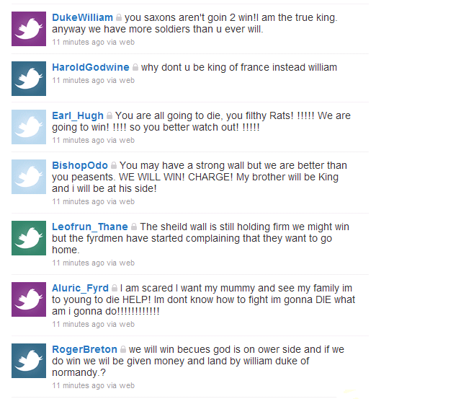
Figure 1. Extract from the Battle of Hastings Twitter stream

Discussion
What emerged from this trial lesson were two things. The first was that pupils needed more time to explore each incident within the battle, to interpret the Bayeux tapestry scene and to consider their participants viewpoint before tweeting. And this needed to be balanced against pupils’ keenness to tweet and see their contribution on screen. Plus some pupils wanted to enter into dialogue with their friends and enemies. So for the next lesson far fewer scenes, indeed maybe only one or two will be considered.
The second was that using Twitter does have the potential to help pupils appreciate the differing narratives within a major event.

Case study 2. Creating a community of practice for history teachers.
Twitter is an ideal technology for setting up a community of practice. It allows the user to form groups and to stay in contact with ease using mobile devices such as phones. In the project it was agreed that the teachers would open an account in Twitter. None were users at the project start. They were to try to send a message, ideally once a day, and respond to each others messages. This had two purposes, one to develop familiarity with the technology and two to establish a community of practice within which we all could learn from each other. To do so we adopted a simple code of practice which stated that i) our messages (tweets) would contain no third party names by which students or teachers could be identified and ii) that they should contain nothing that should not be in the public domain.
In practice this did not work for a number of reasons. First the teachers were not already Twitter users so it was an extra task in their already busy lives. Second all of their schools had a blanket ban on twitter so tweets had to be sent from their home computers or mobile phones.
However that is not to say that it could not work. There are history teachers who already use Twitter and there is at least one example of trainee teachers using it at The University of Waikato in New Zealand. They used Twitter to reflect on their experiences on teaching practice. Nigel Robertson highlighted the advantage of Twitter’s flexibility. The trainees posted tweets by text message (SMS) on their mobiles. This meant they were not tied to finding a computer or internet access and could tweet as soon as possible after an event. See also Stannard (2009).
For history teachers they might discuss issues arising from their own teaching. These might relate to classroom management but could also address issues of historical focus, how to develop discussion, handle sensitive topics such as Holocaust, terrorism, racism and so on. A useful starting point for those interested in exploring this would be the HodderHistory twitter stream which is followed by a community of history teachers. http://twitter.com/HodderHistory

Case study 3 Discussion with an author, Gill Harvey, about writing historical fiction set in Ancient Egypt
The set up
The session objective was for the pupils in a mixed age school book club (Year 5 to Year 8) to discuss the writing of historical fiction set in Ancient Egypt with the author Gill Harvey. http://gill-harvey.com/ (For reading group you could substitute history club or history class and for Ancient Egypt you could substitute any historical setting.) In the session the pupils, in five groups of 3 or 4, would tweet their response to a story character, setting, and plot task based on Egyptian tomb paintings from the British Museum, the paintings from Nebamun’s tomb of i) a banquet, ii) pond and garden, iii) geese count. They can be found at the British Museum website http://www.ancientegypt.co.uk/life/story/main.html

Each pupil group will then have the chance to ask single questions following up Gill’s responses on their story ideas or asking about Gill’s writing in general, or on specifics within the four published titles in the Egyptian Chronicles series. In order to do this before the session the pupils would: -

1. read some of Gill Harvey’s books;
2. reactivate their prior knowledge of Ancient Egypt;
3. study a couple of Egyptian tomb paintings to explore character, setting and plot development;
4. practice how to express their ideas and ask questions within the 140 character constraints of Twitter.

Secondly a date was agreed between school and author for a one hour session. Attempts to book a fall back date (in case of last minute technical hitches) were unsuccessful.

Thirdly the school set up a Reading Group twitter account and booked the schools ICT suite. Additionally the school barrier to Twitter had to be removed for the duration of the session; normally Twitter is banned.The plan was for each group to be able to send their tweet and for all to be able to read these on the big screen. Prior to the session a trail run was made where the pupils discussed history and historical fiction with an outside historian. This reassured all that the system was working. In the event technical problems in school the day before the actual session left all ICT services out of action until the very last minute and in the end an amended version of the session ran.

The session
As noted above technical problems across the entire school put the session in jeopardy until the very last minute and in the end a reduced version was run on a single stand alone computer. This inevitably was not as effective as not all the pupils were then present, the focus of their preparation was reduced and unsurprisingly those not at the computer lost interest. Having said that an interesting conversation did take place as shown in Figure 2 below. Pupils, as individual members of the group, tweeted Gill Harvey during a period of about one hour and she replied.
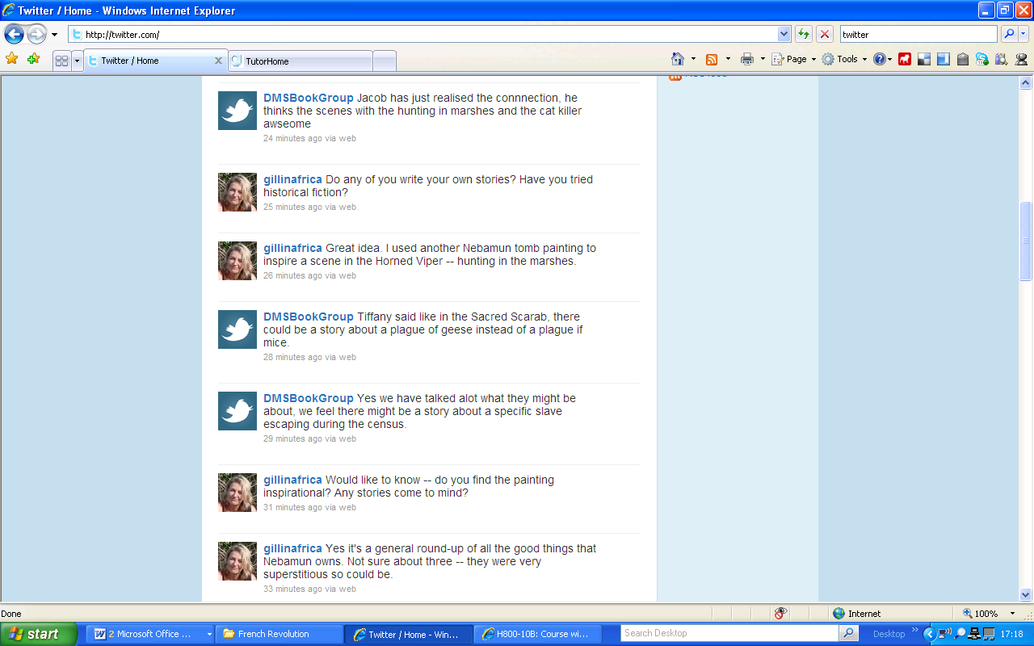
Figure 2. Extract from the Book Group / Author Twitter stream
The learning
The pupils enjoyed the novelty of using Twitter and the stimulation of being able to talk to an author. In the extract from the discussion shown it is clear that some pupils are making the link between an historical source and a scene in a book that the author has created by drawing upon that source. Pupils also made gains in their knowledge of Ancient Egypt and their understanding of the writers’ techniques.

Discussion
One of the most noticeable things about the discussion was how fast paced it was, a lot of questions could be asked and answered in a very short space of time. Moreover that discussion had more coherence at the time than might appear from the final record. So the point made by Gill Harvey how she used the hunting scene whilst separated by another tweet from the Book Group answer was instantly grasped.

Of the session Gill Harvey commented, ‘It was a real pleasure. Their questions were actually more interesting than a lot that I get asked -- they'd clearly done their homework. It all went more quickly than I expected too, in that we covered a lot of ground and questions flew to and fro. Q&A sessions are usually 10 mins at the end of a performance, though, so I suppose the thing is that this is a novel and fun way to do things virtually.’ The pupils said, ‘we enjoyed talking to Gill Harvey’, and some became fans and buyers, of her writing.

This activity could be adapted to pupils of any age discussing with any author of ‘good’ historical fiction or with a historian about their writing on any historical subject, most obviously at AS and A2 level.

Case study 4 Historical debate - Who was the most important figure in Ancient Medicine?
The set up
The lesson objective was for the pupils in a mixed ability Year 10 to debate in role the question – Who was the most important figure in Ancient Medicine. In the lesson eight groups of pupils would take on the role of a range of figures, some real, some imaginary. First they would be asked to suggest a treatment for a particular set of symptoms, then they would be asked to enter into debate. They were asked to put forward two reasons why their character was most important and then were able to enter into individual conversation/ debate with the other individuals/groups. In order to achieve this a number of preparations were necessary.
Firstly the history. Pupils needed to know about the individuals concerned and as this came after their study of Ancient Medicine as part of their GCSE course this activity would serve to reinforce and extend their existing knowledge.
Secondly the software – Twitter. This was possible thanks to the enthusiastic cooperation and hard work of the school’s ICT Coordinator. 1. A set of fictitious email accounts in the names of the figures from Ancient medicine such as Priest_Akakios had to be set up. 2. Then using these email accounts a set of Twitter accounts were set up. 3. Next each of these Twitters was set to follow the teacher, Nigel Watt, so that the Twitter stream could be shown on the board in the lesson. Additionally the school barrier to Twitter had to be removed for the duration of the lesson, normally Twitter is banned.
Thirdly the hardware. The school has a set of bookable laptops. Eight were booked for use in the chosen lesson, one for each character. The classroom in question had wifi access. In the event during the lesson all this technology worked smoothly.
The lesson (See appendix 2 for lesson plan)
Prior to the lesson a number of additional materials were created. These were a task sheet which included an initial activity designed to help studnets into the roles and a summary sheet for each character.

The learning
During the lesson the sequence of activities as planned was followed. Pupils were very engaged by the opportunity to use Twitter. A small number reported they had their own twitter accounts. They eased themselves into their roles through the preliminary task and then by considering what treatments to suggest. They then moved into the formal part of the discussion advancing two reasons for their character’s importance as shown below in Figure 3. Then a number of individual exchanges developed with some quite high level thinking before, towards the end of the lesson the focus of some began to wane and the teacher moved to the plenary.

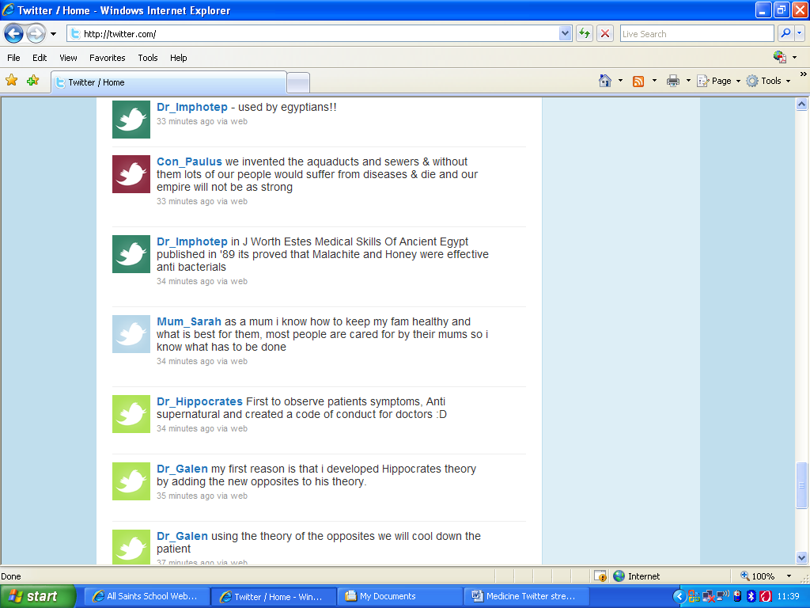
Figure 3 Extract from the Medicine Twitter stream just after the groups had been asked to suggest two reasons why their character was the most important figure in Ancient Medicine.

Discussion
The lesson worked very well on a technical level. Just one group experienced log on problems and this turned out to be a simple error in setting up user names. On a history level the lesson worked very well. The twitter stream reflected pace, many more questions and comments were possible then in a normal role play debate. Moreover as pupils considered in their groups what to tweet there was rigour in their thinking and rigour evident in some individual tweets.

Pupil response
Pupil response was very positive, one complaining as they packed away, ‘I was enjoying this lesson’. They were also very perceptive in their reflections upon the activity in the plenary session. These are added to the teacher perceptions in the table below.

Pluses | Minuses
Enjoyment – it was ‘cool’ and amusing too | technical – set up was time consuming
The anonymity of the group enabled all to contribute | Technical – having to refresh the twitter stream
Seeing the comments (tweets) fixed on the screen aided the thinking process | Technical – visibility of tweets on classroom whiteboard screen
Pupils felt able to bounce ideas and take risks | Technical – one group experience log on problems
Pupils could contribute without interruption and without waiting their turn | Lacked the cut and thrust of verbal debate
Replies came back really fast | Twitter stream could ‘appear’ a bit disjointed/ meandering
‘Don’t repeat yourself – helps you remember’ | There is a point at which the quality of interaction begins to degenerate
Sheer number of contributions possible | Sheer volume of tweets to read
Served as useful revision | Time consuming – no time to follow up

Case study 5 Historical role play – the Opium Wars
The set up
The lesson objective was for the pupils in a mixed ability Year 9 class to discuss in role the 1839-42 Opium War in order to i) establish their understanding of the causes of the war, why the British won and what effects it had on China; ii) increase student confidence in analysing war and empathising with key individuals and iii) trial the use of discussion forums.

The role play had to be set up in a Moodle discussion forum as the school would not shut down the filtering system that blocked Twitter for an hour.

For the lesson the teacher decided that four characters was more manageable than eight and so the class was split in half with the same four characters in each, namely the Chinese Emperor, a Chinese Junk Commander, the British Admiral, Pottinger and a British opium trader

Eight lap tops were brought into the room prior to the lesson start and desks were arranged in two circles so that the participants in each class half were facing each other.

The sequence of events to be debated in role were conveyed with a series of PowerPoint slides containing key information, two paintings one British and one Chinese of the main sea battle and instructions for each group on how to enter the forum and the role that had been assigned to help them frame their comments. They were also given a word limit (in place of the Twitter 140 character constraint) but in their excitement soon forgot this.

The lesson
Students discussed the battle as the comments in Figure 3 below show. They were then brought together in a whole class discussion before moving back into the forum to discuss a second point in the narrative, what should be in the Treaty of Nanking.

(chinese commander) We feel deply upset that the british have sent warships. this battle is unecerssary and there will be devistating losses to each side! we feel that the british should withdraw or action will be taken!!!

We the British Empire, demand that you give us the port of Hong Kong where we are free to exchange opium without any restrictions. This port will stay with us for a term of 100 years where we will hand it back over to Chinese hands - if you ever attack our opium fields again we will hold the port indefinitely.
OPIUM TRADER

The learning
Students were excited and engaged to be doing the activity and the beginning comments show some imagination and would not have been achieved so easily with ‘normal writing.’ The quality of pupil responses deteriorated towards the end of the activity. ‘Students remembered more about the Opium wars than I would have expected and produced some good analytical pieces of writing for homework. They enjoyed the process and I think would even if it became quite a regular feature, but controls on inappropriate language would have to be very strict.’ After the lesson was over I asked the ICT department to close the forum so that only I had continued access to it. That way none of them could add anything from home!

Of course another route with this type of work is for it to continue as a homework activity. See the articles in Teaching History in the reference list.

Reference list
Barack, L. (2009) ‘Twittering Dante. New Models for student writing in the digital age’, School Library Journal. 4 January, available online at http://www.schoollibraryjournal.com/article/CA6647718.html

Karrer, T. (2010) ‘Twitter for Learning – 55 Great Articles: eLearning Technologies’, blog entry available online at http://elearningtech.blogspot.com/2010/03/twitter-for-learning-55-great-articles.html

Martin, D., with Matt Ashdown, Alison Dawson, Julie Grindel, Ann Steel, Rich Bailey, Melanie Young, Gary Anderson, Kitty Forester, Nigel Watt, Suzanne Hart, Liz Dowling (2008). ‘What do you think? Using online forums to improve students’ historical knowledge and understanding’, in Teaching History, Issue No 133, December 2008.

Martin, D., Coffin, C. & North, S. (2007) 'What's your claim? Developing pupils' historical argument skills using asynchronous text based computer conferencing', in Teaching History, Issue No 125, March 2007.

Stannard, R., (2009) ‘Tweet yourself to a new circle’, article published 1 Sept. 2009, Times Higher Education Supplement, available online at http://www.timeshighereducation.co.uk/story.asp?storycode=407984

Appendix 1 Hastings lesson plan Thursday 11th March 2010
Class: Year 7 mixed ability, 31 pupils, 12 girls & 19 boys
SEN: 10 on the SEN register, TA present

Aim: For the pupils to create multiple narratives on the Battle of Hastings, based on characters that fought in the battle.
Objectives:
- To explore the potential of Twitter as a resource for use in the history classroom.
- To encourage pupils to participate in collaborative learning.
- To use scenes from the Bayeux Tapestry as a stimulus for thought and learning.
Resources:
- Laptop PCs (x9)
- Wireless network and internet access
- PowerPoint slides on the Bayeux Tapestry, plus ‘hard copy’ versions
- Photocopied user name details for each group
- Starter activity sheets
Sequence:
1. Settle class and register. ‘How do you feel?’ settling activity.
2. Brief class about the lesson. Explain that the lesson will focus on peoples’ interpretations of events. Emphasise the novelty of the approach.
3. Organise pupils into groups. Hand out starter activity sheets
4. Instruct one member per group to go to LRC to collect a lap top computer. While that is happening, the other members of the group tackle starter activity.
5. Ask each group to log on as soon as the computers become available. Remind pupils to continue starter activity as they wait. Distribute user name sheets, one ‘character’ per group.
6. Once all computers are logged on, explain process of accessing Twitter to class (refer to instructions on whiteboard). Demonstrate how the messaging process works, i.e. limit to 140 characters, countdown facility, send, etc.
7. Set the historical scenario. Use PowerPoint slides on Bayeux Tapestry. Explain who the characters are. Consider why they were fighting, what they hoped to achieve, etc.
8. Let battle commence! Reveal first slide and distribute hard copies to the groups. Allow c 3 or 4 minutes thinking and discussions time. Encourage some drafting of ideas. When the instruction is given, the groups type their ‘tweet’ and send. Reveal Twitter stream (NB! Will need to ‘refresh’ every time).
9. Repeat process for the next four stages of the battle. Judge whether it is appropriate to discuss each stage. Intervene and guide as appropriate.
10. If we get to the death of Harold, encourage pupils to reflect on experiences, e.g. did anyone’s views change as the battle developed? If so, why? When was the turning point in the battle? Who had most to lose and why?
11. If possible, five minutes before the end of the lesson, return computers to classroom and class return to seats. Did you enjoy this method of working?
Appendix 2 Medicine lesson plan Tuesday 29th June 2010
Class: 10T GCSE History (mixed ability)
Boys: 15 Girls: 10
SEN: 5 on register – I statement, 4 behaviour
AIM: For pupils to decide who made the most important contribution to ancient medicine
OBJECTIVES:
- To recap some recent learning on the GCSE Medicine Through Time course.
- To develop the students’ reasoning skills
- To explore how the effectiveness of micro-blogging, through Twitter, as a forum for debate.
RESOURCES:
- Lap top computers
- Textbooks and exercise books
- Whiteboard projector
- Wireless network
- Briefing sheets
SEQUENCE:
1. Settle class. Starter – consider criteria for importance/significance as far as contributions to medical knowledge are concerned.
2. Organise collection of laptops and movement of class into groups. Whilst class are doing this, starter activity – picture annotation related to aspects of ancient medicine.
3. Once in groups and lap top computers are logged on, start briefing. Allocate groups to a character in ancient medicine. Run through briefing sheet. Field questions as necessary.
4. Allow c5 minutes preparation time. Groups use textbooks and their notes to prepare their case.
5. Tweet 1 – Statement of fact – what did each character do to contribute to ancient medicine, summarised in 140 characters, OR How would you treat this patient?
6. Tweets 2 & 3 – Development of case – exemplification of why it could be argued that character could be considered to be the most important person in ancient medicine.
7. Remaining Tweets – Counter arguments to points raised by other characters.
8. Class vote – Who was the most important and why?
NB! Will need to stop intervene from time to time to draw together points as they are raised, e.g. use of language, reasoning, factual issues etc.
9. Allow c 5 minutes to return computers.

Appendix 3 The affordances of Twitter and Moodle asynchronous forum compared

Twitter | Forum
140 characters including spaces limit | no character limits
displays with the most recent at the top of the screen | offers flexibility on display options
allows no control of presentation | allows changes to font size, style, colour and background
Metaphor - Twitter stream | Metaphor - Discussion thread
is not threaded although you can reply to another Twitterer | allows the argument to be threaded
Discussion makes sense in the moment to the participants | Discussion makes sense in the moment and can be reconstructed
offers facility to form a group with just those involved | can be set up to form a group with just those involved
On the institution VLE issue which is most important.
is outside the VLE/institutional control | is within VLE/ institutional control
is blocked in some/many institutions | is freely available in most institutions

Appendix 4 Alternatives to Twitter
Edmodo.com
Tumblr.com
Plurk.com
Jaiku.com
Posterus.com

Appendix 5 Safety rules
Don’t let students tweet anything that would identify themselves (this includes location based information)
Care should be taken if students are to upload photos for their account.
Make sure that users Protect their updates in their settings – this way only the people they allow to follow them can see their tweets. This also seems to stop the spam followers who try to latch onto your feed after certain keywords appear.
Ensure that an adult (usually the teacher) is able to follow the Tweets
See also http://www.digmo.co.uk/edu/ten-e-safety-tips-for-twitter/

