Historical Association
Survey of History in Schools in England 2012
Authors: Dr Katharine Burn, Institute of Education, London and Dr Richard Harris, University of Reading

1. Key Stage 4 (GCSE)

1. 1 What impact has the introduction of the E-Bacc had on GCSE history?

1.1.1 Uptake of history at GCSE

One way in which we sought to compare uptake of GCSE History before and after the introduction of the E-Bacc was simply to look at the proportion of students in Year 10 studying history. While this cannot take account of students studying a one-year programme in Year 9, it offers a reasonable overview of the proportion of Key Stage 4 students who have continued with the subject. As the following chart demonstrates, the proportion of schools in which 30% or fewer students are taking GCSE history has fallen slightly, from nearly 31% to just over 25%. Although there is also a very slight and essentially insignificant dip (of 1%) in the proportion of schools in which more than 60% of students are studying the subject, the positive news is that in 75% of the schools that responded to the survey more than a third of pupils are continuing with GCSE. In 24% of these schools more than 45% of students are taking history and in 15% of them more than 60% of Year 10 students are taking GCSE history.

Figure 1: The proportion of Year 10 students taking GCSE history in 2011 & 2012
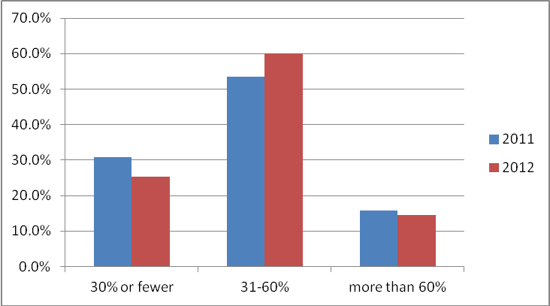

However, when the figures are analysed in relation to different types of school, as shown in Figure 2 it can be seen that it is still the old style academies (which tend to be in areas of socio-economic deprivation) that have fewer students continuing with the subject into Year 10. This pattern is essentially the same as that observed in 2011 (which is shown in Figure 3).

Figure 2: 2012: The proportion of Year 10 students taking GCSE history

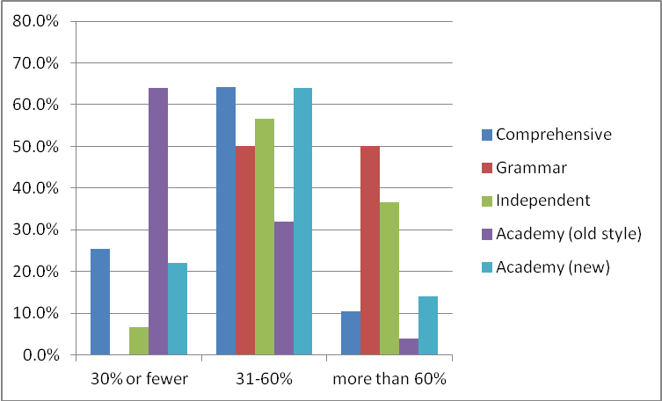

Figure 3: 2011 - Year 10: proportion taking GCSE history

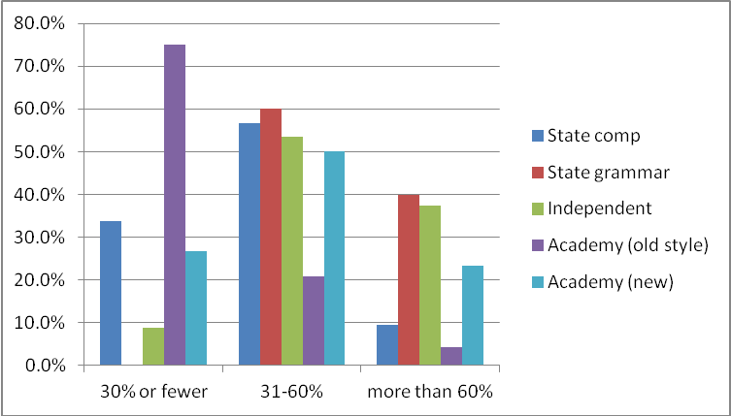

1.1.2 Changes to the number of students taking GCSE and to the number and size of classes

Respondents in 2012 were also asked directly about any changes that there had been to the number of students taking GCSE and, as a consequence, to the number and sizes of their GCSE groups.
Fifty percent of all respondents reported that there had been an increase in the number of students taking GCSE. This trend was evident across all types of schools, and it is encouraging to note that it has impacted particularly positively on the old style academies, nearly 70% of which reported an increase. Perhaps because they already had such a high uptake of history, far fewer independent schools (only 22%) reported an increase in numbers. Around 44% of schools reported that there had been no obvious change in numbers (with this stability much more evident in the independent sector).
Figure 4: 2012: Reported changes to the number of students taking GCSE

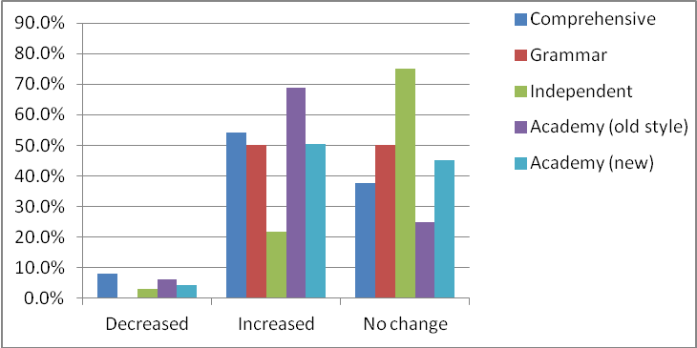

The increase in numbers is generally reflected in an increase in the number of GCSE groups, as the following chart indicates. However, many teachers are reporting both an increase in the number of classes and an increase in the average class size, while some have simply faced an increase in the average group size. As noted above, 50% of respondents reported an increase in numbers at GCSE, while 43% reported more GCSE classes and 37% reported larger group sizes – again particularly in the old style academies.

Figure 4: 2012: Reported changes to the number of GCSE classes

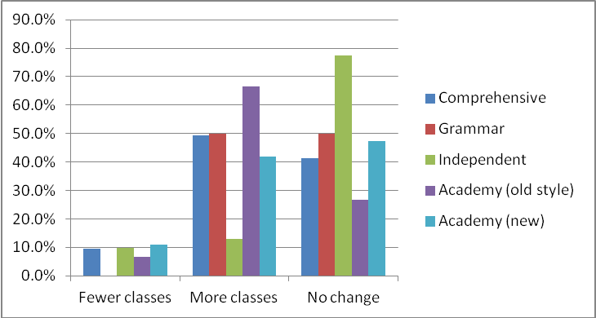

Figure 5: 2012: Reported changes to the average size of GCSE classes

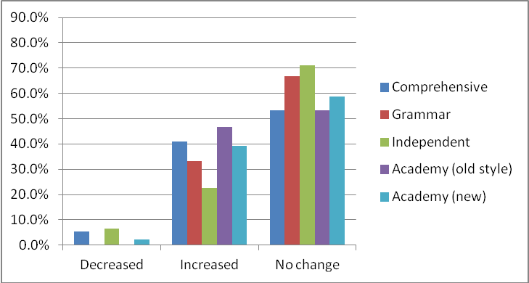

To allow us to examine the impact of increased GCSE uptake on class sizes in more detail, respondents were asked to give the average size of the GCSE groups in Year 10. The following chart indicates that while there are very few schools (less than 2%) in which more than 30 students are being taught in a class, more than 40% of the comprehensive schools and new academies reported class sizes of between 26 and 30 students. Only 20% of the grammar schools and only 3% of the independent schools are working with groups of more than 25 students. As discussed below, some teachers are anxious about the pressure that working with large groups creates, especially if they include students who have been compelled to take the subject.

Figure 6: 2012: Average size of GCSE classes in Year 10

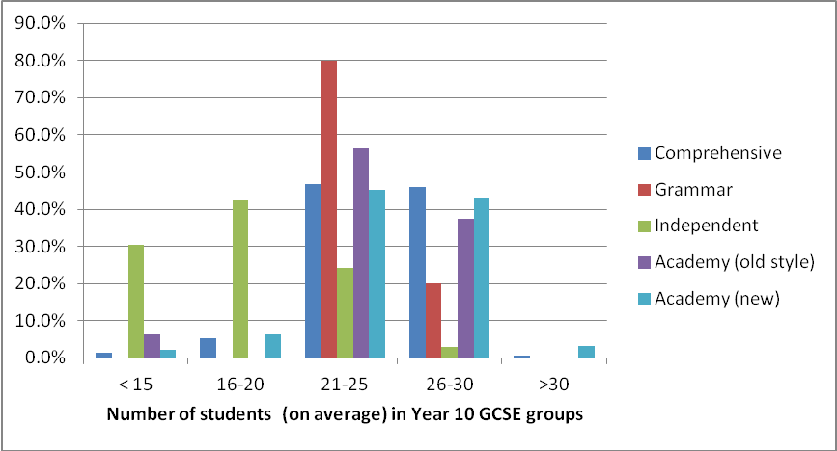

1.1.3 Time allocated to GCSE history

We also asked if the time allocated to GCSE history had changed at all in the last year, but in most cases there was very little difference, with only 6% of schools reporting an increase in time allocation and 4% reporting a decrease. Establishing the actual amount of time allocated to teaching the subject at GCSE is a complex task because schools now offer a variety of routes and timescales. While some schools follow the traditional pattern of a two-year GCSE course, many of those that have introduced a two-year Key Stage 3 use the time gained to follow three-year GCSE courses, while some have now introduced a one-year GCSE programme. The reason for doing so, seems to be to maximise the number of GCSE passes (at grades A*-C) secured by their students. Those who complete the course with a sufficiently high grade can go on to undertake other GCSEs, while those who do not achieve at least a grade C may have the opportunity to study the course again and re-take the exam a year later. Some schools offer both one and two-year GCSE courses while others may have two and three-year courses running, or have re-sit groups running in Year 11.

The following chart illustrates how much time is allocated to history GCSE for students following a traditional two year course. While the most common time allocation is between two and two-and-a-half hours each week, there is considerable variation from this pattern with some types of school (particularly old-style academies) giving rather less than this, and some giving rather more. Practice in the old style academies in particular seems to span the entire spectrum, but this is true to a lesser extent of other types of school too. The independent schools seem to be most likely to give significant time to history.

Figure 7: 2012 Average time allocated to GCSE history each week (for students following a two-year GCSE course)

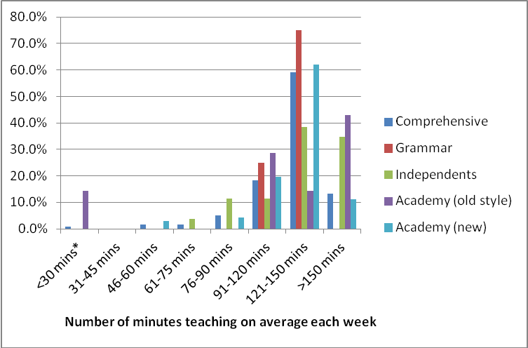

1.1.4 The proportion of GCSE classes that are taught by subject specialists
In most cases all GCSE history lessons are being taught by history specialists. However, while this is true for all of the grammar school respondents and 96% of those from independent schools, it is true for less than half of the old style academies, several of which report that more than a quarter of GCSE history groups are taught by non-specialists. Fourteen respondents reported quite specifically that there had been an increase in non-specialists teaching GCSE history as a direct result of the introduction of E-Bacc.

Figure 8: 2012: Proportion of GCSE history classes that are taught by history specialists

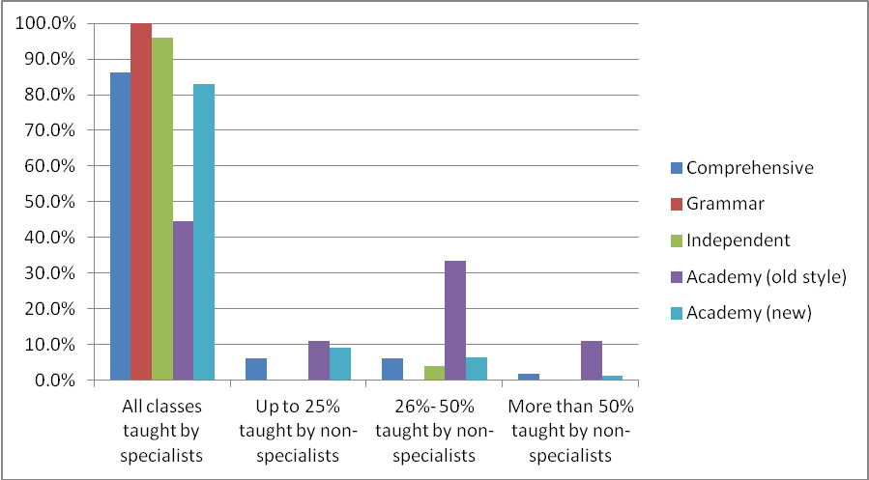

1.2 How much choice do students have about whether to pursue history at GCSE?

Figure 9 shows that nearly 60% of respondents report that students have a free choice about whether to take history or not. The figure for independent schools is 75%, while only 46% of old-style academies offer this freedom.

In 17% of schools all students are required to study at least one humanities subject (i.e. either history or geography) and in most of these cases the students can opt to take both subjects. Compulsion for all students to take at least one humanities subject is strongest in the grammar schools (50%) and new academies (23%). No independent school forces all children to choose between history and geography although some grammar schools do.

Twenty-four percent of respondents reported that there was compulsion for some students to take history (1%) or to choose at least one subject from history and geography. Again, most schools that required this of some students allowed them to opt for both subjects if they wanted. Only 3% of schools force all students to choose between the two subjects and a further 4% requires some students to make that choice.

Figure 9: 2012 GCSE 'options' system showing the extent to which history is prescribed
Since some schools offer all students the same range of choices whereas others impose certain limitations on some pupils respondents were asked to choose the one description that best matched the options/pathway system that operated in their school:
1. All students have a free choice to opt for history
2. All students must choose to take either history or geography and can also choose to take both.
3. All students must choose to take either history or geography, but they cannot do both.
4. Some students have to take history.
5. Some students must choose to take either history or geography and can also choose to take both
6. Some students must choose to take either history or geography, but they cannot do both.

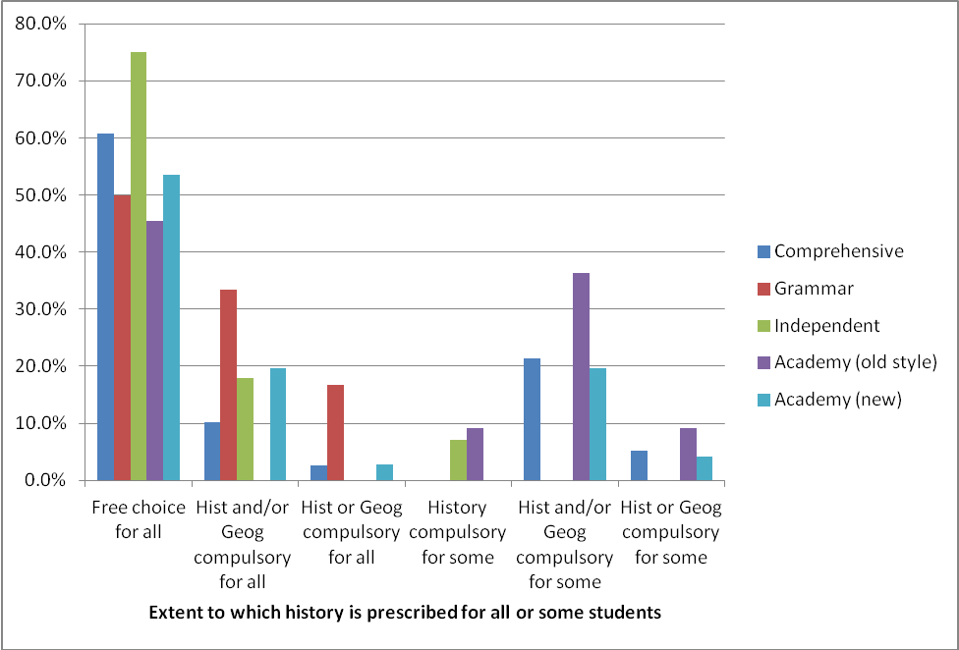

In total therefore it would appear that the number of schools that force some students to choose between history and geography is relatively small (only 7%). However, it is not clear whether the schools that give candidates a free choice about studying history provide the opportunity for them to take both history and geography.

In the schools where there is an element of compulsion for some students, the explanations given about what kind of students are required to take history or to choose at least one of the humanities always relate to their level of attainment. In some cases this is expressed in terms of expected attainment (for example ‘those expected to achieve a grade C or higher’) or in relation to their current achievement (usually a ‘minimum of level 5a in Key Stage 3’). In a very few cases the calculation is based on another E-Bacc subject altogether, with candidates who are thought likely to achieve a grade C in MFL being required to take a humanities subject to ensure that they will meet the overall E-Bacc requirement.

There is a very wide variation between schools as to which proportion of students fall into the top category to whom the compulsion applies, ranging from the ‘top third’ to the top 95%. (Both these extremes are figures given by comprehensive schools). While some schools make history compulsory for ‘top’ sets only, others refer to the ‘middle-higher bands’ or to the top 50% or 60%. In some cases a group of 20 -25 are explicitly excluded and cannot take history even if they wish do so, while all other students are required to take history and/or geography.

1.3. What restrictions are currently in place that prevent or strongly discourage students from taking GCSE history?
Thirty-one percent of all schools responding to the survey reported that some students are actively discouraged or prevented from taking history at GCSE. This proportion is similar across all types of schools, except for the grammar schools none of which reported any restriction on students choosing history.

Figure 10: 2012: The proportion of schools that impose a restriction on who may study GCSE history

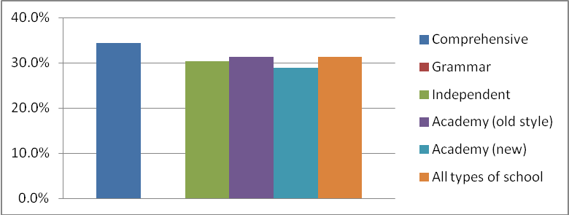

The figure for 2012is almost twice as high as that reported in 2011 when only 16.0% of the 376 schools that answered this question reported some kind of restriction preventing certain students from opting for the course. Since the figure for 2010 was also around 16%, responses in 2012 appear to indicate a shocking rise in the restriction of access to history at Key Stage 4.

In most cases the reason for the restriction is students’ previous attainment and assumptions about the kind of grade they are likely to get at GCSE. In 18 cases the teachers specifically mention that it is the students’ low levels of literacy (or the literacy demands of the subject) that mean they are directed away from history:

Some students are discouraged from opting for the subject due to the high level of literacy required especially for the Controlled Assessment. There is also the fact that Geography offer a foundation paper and the History boards do not meaning it is suggested to some students that Geography is a better pathway.
(Teacher 212, comprehensive)

Only one respondent refers to an alternative history qualification: the OCR Applied History Certificate (level 1/2):
Some students are offered (from this year) the new OCR Applied History Certificate (Level 1/2) if it is felt that they will struggle with the exam element of GCSE history due to literacy problems/Special Educational Needs etc.
(Teacher 40, comprehensive)

Again, there is considerable variation in the restrictions that are applied. While some schools regard a potential grade E as a worthwhile achievement and allow students to continue on that basis, others only allow students to follow the course if it is believed that they will achieve a Grade C. Several schools refer to pathway systems in which history is simply not an option on certain pathways:
Students are categorised according to ability: EBacc students, the Business & Enterprise pathway, an alternative pathway for lower achievers.
(Teacher 171, comprehensive)

While some schools refer to a very small number of students who would be prevented from taking history on these grounds, others suggest that as many as 50% of students might be unable to opt for the subject:
Students in the bottom half of the year group in terms of their ability are not allowed to take History. (Teacher 156, old-style academy).

Some history teachers make it very clear that the restriction or discouragement is coming from other colleagues in school (Special Needs Co-ordinators or members of the Senior Leadership Team):

Boys who are not academically minded and/or have literacy problems [are discouraged]. This is not official and is despite the fact that as Head of History I tell any parent and indeed the SLT that if a boy enjoys history and wants to take it at GCSE then I am quite happy for them to do so whatever their ability. (Teacher 27, new academy)

Lower-attaining students strongly discouraged from taking History. They are often steered towards ICT as an alternative option by the SENCo, who teaches ICT and discourages them from taking History. (Teacher 188, new academy)

In other cases history teachers have reluctantly concluded that the demands of the current GCSE courses mean that they simply cannot be accessed by certain students:

They do not have the literacy requirements to get a GCSE in history. I used to be appalled by this but, over time, I have accepted it. The history GCSE is consistently significantly harder than other GCSEs with no tiering and high literacy demands. I have seen too many lower ability pupils opt for history because they love it and become slowly disillusioned with it over the following two years, leading to non-attendance and G or U grades from pupils who would be capable of a D.
(Teacher 62, comprehensive)

The sheer variety in the approaches adopted by schools is the most worrying aspect of these responses. While some lower attaining students would be positively encouraged and supported in taking history in some schools, the same students would simply not to be allowed to pursue the course at all in a different school context. This obviously reflects the choices that schools have made, but in certain cases the students have no choice at all.

1.4. How have teachers assessed the impact of E-Bacc on GCSE?

Respondents were invited to comment on the nature of the impact on GCSE provision within the school. As the following chart indicates, most teachers (60%) felt that it was too soon to be sure what its implications would prove to be. Where the respondents expressed an opinion, these were more often positive (23%) than negative (3%), although a further 14% regarded the results as mixed – and many of the explanatory comments tended to give a mixed verdict event where teachers had indicated overall that they had a positive or negative view.

Seventy teachers provided written comments to explain their responses. Overall the responses suggest that there is a growing fragmentation of school provision, with opportunities to study history at GCSE dictated by local school circumstances and priorities.

Figure 11: 2012: Teachers' judgements about the impact of E-Bacc on GCSE provision

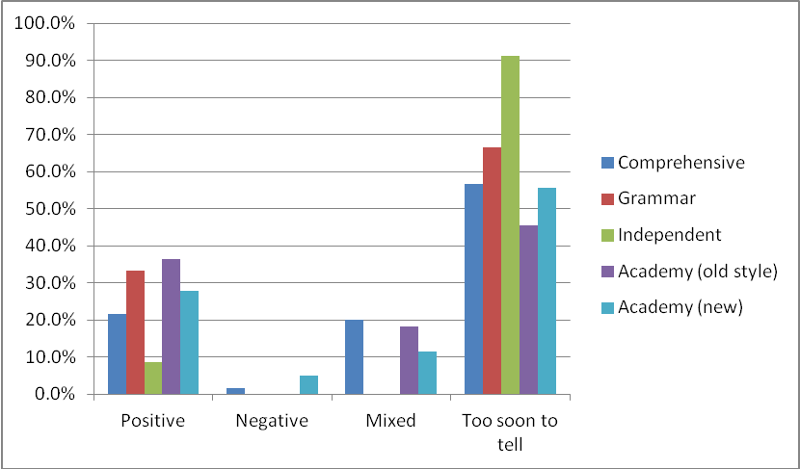

Fifteen of those who provided comments felt that the impact of E-Bacc had been positive. Of these, five mentioned the improved status and profile given to history by the school, parents and/or pupils. Four teachers mentioned more pupils opting to study history at GCSE as a positive, although two gave the caveat that it was only the higher attaining pupils who were opting to study it. One teacher noted within her essentially positive response that a more accessible form of specification was required for lower attaining pupils. Only two teachers mentioned more time being given to history at Key Stage 3 as a result of the E-Bacc, and in one school a teacher said that the E-Bacc was offered to pupils outside of normal school hours.

Five of the respondents who provided comments to explain their views judged that the introduction of the E-Bacc was entirely negative. All of them cited the lack of pupil choice as a major concern – some pupils were being forced to do history, others were being pressured to do history, and one teacher regretted the fact that whereas in the past students could have opted to take both history and geography now they could only take one.

Twenty-one teachers who provided comments judged that the impact was mixed. Four teachers mentioned the increased uptake in GCSE numbers, but reflected that this came at the expense of pupil choice. This lack of choice was seen as a problem leading to a lack of pupil engagement. Other concerns raised by these four teachers were the fact that only the more able students were taking history, and the increased pressure to ‘perform’ and get strong results,

More students are studying it but some students are now studying it who would probably have picked other options given free choice. These students lack the commitment that those who choose History freely had. (Teacher 166, comprehensive school)

This broad range of concerns was picked up by other teachers. The most common concern, mentioned by eight other teachers, was the lack of pupil choice. Another four raised the issue of a lack of resource to support the increase in numbers studying the subject, which was a particular concern where teachers were having to teach students with lower academic profiles.

Five teachers reflected that the current GCSE was too challenging for some pupils. This issue was identified in two different ways. In some cases the introduction of the E-Bacc has reinforced the idea that history is a ‘difficult’, academic subject so only the higher attaining pupils were opting, or being allowed to opt, to study history. In other cases, a broader spectrum of pupils was studying history which presented challenges for teachers.

Our current Year 10 cohort are the weakest we have ever had since I have been at the school (11 years). If it hadn't been for the E-Bacc I suspect we would have only had 3 groups this year. Many of them are struggling and because they find it hard, behaviour is beginning to be an issue and the quality of their work is poor. We have had to bring in intervention initiatives and those who are underachieving have to stay for an hour after school on a Friday for extra help. The cohort is selected on the basis of regular 'mid unit tests'. The current Year 9 group are very bright – we could have nearly 120 students doing GCSE next year – unfortunately it looks like there will still only be four groups so 30 per class. This will cause issues re resources (we'll have to buy in more textbooks) and of course marking/report writing. (Teacher 278, new style academy)

Twenty-nine teachers among those who explained the reason for their views felt that it was too soon to judge the impact of the E-Bacc, or felt it had had no impact. In a number of cases this was because history was already strong within the school with healthy numbers opting for the subject, in others it was to do with ideological reasons or the local context.

History has always been popular within the school with 50% choosing it in an open option in the current Year 11. So far no problems with more pupils taking it except for the impact on KS3 which might come through to KS4 in subsequent years (Teacher 144, comprehensive school)

Our senior management is anti-anything a Conservative government might do and determined to ignore the EBacc. (Teacher 110, comprehensive school)

At present, most local colleges and universities are not promoting the E-Bacc so few students seem to be that interested in it. A number of students are not interested in languages so have decided to opt out of the E-Bacc as a result- they want the freedom to choose the subjects they like / need for careers.
(Teacher 147, comprehensive school)

In a few cases the lack of impact was due to school priorities, because the school was focusing on other subject areas.

For some reasons some staff still advise against taking Geography and History. I know not why... EBacc has been very successful in recruiting more linguists and separate scientists – I think it has had a greater impact there.
(Teacher 34, new academy)

Because the school is encouraging brighter pupils to take triple science, this is having an effect on how many can take E-Bacc. (Teacher 196, new style academy)

In summarising the teachers’ perspective on the E-Bacc, it is clear that the positives are essentially to do with an enhanced profile for the subject and an increase (in some schools) in the number of pupils studying history at GCSE. The range of concerns is broader. Teachers are particularly concerned about the reduction in pupil choice (in some schools), the pressure to improve results, without additional resources, the challenge that history presents for the lower attaining pupils. Other additional issues raised relate to the growth in class size at GCSE and the impact on Key Stage 3 provision.

2. Key Stage 3

2.1 What evidence is there that the introduction of the E-Bacc has protected or enhanced the teaching of history at Key Stage 3?

2.1.1 The impact of E-Bacc on the provision of specialist teaching

In 2011 concerns were highlighted regarding a growth in the number of pupils being taught by non-specialist history teachers. Both grammar and independent schools were able to provide the vast majority of Year 7 pupils with specialist teaching. Both comprehensive schools and new style academies were only able to provide specialist teaching for 40% of their classes, which dropped to just over a third for old style academies.

Figure 12 2011: The proportion of history lessons in Year 7 taught by non-specialists

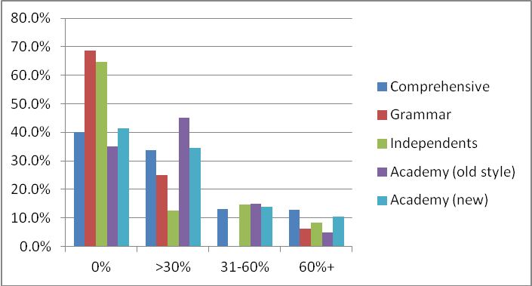

Figure 13: 2012: The proportion of history lessons in Year 7 taught by non-specialists

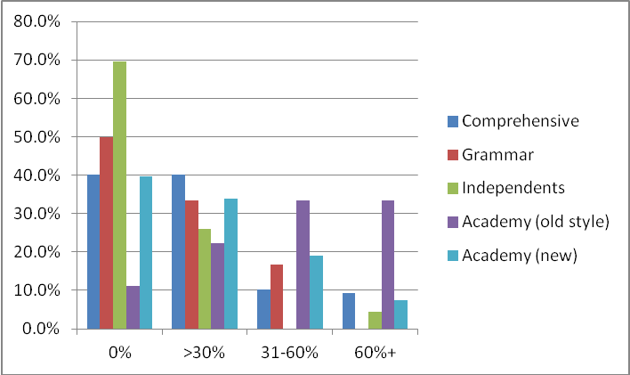

The 2012 survey shows these concerns still exist. Although there is some stability in the overall picture, there are indications that the situation is getting worse rather than better. Across all schools, around one fifth of respondents report that the E-Bacc has meant more non-specialists teaching in Key Stage 3.

In both comprehensive schools and the new academies 40% of respondents report that they are able to provide specialist teaching in Year7, which suggests a stable picture when compared with last year, but illustrates an on-going concern. The situation appears significantly worse in grammar schools with only half of them reportedly able to provide specialist teaching for all Year 7 pupils, but the fact that so few schools of this type responded to the survey makes this figure an unreliable one from which to generalise. Although the actual number of old style academies which replied to the survey was also limited, their responses show that the degree of specialist teaching available is very restricted. Overall more schools are reporting that between 31-60% of classes are being taught by non-specialists. As one teacher explained:

[We] now have MFL, Geography, Food tech, and other non-specialist teachers teaching History, many classes are now 'shared' between two teachers which they weren't before - with a clear negative impact on pupils' progress and enjoyment.
(Teacher 5, new style academy)

Just over 75% of respondents reported that the staffing changes they had experienced were not directly related to the introduction of the E-Bacc; rather they reflect general issues over staffing and timetabling, which seem likely to have derived from the budgetary impact of the current spending cuts. However, over a fifth of respondents claimed that the changes to staffing were a direct and negative impact of the E-Bacc. With more pupils studying history at GCSE, specialist teaching resource is being directed towards those classes, but few schools have recruited more history teachers to cover the increase in teaching load; in fact only four schools out of 239 who replied to this question said that more specialist teachers had been recruited to help teach Key Stage 3.

2.1.2 The impact of E-Bacc on the way history is presented in the curriculum

Overall, in comparison to the results reported in 2011, there is a great deal of continuity in curricular provision for history at Key Stage 3, with the vast majority of schools teaching history as a discrete subject. It is difficult to analyse the trends in comprehensive schools and the new academies, partly because the newer academies were former comprehensive schools (and thus would have appeared as comprehensive schools in last year’s survey), and so fluctuations in provision may be disguised by a change in a school’s status. As in previous years, the old style academies are less likely than all other types of school to offer history as a discrete subject.

Only 29 out of 244 respondents to this question claimed that changes had been made to the structure of their Key Stage 3 provision as a result of the introduction of the EBacc. While some schools have undoubtedly reviewed and strengthened their Key Stage 3 provision, others have reduced further the time allocated to history for all in order to give some students more time to do history GCSE (taking the course over three years instead of two). Thus while those who opt for history as a GCSE (or who are permitted to take it) may get more focused history teaching than would have been the case previously. Many others, however, who would previously have studied Key Stage 3 history in Year 9, now give up the subject altogether at the end of Year 8 (at the age of age 13). In some cases schools which continue to follow a traditional three year Key Stage 3, are asking pupils to choose between history and geography at the end of Year 8 so that they study only one of the two subjects for the final year of Key Stage 3.

Table 1: The inclusion of history within the Year curriculum in 2012 compared with 2011
2012 figures are presented in plain text. (2011 figures are presented within brackets in italics)

 | As a discrete subject | As a distinct subject within humanities | Within integrated humanities | Other | Total respondents
All schools | 179  (287) | 26  (40) | 19  (28) | 6  (20) | 230  (375)
All schools | 77.8%  (76.5%) | 11.3%  (10.7%) | 8.3%  (7.5%) | 2.6%  (5.3%) | 230  (375)
Comprehensive | 90  (181) | 12  (30) | 10  (21) | 3  (17) | 115  (249)
Comprehensive | 78.3%  (72.7%) | 10.4%  (12.0%) | 8.7%  (8.4%) | 2.6%  (6.8%) | 115  (249)
Grammar | 5  (16) | 0  (0) | 1  (0) | 0  (0) | 6  (16)
Grammar | 83.3%  (100.0%) | 0.0%  (0.0%) | 16.7%  (0.0%) | 0.0%  (0.0%) | 6  (16)
Independent | 22  (48) | 1  (2) | 0  (1) | 0  (1) | 23  (52)
Independent | 95.7%  (92.3%) | 4.3%  (3.8%) | 0.0%  (1.9%) | 0.0%  (1.9%) | 23  (52)
Academy (old style) | 5  (14) | 3  (4) | 1  (1) | 1  (0) | 10  (19)
Academy (old style) | 50.0%  (56.0%) | 30.0%  (16.0%) | 10.0%  (20.0%) | 10.0%  (8.0%) | 10  (19)
Academy (new) | 56  (28) | 10  (4) | 7  (1) | 2  (0) | 75  (33)
Academy (new) | 74.7%  (84.8%) | 13.3%  (12.1%) | 9.3%  (3.0%) | 2.7%  (0.0%) | 75  (33)

2.1.3 The impact of E-Bacc on the time allocated to history at Key Stage 3

In 2011, as in previous years, more schools were cutting the overall time allocated to history at Key Stage 3 than were increasing it. The figures from the 2012 survey suggest that this situation is stabilising. Out of 222 responses to this question for Year 7, 12 reported an increase in time whilst 13 reported a decrease in time allocation. A similar picture is evident in Year 9 with ten schools reporting an increase in time as opposed to 12 decreasing time.

The actual amount of time allocated to teaching history each week continues to vary considerably from school to school and by school type. As in previous years, the older style academies are generally less generous in providing curriculum time for history. Unusually this year the amount of time reportedly provided in independent schools is less than that provided in comprehensive and grammar schools, with just over a fifth of independent schools giving 90 minutes or more to history, compared to almost half of comprehensives and grammar schools. The reason for this is not clear and it is possible that it merely reflects the practices of a different sample of schools from those that responded last year, as only one of the independent school respondents actually suggested that the amount of time allocated to history had decreased from the previous year.
In Year 9, comprehensive schools also appear very strong in terms of the amount of time allocated to the subject. Almost 45% respondents from comprehensives schools report that their school provides 90 of minutes of history per week; however it is not altogether clear whether this is due to the increasing numbers of schools that have a condensed Key Stage 3 and start GCSE classes in Year 9.

Figure 14: 2012: The amount of time actually allocated to history in Year 7

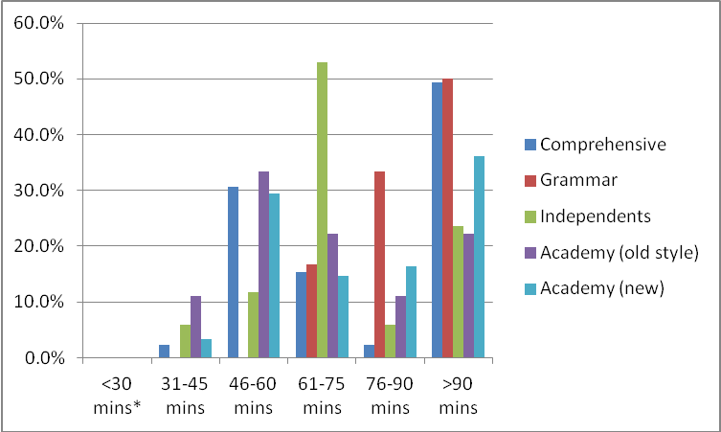

In general it appears that the situation regarding time allocation (both the overall trend and the actual amount of time allocated) has not significantly altered in comparison to the findings of the previous survey. The number of schools increasing or decreasing time for history is more evenly balanced than previously, whereas the variations in time allocation are consistent with the patterns discerned in previous years (except for the responses from the independent schools this year).

Figure 15: 2011: The amount of time actually allocated to history in Year 7

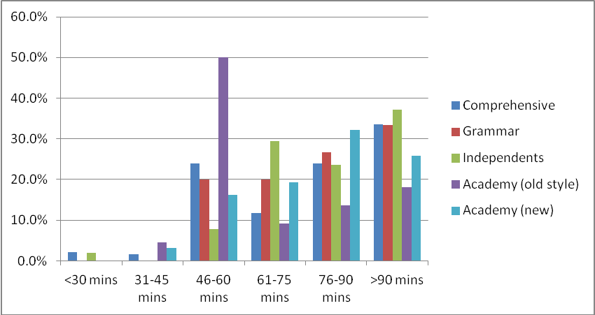

2.1.4 Overall impressions of the impact of the E-Bacc on Key Stage 3 history

As the results so far have shown, the effects of E-Bacc on Key Stage 3 history teaching are essentially very mixed. It is possible to find many examples where the position of history has been significantly strengthened. Seven schools have re-introduced a discrete history course rather than integrated humanities teaching in Key Stage 3.

Year 7 used to be taught an appalling humanities syllabus! That has been thankfully abandoned in favour of something more rigorous. (Teacher 62, comprehensive school)

Eight schools have increased the amount of time allocated to history at Key Stage 3, and one school that had allowed some students to drop history in Year 9 has re-instated it as requirement for all students.

However it is equally possible to find examples of schools where history provision for all students has been weakened. Ten of the respondents reported that their school s had introduced a two-year Key Stage 3 allowing pupils to give up history at the end of Year 8, while two more had allowed students to give up either history or geography at the end of Year 8 to allow more time for the other subject at Key Stage3. These kinds of changes are based on the assumption that dropping other subjects earlier will give students more time to focus on those that they will go on to take for the E-Bacc and thus enable them to achieve higher grades in the necessary range of subjects. However such an approach inevitably narrows students’ experience of the curriculum and those who do not plan to continue with history therefore receive even less history education than they would have done previously.

The other crtical concern for Key Stage 3 prompted by the E-Bacc, has been the increase in non-specialist teaching at Key Stage 3:

This is a huge concern. An RE teacher with some experience/knowledge of History teaches the bulk of these and two other non-specialists. This number will only increase further. (Teacher 89, new academy)

Due to the increase in GCSE teaching some of the Key Stage 3 teaching had to be passed outside the department. (Teacher 121, new academy)

Small department, resources must be focused on GCSE, so Key Stage 3 suffers.
(Teacher 224, comprehensive school)

