CONTENTS
PREFACE
SUMMARY
Overview
Section 1: The report
1.1 Report data
1.2 Survey returns and the National Curriculum for History
Section 2: History teaching in schools: the taught curriculum
2.1 What is taught: historical content
2.2 What is taught: history as enquiry
2.3 Curricular organisation, time allocation and the yearly pattern
2.4 The school curriculum
2.5 Curriculum development
Commentary
Section 3: The history teacher's craft: professional knowledge – pedagogy
3.1 The surveys: aspects of teachers' professional knowledge (pedagogic knowledge)
3.2 Academic subject knowledge: historical knowledge and history as enquiry
3.3 Teaching strategies, approaches, activities and resources
3.4 Assessment
3.5 Progression
Commentary
Section 4: History leadership and training
4.1 The extent of subject leadership training
Commentary
Section 5: Initial Teacher Training and Continuing Professional Development
5.1 Introduction
5.2 Extent and provision of training
5.3 Preferred method of training
Commentary
Section 6: Conclusions: The Historical Association's 2010 & 2011 primary history surveys report
6.1 The National Curriculum for History: present into future
6.2 Historical content
6.3 Chronological understanding
6.4 Integration and cross-curricularity
6.5 Initial Teacher Training and Continuing Professional Development
Appendix: Ofsted School Report, December 2010 [our enumeration]

PREFACE
The Historical Association is a national charity incorporated by Royal Charter founded in 1906 to further the study and enjoyment of history. Our 6,000-plus membership is largely made up of those who have a professional interest in history: teachers, academics, museum educators and archivists.
In 2010 the Historical Association conducted a national primary history survey to provide a detailed picture of history teaching in 17,000 state primary schools. The Association’s aim was to inform its provision for teachers and to provide evidence for the development of a new National Curriculum for History for implementation in 2014.

In April 2011 we reported the findings from the 2010 survey. The positive response to our report encouraged us to conduct a second survey in the autumn of 2011. The 2011 survey built on the first but with additional questions on a range of central issues that the first report had raised. This report combines findings from the 2010 and 2011 primary surveys’ 525 returns.

The survey received returns from teachers in a cohort of over 360 English schools that teach the National Curriculum for History as an integral element in their curricula. These schools teach history in four ways: as a discrete subject, as an element in integrated programmes, as project-based work or as a combination of all three approaches.

The surveys reflect two key points in Ofsted’s history subject report of March 2011, History for All.

In the schools visited history was generally a popular and successful subject, which many pupils enjoyed. Achievement was good or outstanding in 63 of the 83 primary schools…
History teaching was good or better overall in more than three quarters of the primary schools visited….

In most of the primary schools visited, there was not enough subject-specific expertise or professional development to help teachers to be clearer about the standards expected in the subject and to improve their understanding of progression in historical thinking. (Ofsted 2011)

The surveys indicate that the 2014 National Curriculum for History should:

- be used to reinvigorate the primary history curriculum through the introduction of a broader range of topics, a more coherent content core and better transition to what is taught at Key Stage 3 (KS3);
- be used to address the concerns expressed in this and Ofsted’s history subject report of March 2011 – namely concerning chronology, assessment, progression, transition and training;
- provide children up to the age of 11 with the opportunity to learn about key aspects of British history from ancient to modern times along with the history of some of the important societies and events in European and world history;
- instill a secure chronological framework through revisiting some periods and topics in greater depth and complexity as the pupils progress from one key stage to the next;
- take account of the UK’s evolving cultural, ethnic and religious diversity; include a guaranteed weekly time allocation for the subject;
- incorporate provision for initial and continuing teacher training, education and continuing professional development (ITT/CPD). The surveys revealed that for primary history teachers there is little or no professional development available. A professional development programme will enable satisfactory history provision to become good and good to become outstanding.

Penelope Harnett and Jon Nichol

SUMMARY

Overview

The summary is in six sections, the last of which brings together the Historical Association's recommendations based on the survey findings. The appendix gives a detailed account of outstanding history teaching in a primary school taken from a December 2010 OFSTED report. The account illuminates holistically many of the points that the primary survey covers.

Section 1: The report

1.1 Report data

The report is based upon data from the Historical Association’s 2010 and 2011 national surveys of 17,000 state primary schools. The 2010 survey had 33 questions.

The 53 questions in the 2011 survey included 20 new ones. These investigated issues central to the future of history that responses to the first survey’s 33 questions had raised.

1.2 Survey returns and the National Curriculum for History

There were 525 returns to the 2010 and 2011 surveys. There were responses from teachers in a cohort of 360-plus schools. Their returns indicated that their schools taught the National Curriculum for History as statutorily prescribed and developed since 1990.

Section 2: History teaching in schools: the taught curriculum

2.1What is taught: historical content

The 360-plus survey schools teach the two elements of the National Curriculum for History: historical content (facts), i.e. what pupils learn about our past; and history as enquiry, i.e. how they learn about the past – the skills, processes and disciplinary concepts of history as an academic discipline.

The historical content for the primary phase consists mainly of British history topics from the Roman period to the present day within a developing chronological framework for 5–14-year-olds. The National Curriculum for History also includes topics on classical civilisations, world history and social and economic history.

British history forms the bulk of teaching, with local and personal history more prominent in Key Stage 1 (KS1). Throughout the primary curriculum, the wider UK is rarely taught and most European/global history is confined to a few topics such as Ancient Greece and Ancient Egypt. Having said that, the survey indicated that some schools had introduced other world history topics such as the Aztecs and the Indus Valley.

A majority of schools (73.8 per cent of the total responding to the question) taught local and community history which, given the geographical distribution of the respondents, suggests that a range of regional histories may be being taught. Visits to museums and historic sites were used by 86.5 per cent to further develop their pupils’ understanding of the past.

The proportion of teachers who said that they made links between the past and the present day through some of their history teaching was 90.1 per cent.

Only 51.1 per cent felt that children’s knowledge of world history was developed through their history lessons. This may be in part as a result of the National Curriculum for History which at KS2 specifies that only one world history study unit has to be taught.

Of particular concern is the data which show that multi-cultural British history was only taught in 24.1 per cent of the schools that responded to this question. Factors such as the lack of both suitable resources and teacher expertise have been used to explain this. In mitigation, the 2010 HA survey indicated that a significant number of teachers felt that creating an inclusive history curriculum should be accorded a high priority.

The National Curriculum for History’s historical content has not changed greatly since 1991; nor has it been reviewed since 1999, when minor adjustments were made to reduce prescription and provide schools with greater flexibility.

2.2 What is taught: history as enquiry

The National Curriculum for History’s second element, history as enquiry, teaches pupils to think like historians. This develops their understanding of:

- the process of enquiry: questioning, investigation, recording, synthesis, analysis, organisation of data, writing reports, accounts and narratives;
- academic history’s disciplinary concepts, primarily – chronology; causation; historical evidence; historical narratives, accounts and reports; historical interpretations, historical imagination;
- the communication of historical knowledge and understanding.

54 per cent of those who responded felt that historical thinking (concepts and processes) was well developed by their history curricula, in contrast to 90 per cent who felt that historical content – historical knowledge and understanding – was well developed.

This may help to explain inspection evidence of history in primary schools, where HMI (OFSTED, 2007 and 2011) comment that in some schools insufficient attention is paid to children’s progression in the development of historical skills and concepts.

83 per cent of teachers felt that the history they taught helped pupils acquire a chronological framework of the past. Having said that, how children make sense of the British narrative of the past may be limited. HMI (OFSTED, 2007 and 2011) comment on the fragmented nature of children’s understanding of key events and their inability to make links between historical knowledge over different periods of time.

2.3 Curricular organisation, time allocation and the yearly pattern

In the Early Years Foundation Stage (EYFS), 3-5 age range, 85 per cent of schools integrate history in the curricular area Knowledge and Understanding of the World.

At KS1, 5-7 age range, history is taught within an integrated programme or as an element of project work. At Key Stage 2 (KS2), 70 per cent of schools still teach history within integrated programmes or project-based work. In 30 per cent of schools at KS2 some or all history is taught as a separate subject, doubling the amount of such teaching from EYFS and KS1.

History is usually taught for less than an hour a week in the EYFS and from 1 to 2 hours per week at KS1 and KS2.

Two-thirds of history is taught in termly blocks, the remainder on a weekly basis.

These figures in both the 2010 and 2011 surveys by the Historical Association were broadly the same, indicating a stable pattern over this time period.

2.4 The school curriculum

History is an established school curriculum subject: 64 per cent of replies said it had medium priority, 10 per cent high or very high priority.

2.5 Curriculum development

The 2010 and 2011 primary surveys asked teachers what changes they would like to the National Curriculum for History.

- Only 6 per cent of teachers were very satisfied with the current history curriculum; 15 per cent called for a complete change to the programmes of study and 43 per cent called for minor changes. 54 per cent of teachers asked for more opportunity for cross-curricular work and 32 per cent requested more or different topics. The proportion of teachers who want history to be included in the common core of the primary curriculum was 78 per cent.

Figure 1
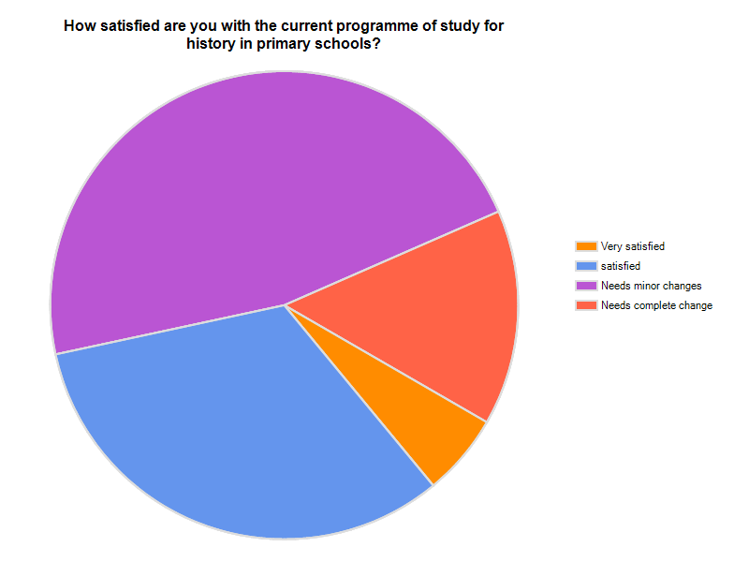

Figure 2

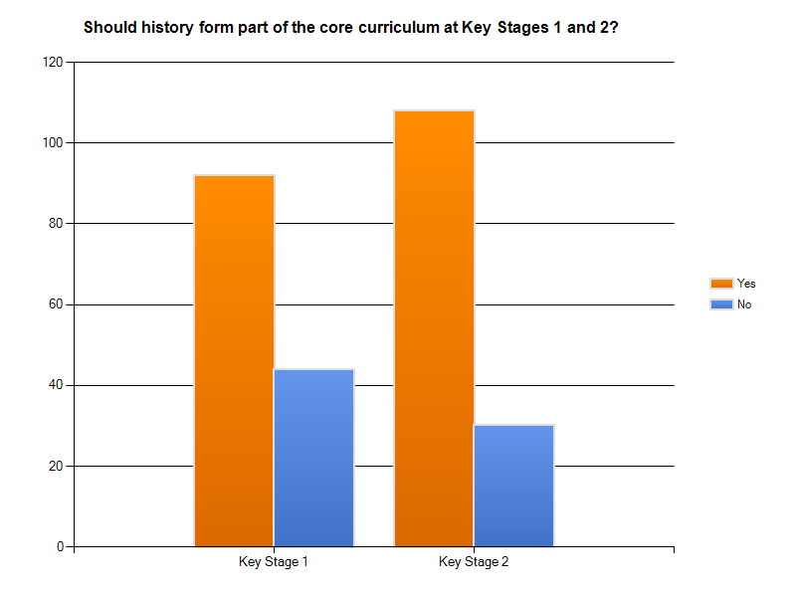

Commentary

There is clear evidence from the 2010 and 2011 surveys that the main British history topics set out in the National Curriculum for History are being widely taught. Be that as it may, whether this leads to pupils assimilating an English or a British narrative of the past is less clear. Other evidence, including successive Ofsted and QCA history subject reports from the last 10 years, indicate that it is English history being taught and the broader British narrative is neglected. Some teachers recognise the importance of other, minor narratives: the personal and familial, the local, the communitarian, the social, the multi-cultural and the global/world dimension.

The evidence from the survey suggests that the vast majority of primary schools adhere closely to the topics set out in the National Curriculum for History although there is no guarantee or requirement that these are taught in chronological order. Mixed-year classes make a sequentially chronologically structured history curriculum particularly challenging. The 2011 survey returns strongly indicate, however, that many teachers recognise and understand the nature and role of chronology.

The original National Curriculum for History introduced into schools in 1991 and refined in 1995 following the Dearing review provided little guidance on curriculum organisation and planning. The planning and implementation of the history curriculum was left to individual schools. Having said that, the Historical Association's 2010 survey showed how subsequent QCA schemes of work published in 1998 (QCA and DFEE, 1998), have dominated and determined the way the National Curriculum for History is taught in many primary schools.

.

Section 3: The history teacher’s craft: professional knowledge – pedagogy

3.1 Aspects of teachers’ professional knowledge (pedagogic knowledge)

The Historical Association's surveys of 2010 and 2011 investigated four aspects of teachers’ pedagogic knowledge in relation to teaching and learning in history. These were:

- academic subject knowledge – historical content and history as enquiry;
- knowledge of history teaching: teaching strategies, approaches and activities, i.e. how to plan, resource and to teach history;
- assessment, and
- progression.

3.2 Academic subject knowledge: historical content and history as enquiry

The surveys’ evidence suggests that teachers believe that they have sufficient knowledge of the National Curriculum for History’s historical content. For example the vast majority of schools taught the topics prescribed in the programmes of study and there is a clear focus on the development of historical knowledge and understanding in 83 per cent of the schools surveyed. This may be due in part to the fact that the content of the National Curriculum has hardly changed in the past 20 years and is therefore very familiar to many primary teachers. The presence of QCA guidance such as the schemes of work for primary history (published in 1998) – and still used very widely, according to Ofsted – may be another factor. Evidence from Ofsted suggests, however, that history as enquiry is taught less well in many schools, and in many instances this is the difference between lessons being satisfactory or good to outstanding. Pupils' understanding of the nature and provenance of historical interpretations, historical sources and historical evidence and its validation enriches and enhances the quality and depth of their historical thinking and knowledge.

The 2011 survey investigated one seminal aspect of the history as enquiry element: the teacher’s knowledge of chronology.

The teachers’ responses revealed that while some aspects of chronological understanding seemed to be well understood (the teaching of historical terminology and conventions [72.3 per cent] and the sequencing of time and events [83.9 per cent]), others were less developed (developing children’s sense of period [59.9 per cent], their ability to make links between different time periods and events [63.9 per cent] and appreciation of the length of time [34.3 per cent]). This appears in part to support Ofsted’s evidence on the fragmented nature of children’s understanding of key events and children’s inability to make links between historical knowledge over different periods of time.

Figure 3
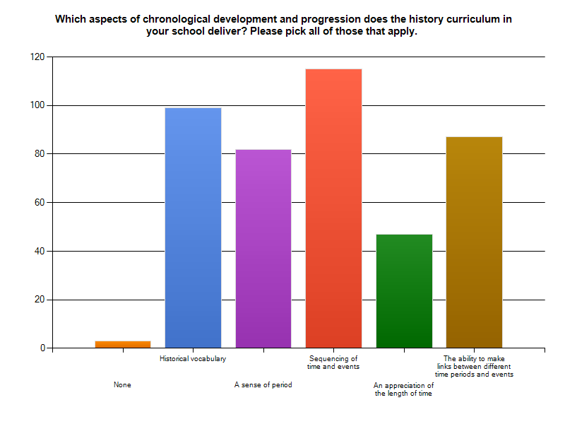

3.3 Teaching strategies, approaches, activities and resources

72 per cent of teachers used a variety of teaching methods. We did not survey these methods. The teachers overwhelmingly requested support and access to resources for teaching as figure 4 below indicates.

Figure 4
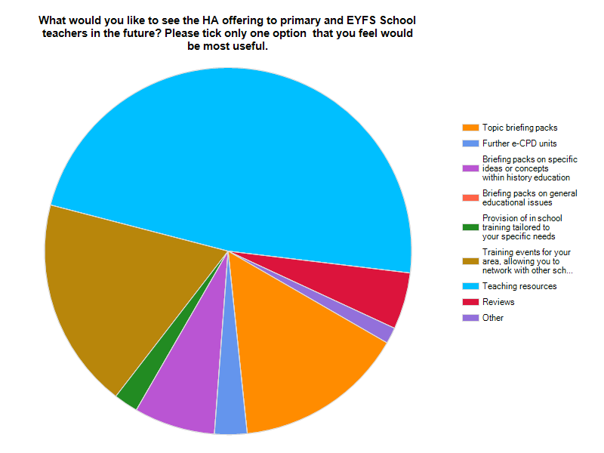

3.4 Assessment

Of teachers responding to the 2011 survey 63.5 per cent did not assess history formally. Of the teachers that did assess history formally, 35 per cent assessed it termly, and 21.9 per cent assessed it yearly.

Without regular formal assessment, it is difficult to see how children’s progress in history is being monitored in many schools. The irregularity of formal assessment of history in primary schools may point to issues relating to the status of the subject within schools.

The proportion of teachers who found the history level descriptions quite useful was 63.2 per cent while 30.1% found them not useful. This suggests that either some revision of these descriptions may be overdue or that some schools would benefit from further training in how to use the level descriptions effectively.

Only 52.6% shared some formal or informal assessment information with parents and children.

3.5 Progression

Of teachers' responses, 70.8 per cent said that their schools plan for progression from 5 to 11, while 29.2 per cent said that their schools do not plan for progression across the key stages.

Survey data indicated that 70.8 per cent of teachers planned for progression in the key historical skills and concepts, which is encouraging. This also contrasts with recent Ofsted findings and earlier QCA subject reports which found that progress in history is often measured in the form of enthusiasm and factual knowledge rather than progress in historical thinking.

A major element in progression is transition from the primary to the secondary phase, i.e. KS2 to KS3. Returns from 89.1 per cent of the schools indicated that there was no liaison over the transition in history from primary to secondary school. This is clearly continues to be an area of serious concern and was picked up by Ofsted in the 2011 triennial report into history, History for All.

Commentary

The surveys did not investigate the different kinds and range of teaching approaches and activities used in teaching the National Curriculum for History. Inferential evidence comes from the surveys’ history as enquiry responses. They suggest that to teach the wide-ranging and challenging aspects of historical thinking involved requires a rich, sophisticated and diverse pedagogy. Ofsted school reports contain supporting evidence for this hypothesis. For an example, see the Appendix.

Given lower levels of confidence displayed by respondents in terms of historical thinking, there may be issues here relating to teachers' understanding of what progression in history looks like.

The inadequate nature of history assessment and its infrequency, either termly or yearly, may suggest that formative assessment is not a common element in history teaching. The pattern of assessment the surveys reveal contrasts sharply with that for literacy and numeracy. Formative assessment of history needs to be on a continuous basis that monitors, records and reports each pupil’s progress and gives individual advice and support to maximise attainment.

Without formative assessment it is difficult to have effective historical learning.

Section 4: History leadership and training

4.1 The extent of subject leadership training

Subject leadership is the key to good and outstanding teaching. Over two-thirds of the respondents to the surveys were history subject leaders. Only 12 per cent had been trained for a history leadership role, however.

Figure 5
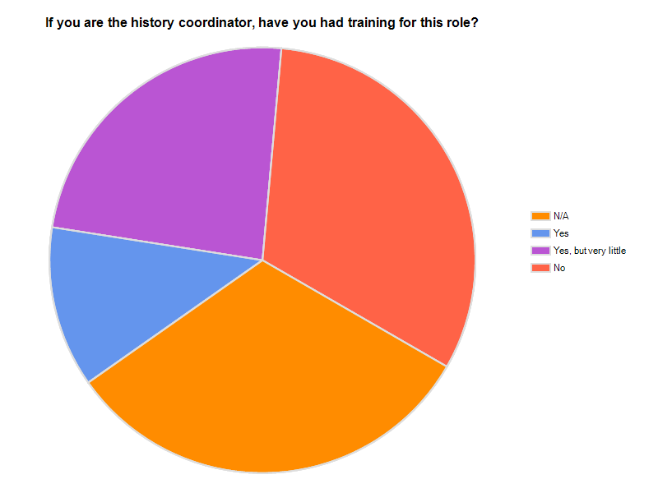

Commentary

To ensure effective leadership, specific leadership training should be an element of ITT and CPD. Without a progressive, long-term and incremental CPD programme, sustained improvement of history teaching, that is, moving from satisfactory to good and from good to outstanding, could be difficult to achieve.

Section 5: Initial Teacher Training and Continuing Professional Development

5.1 Introduction

The 2010 and 2011 surveys reveal a problem in teacher training in terms of the nature, content, quality and availability of both ITT and CPD for primary history. The survey indicated that there was minimal provision in the ITT phase and that CPD was almost totally absent during the Newly Qualified Teacher (NQT) year and subsequently when teachers were full-time members of a school’s staff.

5.2 Extent and provision of training

40 per cent of the teachers have received no training. Local Authorities and museums provide what little external training is available. Higher Education plays a minimal role – 7.1 per cent according to the survey.

There is little or no professional development provision nationally for teachers of primary school history. The role of Teachers TV, which had been a significant provider before 2010, inevitably diminished rapidly when its funding was withdrawn and closure followed.

Figure 6

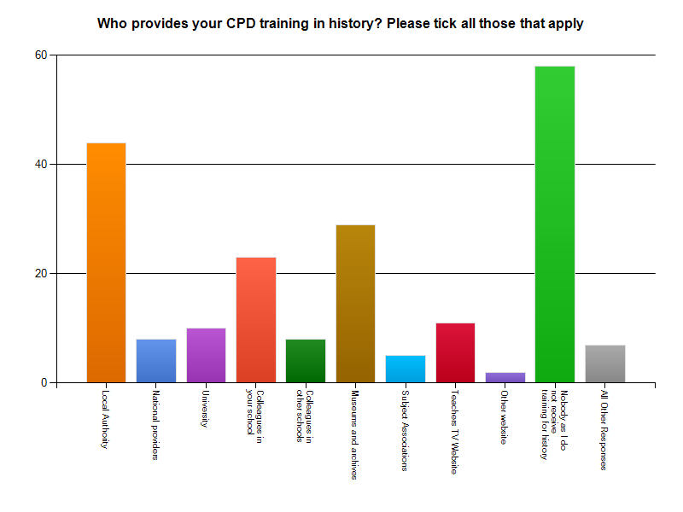

5.3 Preferred method of training

Teachers surveyed preferred in-school, face-to-face, during the day in-service training. They also indicated willingness to participate in locally provided CPD. There was minimal support for weekend and residential courses.

There was support for on-line and distance learning, although the majority preferred face to face in school training (56%)

Commentary

Teachers’ requests for professional development include support for developing their pedagogic knowledge.

Teachers requested CPD for assessment, cross-curricular links, curriculum planning, progression and supporting Gifted and Talented pupils, all of which are central aspects of effective history teaching.

Teachers identified teaching resources in general and sources for local history in particular as the most important areas for support. The proportion of respondents indicating that they would like the Historical Association to provide teaching resources above all else was 47.9 per cent, while 54.8 per cent indicated lack of funding for history resources as a crucial issue.

The survey returns from primary teachers indicate the need for some school-based in-service training to be available to all teachers of history.

- Such in-service training would have to deal with the deficits in pedagogic knowledge that school reviews have indicated alongside a needs-driven professional development programme.
- School CPD programmes need to be long-term, incremental and progressive, tailored to individual teachers’ personal development planning.
- The medium for such professional development could be a national network of primary school consortia that can draw upon the expertise of external bodies, including subject associations, higher education, other bodies and agencies and secondary schools.

Section 6 Conclusions: The Historical Association’s 2010 & 2011 primary history surveys report

The conclusions set out in this section are based on the evidence from the 2010 and 2011 surveys.

6.1 The National Curriculum for History: Present into future

The National Curriculum for History is currently under review. The review will provide an opportunity to address issues and concerns expressed in the Historical Association's 2010 and 2011 primary surveys. This should ensure that the 2014 National Curriculum for History leads to a revitalisation of the history primary curriculum along with greater coherence and progression between the primary and secondary history curricula and their teaching.

The National Curriculum for History is still based largely on the 1991 model and has not been reviewed since 1999. The evidence from the surveys and other sources indicates that the National Curriculum for History has been successful in laying solid foundations for primary history in the vast majority of schools in England. As a result, primary schools should be in a good position to implement any future changes to the history curriculum. Be that as it may, an accompanying training programme accessible to all schools would ensure that this was done effectively.

6.2 Historical content

The curricular framework needs revision.

The new curriculum should include a broader range of topics, a more coherent content core and better transition to what is taught at KS3.

The content of the primary history curriculum should include periods from ancient through to modern times and cover aspects of local, British and wider world history. It should instil a secure chronological framework and lay solid foundations for the further study of history from 11 to16 where some periods and topics could be revisited in greater depth and complexity to aid pupils’ progress.

Greater prominence should be given to the UK’s cultural, ethnic and religious diversity and how this diversity has been shaped by the past.

6.3 Chronological understanding

Any new history curriculum would need to address the fragmented nature of pupils’ understanding of key events and their inability to make links between historical knowledge over different periods of time. This could perhaps be achieved through the inclusion of some themed chronological units and by placing a greater emphasis on developing pupils’ sense of period and ability to place key events and developments within a broad chronological framework. This could be supplemented with guidance on curriculum organisation and planning, especially for schools where there are mixed-age classes. Overall, pupils need to acquire a macro chronological understanding of the past, an overall historical map, and micro-historical knowledge, a detailed historical map of topics they study on the overall historical map that provides orientation, context and guidance.

6.4 Integration and cross-curricularity

Support and guidance is needed on ways of teaching history within integrated and cross- curricular approaches. This could also include specific guidance on how history links with learning in literacy with a focus on reading difficult and challenging text, writing and oracy, mathematics and science.

6.5 Initial Teacher Training and Continuing Professional Development

Primary teachers would benefit enormously from professional development in history at all stages of their careers. For history the surveys have revealed three principal areas of concern:

- Initial Teacher Training Major reform of ITT is needed to provide the minimum required for all NQTs to teach good or outstanding history.
- History curriculum leadership Currently there is no training in leadership for almost 90 per cent of history subject leaders.
- Overall CPD In order to enable history teachers to become first-class practitioners, with reference to the areas the survey and other evidence highlight as being deficient, comprehensive CPD should be provided. There are multiple factors involved. Our survey suggests that this is an area that urgently needs review. It calls for the development of a CPD plan that can be implemented effectively and locally within individual schools and consortia.
APPENDIX: OFSTED SCHOOL REPORT – DECEMBER 2010

The primary survey mentions the factors that make for outstanding history teaching and pupils’ historical learning. We felt that it would be useful to publish an appendix that illuminate what such teaching is like. The Appendix is taken from an OFSTED school report that paints a comprehensive picture of the shape, focus, enthusiasm, enjoyment and quality of history teaching that combines symbiotically both historical substantive content and the sophisticated way of thinking, syntactic knowledge, that ‘Doing History’ involves.

[our enumeration]

1 Achievement in history is outstanding

1.1 While there is variation between pupils, overall, they achieve above average standards and their progress is outstanding. There are many examples that could be cited of this excellent progress. However, particularly interesting is the progress of pupils with English as a second language. The school has a large number of such pupils, well above the national average. In one example, a Year 2 pupil who arrived at the school with no English at all, could by Year 4, read, write, draw and talk about history in a way that showed very sound knowledge, understanding and an ability to interpret historical evidence.

1.2 Pupils’ personal development is also outstanding. In a Year 6 class studying the Second World War, though initially a little reluctant to say what they thought, pupils soon began to express views about the war. They responded well to prompts about right and wrong, democracy and dictatorship. In Reception, pupils were beginning successfully to sort out time by locating themselves in relation to parents and grandparents.

2 Quality of teaching in history

The quality of teaching in history is outstanding.

2.1 Teachers are very committed to the subject and are keen to share their enthusiasm with pupils. As a result, the content of lessons is rich and delivery is well paced, challenging and well matched to the needs of the pupils. Teaching assistants are deployed very well to support pupils, gently nudging them forward. The care that teachers have for pupils was confirmed by pupils when they were interviewed. Pupils also appreciated the many different activities they are given to do.

2.2 There is a thorough assessment system which is used to inform teaching and to provide effective reporting to parents. There are helpful comments made by teachers at the end of pupils’ written work. Pupils are able to say how well they are doing in history.

There was evidence of outstanding teaching in classes, in wall displays and in pupils’ work. One example was a Year 2 class which had been on a visit to a local country house. The teacher used the interactive whiteboard, Dr Who music, and clothes from the 18th century to give pupils the opportunity to question their fellow pupils who role-played children from the past and the present. The history was excellent because of the focus on interpreting evidence and the lesson was fast but suitably paced for the pupils. Above all, it was fun.

3 Quality of the curriculum in history

The quality of the curriculum in history is outstanding.

3.1 The curriculum is thoughtful, innovative but cautious. At its core are topics such as the Victorians and the Ancient Greeks the content of which is accurate, motivating and encourages exciting teaching. But what is interesting is the way in which staff have begun to move the curriculum on by developing new topics based on relevance to pupils and by ensuring that history contributes to learning essential skills, particularly literacy. They have very successfully blended history with other subjects while still preserving its subject integrity.

3.2 So, for example, in preparation for a two-week ‘International Arts and Literacy’ curriculum focus, staff looked carefully at the ethnic mix of the school to select the stories of famous people who were relevant to the identified groups; for example, Gandhi, Usain Bolt, Mary Seacole and Benazir Bhutto. Although the focus of the week was literacy, it drew very heavily on history. The historical knowledge and understanding of pupils at the end of the week reflected in written work, discussions and in displays in the school hall were impressive.

3.3 Chronology is very clear within topics but, because of the way the curriculum is organised, it does not obviously offer pupils an overall chronology covering all the topics studied. It currently has a clear rationale but, nevertheless, given the school’s insistence on a curriculum relevant to pupils, there is scope to ask questions such as ‘Why are we studying the Tudors and what of the Tudors should we study’?

3.4 Resources are used very well as are visits to local historical sites. Year 2 visit the local war memorial as part of their Remembrance Day work; Year 6 visit the Imperial War Museum; Year 4 to go to Hampton Court and Year 5 to the Museum of London as part of their Victorian topic. Effectiveness of leadership and management in history

4 The effectiveness of the leadership and management in history is outstanding

4.1 The effectiveness of the leadership and management in history is outstanding.

4.2 The subject coordinator leads and manages well; she has engaged all staff to become part of the management team taking initiatives to improve the subject.

4.3 The coordinator has a very good view of the strengths and issues for development in relation to history. Self-evaluation is excellent, supported by the effective assessment of pupils’ performance in the subject.

5 Areas for improvement, which we discussed, include:

5.1 clarifying the rationale for the curriculum to support even more the school’s interest in creating a curriculum which is historically and currently relevant to its pupils ensuring that pupils have a clear chronological overview covering all the topics studied.

5.2 ensuring that pupils have a clear chronological overview covering all the topics studied.

